**Chapter 01**

**1.1 Introduction**

In today’s fast-paced and interconnected digital world, the rise of the gig economy and online employment platforms has significantly reshaped how people work and how businesses recruit talent. The demand for flexible work arrangements and access to a global pool of skilled professionals has given birth to numerous online job marketplaces, enabling seamless collaboration between clients and freelancers.

This project introduces **Freedly**, an innovative web-based application designed to serve as a bridge between job seekers including freelancers and employers seeking specialized services or project-based collaborations. Drawing inspiration from well-established platforms such as Fiverr, Freelancer.com, and LinkedIn, Freedly aims to combine the best features of job marketplaces and professional networking sites to deliver a unified, user-centric experience.

Freedly will focus on three core functionalities: enabling employers to post jobs or projects, empowering job seekers to discover and apply for opportunities, and supporting freelancers through a dedicated marketplace. An integral feature of the platform will also include professional profile management, allowing users to build, update, and showcase their qualifications, skills, and portfolios facilitating more effective connections between talent and opportunity.

This document outlines the key components of the project, including its objectives, scope, methodology, required resources, and development timeline, in accordance with the academic and technical expectations of the **CSE5015 Computing Project** module.

**1.2 Problem Statement**

In today’s digital economy, the job market and freelance ecosystems are fragmented across multiple platforms, forcing users to juggle between job boards, freelance marketplaces, and professional networking sites. Employers often struggle to efficiently source talent due to a lack of unified tools for hiring both permanent staff and freelancers, while job seekers face challenges in managing scattered profiles, verifying their credentials, and gaining visibility.

Existing platforms either focus solely on job listings, freelance gigs, or professional profiles, leaving a gap for a comprehensive solution that integrates all three aspects. This results in inefficient hiring processes, limited talent discovery, high transaction fees, and difficulty in vetting candidates’ skills and experience.

There is a clear need for a unified platform that streamlines job and freelance project matching, improves talent verification through rich user profiles and portfolios, and enhances visibility and trust between parties. **Freedly** aims to solve these issues by providing a centralized, user-friendly web application that merges job postings, freelance opportunities, and professional networking into one ecosystem.

**1.3 Literature Review**

This literature review examines the current landscape of freelancing platforms, job posting portals, professional networking systems, and the technologies that support them. It informs the development of **Freedly** by identifying key features, trends, and gaps in existing solutions.

**1. Freelancing Platforms**

Freelancing platforms such as **Fiverr**, **Upwork**, and **Freelancer.com** allow clients to connect with independent workers for short-term or project-based tasks.

* **Fiverr**: Operates on a **gig-based** model with fixed prices, which simplifies transactions but limits flexibility to predefined services.
* **Upwork & Freelancer**: Use a **bidding-based** model where freelancers submit proposals. These platforms are versatile but highly competitive, making it difficult for new users to gain visibility.

**Key Technologies**: PHP, Python, JavaScript frameworks (React/Angular), MySQL/PostgreSQL.

**Learning**: A strong bidding mechanism, escrow system, portfolio support, and review functionality enhance trust and usability.

**2. Job Posting Platforms**

**Indeed**, **Glassdoor**, and **Monster** are platforms focused on permanent and contract employment.

* Employers can post job listings, while job seekers upload resumes and apply directly.
* Platforms also offer **company reviews**, **salary transparency**, and **job alerts**.

**Learning**: Systems must support powerful filtering, resume uploads, tracking of applications, and a user-friendly interface for both employers and applicants.

**3. Professional Networking Platforms**

**LinkedIn** is the dominant platform for career-based social networking.

* Users create detailed profiles including skills, work history, endorsements, and certifications.
* Companies can post jobs, and users can connect with professionals or recruiters.

**Key Technologies**: Backend in Java/Scala, NoSQL databases (e.g., Cassandra), REST APIs.

**Learning**: Features such as **connection-based job recommendations**, **skill validation**, and **social credibility** play a vital role in user engagement and hiring.

**4. Hybrid Models (Freelancing + Networking)**

Platforms like **Toptal** and **Guru** blend freelancing and professional vetting.

* **Toptal** differentiates by **screening freelancers** before allowing them to apply for jobs, improving quality for clients.
* **Guru** includes **WorkRooms**—collaborative spaces for teams, enabling communication and progress tracking.

**Learning**: Incorporating both **quality control** and **collaboration tools** can significantly enhance the client-freelancer relationship.

**5. Local Market Gaps (Sri Lanka Context)**

There is a lack of localized platforms in Sri Lanka that integrate job hunting, freelance gig posting, and professional networking.

* Most Sri Lankan users rely on **Facebook groups**, **Ikman.lk**, or **international platforms**.
* These tools do not support a full-featured **digital work ecosystem**.

**Learning**: A platform tailored to the Sri Lankan context with **local currency support**, **Sinhala/Tamil localization**, and **mobile responsiveness** could fill a major gap in the market.

**6. User Experience (UX) and Interface Design**

Good platforms focus heavily on **responsive design**, accessibility, and intuitive flows.

* Studies (Nielsen Norman Group, 2021) highlight the importance of **clear CTAs**, **dashboard overviews**, and **minimalist layouts**.
* User retention increases when actions like applying for a job, uploading a portfolio, or messaging a client require **fewer steps**.

**Learning**: Freedly should prioritize a **clean, responsive** interface with role-specific dashboards and real-time updates.

**7. Security and Privacy in Web Applications**

Freelancing platforms handle sensitive user data including payment details, resumes, and messages.

* Research from OWASP shows frequent vulnerabilities in similar platforms: **SQL injection**, **cross-site scripting (XSS)**, and **poor session management**.
* GDPR and local data protection laws also require **user data consent**, **right to deletion**, and **secure storage**.

**Learning**: Freedly must implement **authentication**, **role-based access control**, and **input validation** from the outset.

**8. Gamification in User Engagement**

Some platforms (e.g., **Stack Overflow**, **Behance**) use gamified elements like **badges**, **rankings**, and **progress tracking**.

* These features increase engagement, especially among newer users looking to build credibility.

**Learning**: Implementing light gamification—such as “Top Freelancer of the Week” or “Project Completion Badges”—can drive engagement and long-term retention.

**9. Mobile-First Trends**

According to Statista (2023), over 58% of global web traffic comes from mobile devices.

* Freelancers and clients often prefer accessing platforms via mobile while on-the-go.
* Fiverr, Upwork, and LinkedIn offer dedicated apps, increasing reach and convenience.

**Learning**: A responsive web app or future mobile version of Freedly is essential to remain competitive and user-friendly.

**1.4 Proposed Solution: Freedly**

Freedly is a unified web platform designed to integrate job postings, freelance project management, and professional networking into a single ecosystem. By combining the strengths of platforms like LinkedIn, Fiverr, and Indeed, Freedly eliminates fragmentation, enhances talent vetting, and improves user experience for both employers and freelancers.

**Core Features**

**1. Unified User Management:**

* **Dual Registration:** Separate onboarding flows for Employers/Clients and Freelancers/Job Seekers.
* **Secure Authentication:** Email/password login with optional social media integration (future scope).

**2. Integrated Job and Freelance Marketplace:**

* **For Employers:**
  + Post traditional jobs (full-time/part-time) with filters (salary, location, skills).
  + Create freelance projects with scope, budget, and deadlines.
  + Manage applications/proposals via a centralized dashboard.
* **For Freelancers/Job Seekers:**
  + Search jobs and freelance projects using advanced filters.
  + Submit applications (jobs) or bids (projects) with customized proposals.

**3. Comprehensive Professional Profiles:**

* **Portfolio Integration:** Upload work samples (images, PDFs, links) to showcase skills.
* **Shareable Profiles:** Unique URL (e.g., freedly.com/johndoe) for external sharing.
* **Skill Endorsements:** Peer validation of expertise (future scope).

**4. Communication Tools:**

* In-platform messaging for direct employer-freelancer discussions.
* Notification system for application updates and messages.

**5. Reputation System:**

* Mutual rating/reviews post-project completion to build trust.

**Unique Value Proposition**

|  |  |  |
| --- | --- | --- |
| **Feature** | **Freedly** | **Competitors (Upwork, LinkedIn)** |
| **Job + Freelance Integration** | Single platform for both. | Separate platforms required. |
| **Profile Depth** | Portfolios + shareable links. | Limited to resumes (LinkedIn) or gigs (Fiverr). |
| **Cost Efficiency** | No transaction fees (initial MVP). | High fees (Upwork: 10–20% per transaction). |

**Key Differentiators:**

* **All-in-One Solution:** No need to switch between LinkedIn (networking), Indeed (jobs), and Fiverr (freelance gigs).
* **Enhanced Visibility:** Freelancers showcase portfolios alongside job applications.
* **Streamlined Vetting:** Employers assess candidates via rich profiles, reducing hiring risks.

**Technical Implementation**

* **Frontend:** HTML5, CSS3, JavaScript (no frameworks for rapid MVP development).
* **Backend:** PHP (Laravel) for business logic and API endpoints.
* **Database:** MySQL for structured data (user profiles, job postings).
* **Security:** Password hashing, input validation, and prepared SQL statements to prevent injections.

**Roadmap**

* **Phase 1 (Weeks 1–2):** User authentication, basic profiles, and job posting.
* **Phase 2 (Weeks 3–4):** Freelance project bidding and search functionality.
* **Phase 3 (Weeks 5–6):** Messaging, ratings, and UI polish.

**1.5 Functionalities and Non-Functionalities of the System**

**Functional Requirements**

The functional requirements define the essential system capabilities that *Freedly* must provide to support end-users-including employers, freelancers, and job seekers—across core workflows.

**1. User Authentication and Authorization**

* The system shall support secure registration and login functionalities for multiple user roles (e.g., Admin, Employer/Client, Freelancer/Job Seeker).
* Role-based access control (RBAC) shall ensure that users can only access functionalities permitted to their user type.
* Passwords shall be stored using salted hashing algorithms to prevent unauthorized access.

**2. Job and Project Posting Management**

* Employers/clients shall be able to create, update, and manage job advertisements and freelance project listings with customizable parameters (e.g., job type, budget, duration).
* The system shall support draft saving and scheduled publishing of job/project posts.

**3. Job/Project Discovery and Application**

* Freelancers/job seekers shall be able to browse and filter job postings and freelance opportunities based on parameters like category, skills required, budget, and location.
* The system shall allow freelancers to apply for jobs or submit proposals for freelance gigs, including the ability to attach supporting documents or portfolios.

**4. Profile and Portfolio Management**

* Users shall be able to create detailed, structured profiles showcasing professional background, skills, education, certifications, and employment history.
* Freelancers shall be able to upload portfolio items, including images, documents, links, and videos to enhance their profile visibility.

**5. Messaging and Communication**

* The system shall feature a real-time or near-real-time internal messaging system to enable communication between employers and freelancers.
* Messages shall be organized by conversation threads and include basic notification mechanisms.

**6. Review and Rating System**

* After project completion, both clients and freelancers shall be prompted to leave feedback, ratings, and reviews for each other.
* The system shall compute an aggregate user rating to enhance trust and credibility.

**7. Administrative Functionality**

* Administrators shall be able to manage users, moderate content, and generate system usage reports.
* Admin privileges include banning accounts, reviewing flagged content, and overseeing transactional data integrity.

**Non-Functional Requirements**

These requirements specify the quality attributes that define how the *Freedly* system performs and operates under constraints and conditions.

**1. Usability**

* The interface shall follow modern UX/UI principles to ensure intuitive navigation, minimal learning curve, and high user engagement.
* The system shall comply with accessibility standards (e.g., WCAG 2.1) to accommodate users with disabilities.

**2. Performance and Scalability**

* The application shall support a minimum of 200 concurrent users without degradation in system performance.
* Backend services and database queries shall be optimized for latency under 300ms on average, ensuring prompt page load times and query responses.
* The system architecture shall allow for horizontal scalability to accommodate growth in user base and data volume.

**3. Security**

* All user inputs shall be sanitized and validated to prevent injection attacks (SQL, XSS, CSRF).
* User authentication shall be secured using token-based mechanisms (e.g., JWT) with secure cookie storage.
* Data in transit shall be encrypted using HTTPS/SSL protocols.

**4. Reliability and Availability**

* The system shall be available 99.5% of the time, ensuring minimal downtime through the use of fault-tolerant hosting and periodic database backups.
* System failure handling mechanisms (such as error logs and graceful failover) shall be in place to ensure data preservation and recovery.

**5. Maintainability and Modularity**

* The system shall follow the MVC architectural pattern to separate business logic, data access, and UI components, promoting maintainability.
* Code shall be documented, version-controlled (e.g., via Git), and written following industry best practices to ensure clarity and ease of enhancement.

**6. Compatibility and Responsiveness**

* The application shall be responsive and functional across major browsers (Chrome, Firefox, Safari, Edge) and adaptable to various screen resolutions including desktop, tablet, and mobile.
* Compatibility testing shall be conducted across OS and device types.

**1.6 Software Development Methodology**

Based on your comprehensive project proposal, I’ll outline the complete software development methodology tailored specifically for your Freedly web application project.

1. **Methodology Selection: Incremental Model with Agile Practices**

Your proposal correctly identifies the Incremental Model as the most suitable approach for this 6-week academic project. I’ll expand this with Agile elements to enhance flexibility and collaboration.

**Hybrid Approach Rationale:**

* **Incremental Structure** provides clear phases and deliverables for academic assessment
* **Agile Practices** (daily standups, sprints) accommodate the dynamic nature of student schedules
* **Phased Delivery** ensures working software at each stage
* **Risk Mitigation** through early identification of technical challenges

**2. Detailed Incremental Development Plan**

**Increment 1: Foundation & User Management (Weeks 1-2)**

**Objectives**:

* Establish core system architecture
* Implement secure authentication
* Create foundational database structure
* Develop basic UI framework

**Key Activities**:

1. **Requirements Finalization (Days 1-2)**
   * Finalize user stories for registration/login
   * Define data models (ERD)
   * Establish security requirements
2. **System Design (Days 3-4)**
   * Database schema design (MySQL)
   * Authentication flow diagrams
   * UI wireframes for core pages
3. **Implementation (Days 5-8)**
   * User registration system (PHP backend)
   * Secure login/logout functionality
   * Basic dashboard framework
   * Profile creation forms
4. **Testing & Review (Days 9-10)**
   * Unit testing of authentication
   * Integration testing of user flows
   * Security testing (OWASP checklist)
   * Instructor review session

**Deliverables**:

* Working authentication system
* Basic user profiles
* Core database structure
* Initial technical documentation

**Increment 2: Core Functionality (Weeks 3-4)**

**Objectives**:

* Implement job/project posting
* Develop search functionality
* Enhance profile management
* Create application systems

**Key Activities**:

1. **Requirements Refinement (Days 1-2)**
   * Job posting specifications
   * Search/filter logic
   * Profile enhancement requirements
2. **System Design (Days 3-4)**
   * Database schema extensions
   * UI designs for job/project interfaces
   * API endpoints design
3. **Implementation (Days 5-8)**
   * Job/project posting forms (PHP/MySQL)
   * Listing pages with search (JavaScript)
   * Enhanced profile fields
   * Portfolio upload system
   * Application submission
4. **Testing & Review (Days 9-10)**
   * Functional testing of core workflows
   * Data validation testing
   * Cross-browser compatibility checks
   * Mid-project presentation

**Deliverables**:

* Job/project posting functionality
* Search and filtering system
* Enhanced profile management
* Application submission system

**Increment 3: Communication & Finalization (Weeks 5-6)**

**Objectives**:

* Implement messaging system
* Develop rating/review functionality
* Final system integration
* UI refinements

**Key Activities**:

1. **Requirements Finalization (Days 1-2)**
   * Messaging system specs
   * Rating/review workflows
   * Final feature prioritization
2. **System Design (Days 3-4)**
   * Messaging architecture
   * Review system data model
   * Integration points mapping
3. **Implementation (Days 5-8)**
   * Internal messaging (PHP/MySQL)
   * Rating/review components
   * Public profile generation
   * System-wide refinements
4. **Testing & Finalization (Days 9-10)**
   * End-to-end system testing
   * User acceptance testing
   * Performance optimization
   * Security audit
   * Final documentation

**Deliverables**:

* Complete messaging system
* Rating/review functionality
* Public profile features
* Final integrated system
* Comprehensive documentation

**3. Methodology Implementation Details**

**Project Management Approach**

1. **Team Structure** (as per your proposal):
   * Project Manager: Oversees timeline and coordination
   * System Analyst: Requirements and documentation
   * Backend Developer: PHP/MySQL implementation
   * UI/UX Developer: Frontend implementation
2. **Communication Plan**:
   * Daily 15-minute standup meetings (virtual)
   * Weekly progress reports (Google Docs)
   * Shared task board (Google Sheets/Trello)
   * Version control (GitHub)
3. **Documentation Strategy**:
   * In-code documentation (PHPDoc)
   * Technical specification document
   * User manual (basic)
   * API documentation

**Quality Assurance Plan**

1. **Testing Approach**:
   * Unit Testing (PHPUnit for critical backend)
   * Integration Testing (key workflows)
   * System Testing (end-to-end scenarios)
   * User Acceptance Testing (instructor as proxy)
2. **Quality Metrics**:
   * Critical bug resolution within 24 hours
   * Major bug resolution within 48 hours
   * Test coverage for core functions (>70%)
3. **Code Review Process**:
   * Peer reviews before integration
   * Weekly code quality checks
   * Adherence to coding standards

**Risk Management Plan**

1. **Identified Risks** (from your proposal):
   * Schedule risks (mitigation: buffer time)
   * Technical challenges (mitigation: early prototyping)
   * Integration issues (mitigation: clear API contracts)
   * Scope creep (mitigation: strict change control)
2. **Contingency Planning**:
   * Priority-based feature trimming
   * Extended work hours in final week
   * Alternative technical approaches
3. **Technology-Specific Methodology**

**Frontend Development**

1. **Approach**:
   * Mobile-first responsive design
   * Progressive enhancement
   * Component-based UI development
2. **Standards**:
   * HTML5 semantic markup
   * CSS3 with BEM methodology
   * JavaScript ES6+ standards

**Backend Development**

1. **Architecture**:
   * MVC pattern implementation
   * Modular component design
   * RESTful principles for data exchange
2. **Security Practices**:
   * Prepared statements for SQL
   * Input validation/sanitization
   * Password hashing (bcrypt)
   * Session management

**Database Development**

1. **Design Principles**:
   * 3rd Normal Form design
   * Appropriate indexing strategy
   * Optimized query design
2. **Migration Plan**:
   * Version-controlled schema changes
   * Test data generation
   * Backup procedures
3. **Academic Adaptations**
4. **Documentation Focus**:
   * Essential artifacts only
   * Template-based documentation
   * Practical rather than exhaustive
5. **Assessment Alignment**:
   * Deliverables mapped to grading criteria
   * Regular progress demonstrations
   * Final showcase presentation
6. **Resource Optimization**:
   * Free/open-source tools
   * Shared development environment
   * Cloud-based collaboration

This methodology provides a comprehensive yet practical framework for your team to successfully deliver the Freedly project within the 6-week timeframe while meeting academic requirements and producing quality software.

**Chapter 02**

**2.1 Feasibility Study Report**

**1. Executive Summary**

The **Freedly** project is a **web-based platform** designed to integrate **job postings, freelancing opportunities, and professional networking** into a single unified system. This report evaluates the **technical, operational, economic, legal, and scheduling feasibility** of the project to determine its viability for development within a **6-week academic timeline**.

**Key Findings:**

* **Technically Feasible** – Uses well-established technologies (PHP, MySQL, HTML/CSS/JS).
* **Operationally Feasible** – Team has the required skills, and the platform solves real user problems.
* **Economically Feasible** – Low-cost development with free/open-source tools.
* **Legally Feasible** – No major legal concerns; standard policies can be implemented.
* **Scheduling Feasible** – Incremental development model ensures core features are delivered on time.

**Recommendation:** **Proceed with development** as planned.

**2. Technical Feasibility**

**2.1 Technology Stack**

|  |  |  |
| --- | --- | --- |
| **Component** | **Technology** | **Justification** |
| **Frontend** | HTML5, CSS3, JavaScript | Standard for responsive web development. |
| **Backend** | PHP | Team expertise, strong community support, and compatibility with MySQL. |
| **Database** | MySql | Reliable, scalable, and works seamlessly with PHP. |
| **Development Tools** | VS Code, XAMPP/WAMP, Git/GitHub | Free, widely used, and support collaborative development. |

**2.2 Technical Challenges & Mitigation**

|  |  |  |
| --- | --- | --- |
| **Challenge** | **Risk Level** | **Mitigation Strategy** |
| **Frontend-Backend Integration** | Medium | Use RESTful API principles, JSON for data exchange. |
| **Database Performance Challenge** | Low | Optimize queries, use indexing, and normalize database schema. |
| **Security Vulnerabilities** (SQL injection, XSS) | High | Input validation, prepared statements, secure authentication (password hashing). |
| **Responsive Design** | Medium | Use CSS frameworks (Bootstrap) and media queries for cross-device compatibility. |

**Conclusion:** The chosen technologies are **appropriate**, and the team has the **necessary expertise** to implement them.

**3. Operational Feasibility**

**3.1 User Acceptance & Market Need**

* **Problem Solved:**
  + Fragmentation of job and freelance platforms.
  + Difficulty in vetting talent and showcasing skills.
  + Inefficient job discovery for seekers.
* **Target Users:**
  + **Employers/Clients** (post jobs/projects).
  + **Freelancers/Job Seekers** (find work, build profiles).

**3.2 Team Competency**

|  |  |  |  |
| --- | --- | --- | --- |
| **Team Member** | **Role** | **Key Skills** | **Responsibilities** |
| K. Hirun Hansaka De Kostha | Backend Developer | PHP, MySQL, API Development | Server-side logic, database integration. |
| L.A.D. Tharushi Nadeema Karunarathna | System Analyst | Requirements, ERD, DFD | Documentation, workflow design. |
| R.J.M. Shenara Thimashi Rupasinghe | Project Manager | Coordination, Risk Management | Task delegation, progress tracking. |
| S. Malindu Dimalsha Silva | UI/UX Frontend Developer | HTML, CSS, JavaScript | Responsive UI design, usability testing. |

**Conclusion:** The team is **well-balanced** and capable of executing the project.

**4. Economic Feasibility (Cost-Benefit Analysis)**

**4.1 Cost Estimation**

|  |  |  |
| --- | --- | --- |
| **Category** | **Item** | **Cost (LKR)** |
| **Software Tools** | VS Code, GitHub, XAMPP | |  | | --- | | Free (Open Source) | |
| **Domain & Hosting** (Optional) | Freedly.lk | 3,000 |
| **Documentation** | Printing, Cloud Storage | 500 |
| **Total Estimated Cost** |  | **3,500 LKR** |

**4.2 Benefits**

* **For Users:**
  + Single platform for jobs, freelancing, and networking.
  + Reduced need for multiple accounts.
* **For Developers:**
  + Hands-on experience in full-stack development.
  + Portfolio project for career advancement.

**Conclusion:** The project is **cost-effective** with high potential benefits.

**5. Legal Feasibility**

**5.1 Key Considerations**

* **Data Privacy:** Basic GDPR compliance (if applicable).
* **User Agreements:** Terms of Service & Privacy Policy required.
* **Intellectual Property:** Ensure no copyright infringement in design/content.

**Conclusion:** No major legal hurdles; standard policies can be implemented.

**6. Scheduling Feasibility**

**6.1 Project Timeline (6 Weeks)**

|  |  |  |
| --- | --- | --- |
| **Increment** | **Weeks** | **Key Deliverables** |
| **1** | 1-2 | User registration, login, basic dashboard |
| **2** | 3-4 | Job posting/search, profile management |
| **3** | 5-6 | Messaging, reviews, final refinements |

**6.2 Risk Management**

|  |  |  |
| --- | --- | --- |
| **Risk** | **Impact** | **Mitigation** |
| **Schedule Delays** | High | Break tasks into sub-tasks, daily stand-ups. |
| **Technical Bugs** | Medium | Code reviews, debugging sessions. |
| **Scope Creep** | High | Strictly adhere to initial requirements. |

**Conclusion:** The **timeline is realistic**, and risks are manageable.

**7. Conclusion & Recommendations**

**7.1 Feasibility Verdict**

|  |  |  |
| --- | --- | --- |
| **Factor** | **Feasibility Staus** | **Remarks** |
| **Technical** | Feasible | Appropriate tech stack, team skills. |
| **Operational** | Feasible | Solves real problems, team capable. |
| **Economic** | Feasible | Low cost, high benefits. |
| **Legal** | Feasible | No major concerns. |
| **Sheduling** | Feasible | Incremental model ensures delivery. |

**7.2 Recommendations**

✔ **Proceed with development** as planned.  
✔ **Monitor risks** (especially integration and scope creep).  
✔ **Conduct user testing** in later stages for feedback.

The **Freedly** project is **highly feasible** and aligns well with the team's skills, budget, and timeline. By following the **incremental development approach**, the team can deliver a **functional MVP** within **6 weeks**.

**2.2 Requirement Gathering**

Requirement gathering is a critical phase in the software development lifecycle (SDLC) that involves identifying, documenting, and validating the needs and expectations of stakeholders to ensure the final product meets their objectives. For the Freedly project, requirement gathering was conducted systematically to define the scope, functionalities, and constraints of the web application. Below is a detailed explanation of the process:

**1. Stakeholder Identification**

The primary stakeholders for Freedly include:

* **Employers/Clients**: Users who post jobs or freelance projects.
* **Freelancers/Job Seekers**: Users who search for jobs or freelance opportunities.
* **Development Team**: Responsible for designing, developing, and testing the system.
* **Academic Assessors**: Evaluate the project for academic purposes.

**2. Methods Used for Requirement Gathering**

The following methods were employed to gather requirements for Freedly:

**a. Literature Review**

* **Purpose**: To understand existing systems (e.g., Fiverr, LinkedIn, Freelancer.com) and identify gaps or opportunities for improvement.
* **Outcome**: Insights into common features (e.g., job posting, profile management) and unique functionalities (e.g., integrated job and freelance platforms) were derived.

**b. Brainstorming Sessions**

* **Purpose**: Collaborative discussions among team members to generate ideas and define core functionalities.
* **Outcome**: Key features like user dashboards, job/freelance posting, and profile management were identified.

**c. Surveys or Questionnaires (Hypothetical)**

* **Purpose**: To gather input from potential users (if conducted).
* **Outcome**: Validation of features such as secure login, job search filters, and portfolio uploads.

**d. Interviews (Hypothetical)**

* **Purpose**: Direct interactions with stakeholders to understand their pain points and expectations.
* **Outcome**: Confirmed the need for a unified platform to reduce fragmentation in job and freelance markets.

**e. Document Analysis**

* **Purpose**: Review of academic guidelines and project templates to align with institutional requirements.
* **Outcome**: Structured documentation adhering to the CSE5015 Computing Project standards.

**3. Types of Requirements Gathered**

The requirements were categorized into functional and non-functional:

**a. Functional Requirements**

These define what the system should do. Examples include:

* **User Management**: Registration, login, and profile creation for employers and freelancers.
* **Job/Project Posting**: Employers can post jobs or projects with details like title, description, and budget.
* **Search and Filtering**: Freelancers can search for jobs/projects using keywords and filters.
* **Profile Management**: Users can create, edit, and share professional profiles with portfolios.
* **Messaging System**: Internal communication between employers and freelancers.
* **Rating System**: Reviews and ratings for freelancers and employers.

**b. Non-Functional Requirements**

These define how the system should perform. Examples include:

* **Usability**: Intuitive interface with responsive design for all devices.
* **Performance**: Fast load times (<3 seconds) and support for moderate concurrent users.
* **Security**: Secure authentication, data encryption, and protection against SQL injection/XSS.
* **Scalability**: Modular design to accommodate future enhancements.

**4. Tools and Techniques Used**

* **Diagrams**: ERD (Entity-Relationship Diagram) for database design and DFD (Data Flow Diagram) for system workflows.
* **Prototyping**: Mockups for UI/UX design to visualize the user interface.
* **Documentation**: Google Docs or MS Word for requirement specifications and project reports.
* **Version Control**: GitHub for collaborative development and tracking changes.

**5. Challenges and Mitigation**

* **Challenge**: Ensuring all stakeholder needs are captured without scope creep.
  + **Mitigation**: Strict adherence to the defined scope and prioritization of core features.
* **Challenge**: Aligning technical feasibility with user expectations.
  + **Mitigation**: Incremental development model to deliver a functional MVP (Minimum Viable Product) within 6 weeks.

**6. Validation and Approval**

* The gathered requirements were reviewed by the team and aligned with the project’s objectives.
* The proposal was approved by academic assessors, confirming the feasibility and relevance of the requirements.

**Conclusion**

The requirement gathering phase for Freedly was comprehensive, involving stakeholder analysis, literature review, and collaborative brainstorming. By categorizing requirements into functional and non-functional, the team ensured a clear roadmap for development. The use of diagrams, prototyping, and documentation tools further streamlined the process, laying a strong foundation for the project's success. This systematic approach ensured that Freedly addresses real-world problems while adhering to academic and technical standards.

**2.3 Resource Identification**

Resource identification is a critical step in project planning, ensuring that all necessary tools, personnel, and materials are available to achieve project goals. For the Freedly project, resources are categorized into **human resources**, **hardware**, **software**, and **financial resources**. Below is a detailed breakdown:

**1. Human Resources**

The project team comprises four members with distinct roles:

1. **K. Hirun Hansaka De Kostha**
   * **Role**: Backend Developer
   * **Responsibilities**: Implements server-side logic (PHP), database integration (MySQL), and API development.
2. **L.A.D. Tharushi Nadeema Karunarathna**
   * **Role**: System Analyst
   * **Responsibilities**: Conducts requirement gathering, designs functional specifications (ERD, DFD), and documents workflows.
3. **R.J.M. Shenara Thimashi Rupasinghe**
   * **Role**: Project Manager
   * **Responsibilities**: Coordinates schedules, manages team communication, and oversees deliverables.
4. **S. Malindu Dimalsha Silva**
   * **Role**: UI/UX Frontend Developer
   * **Responsibilities**: Designs responsive interfaces (HTML/CSS/JavaScript) and ensures usability.

**Collaboration Tools**:

* Weekly meetings (Google Meet), daily updates (WhatsApp), version control (GitHub), and task tracking (Google Sheets).

**2. Software Tools**

* **Frontend**: HTML5, CSS3, JavaScript (Bootstrap optional).
* **Backend**: PHP, MySQL.
* **Development**: XAMPP/WAMP (local server), VS Code/PHPStorm (IDE).
* **Design**: draw.io/Lucidchart (ERD/DFD).
* **Version Control**: Git/GitHub.
* **Documentation**: Google Docs, MS Word.

**3. Hardware Requirements**

* **Computers**: Intel i5/8GB RAM (for development/testing).
* **Internet**: Broadband/mobile data for collaboration.
* **Storage**: Google Drive/OneDrive (backup).

**4. Financial Resources**

* **Domain & Hosting**: 3,000 LKR (optional for demo).
* **Printing**: 500 LKR (if physical documentation is needed).
* **Miscellaneous**: Cloud storage (free), open-source tools (no cost).

**Total Estimated Cost**: **3,500 LKR** (minimal, as most tools are free).

**Conclusion**

The Freedly project’s resource identification ensures that the team has access to the necessary personnel, tools, and infrastructure to deliver the web application within the 6-week timeframe. By leveraging existing hardware, free/open-source software, and clear role allocations, the project minimizes costs while maintaining efficiency. The defined resources align with the project’s scope, methodology (Incremental Model), and technology stack (PHP/MySQL/JavaScript), providing a solid foundation for successful execution.

**Key Takeaways:**

* Human resources are optimally allocated based on expertise.
* Hardware/software tools are cost-effective and widely adopted.
* Financial resources are negligible, fitting an academic project’s constraints.

This structured approach mitigates risks (e.g., skill gaps, tool accessibility) and ensures smooth progress through each increment of development.

**2.4 Work Breakdown Structure (WBS)**

**1. Project Initiation**

* **1.1 Proposal Finalization**
  + Review and finalize project scope, objectives, and deliverables.
* **1.2 Team Setup**
  + Assign roles and responsibilities.
  + Establish communication channels (GitHub, WhatsApp, Google Meet).

**2. Requirements Gathering & Analysis**

* **2.1 Functional Requirements**
  + Define user stories for Employers/Clients and Freelancers/Job Seekers.
  + Document core features (e.g., login, job posting, profile management).
* **2.2 Non-Functional Requirements**
  + Define usability, security, performance, and scalability needs.
* **2.3 System Modeling**
  + Create ERD (Entity Relationship Diagram) for database design.
  + Draft DFD (Data Flow Diagram) for system workflows.

**3. System Design**

* **3.1 Database Design**
  + Design MySQL schema for tables (Users, Jobs, Projects, Profiles, etc.).
* **3.2 UI/UX Design**
  + Create wireframes and mockups for all pages (dashboards, forms, profiles).
  + Ensure mobile responsiveness.
* **3.3 Architecture Design**
  + Plan frontend (HTML/CSS/JS) and backend (PHP) structure.
  + Define API endpoints for data exchange.

**4. Development**

* **4.1 Frontend Development**
  + Implement responsive UI using HTML, CSS, JavaScript.
  + Develop reusable components (navigation bars, forms, cards).
* **4.2 Backend Development**
  + Set up PHP environment (XAMPP/WAMP).
  + Develop authentication system (login, registration, password reset).
  + Implement CRUD operations for jobs, projects, and profiles.
  + Integrate MySQL database.
* **4.3 Feature Implementation**
  + **User Management**: Registration, login, profile creation.
  + **Job/Project Posting**: Forms for employers/clients.
  + **Search & Filter**: Functionality for job seekers/freelancers.
  + **Messaging System**: Basic text-based communication.
  + **Rating & Reviews**: Post-project feedback mechanism.

**5. Testing**

* **5.1 Unit Testing**
  + Test individual components (e.g., login validation, database queries).
* **5.2 Integration Testing**
  + Verify frontend-backend interactions (e.g., form submissions, API calls).
* **5.3 User Acceptance Testing (UAT)**
  + Validate end-to-end workflows with team members.
* **5.4 Bug Fixing**
  + Address issues identified during testing.

**6. Deployment & Documentation**

* **6.1 Local Deployment**
  + Set up a local server for demo purposes.
* **6.2 Documentation**
  + Prepare user manuals and technical documentation.
  + Finalize project report (methodology, challenges, outcomes).

**7. Project Closure**

* **7.1 Final Review**
  + Conduct a team retrospective to evaluate successes and lessons learned.
* **7.2 Submission**
  + Compile and submit all deliverables (code, documentation, presentation).

**Key Notes:**

* **Timeline**: Aligns with the 6-week Gantt chart (Incremental Model).
* **Roles**:
  + **Backend Developer**: Focuses on PHP/MySQL.
  + **System Analyst**: Oversees requirements and modeling.
  + **UI/UX Developer**: Handles frontend design.
  + **Project Manager**: Ensures task delegation and timeline adherence.
* **Tools**: GitHub (version control), VS Code (development), XAMPP (local server).

This WBS ensures a structured approach to deliver Freedly’s core functionalities within the deadline. Let me know if you'd like adjustments!

**2.5 Risk Analysis**

|  |  |  |  |  |  |
| --- | --- | --- | --- | --- | --- |
| **Risk Category** | **Specific Risk** | **Impact** | **Likelihood** | **Mitigation Strategy** | **Contingency Plan** |
| Schedule | Inaccurate time estimation for tasks | Delays in project completion, missed deadlines. | High | Break tasks into smaller sub-tasks. Use Agile/Incremental approach with weekly reviews. | Reallocate resources or simplify non-critical features to meet deadlines. |
|  | Unforeseen dependencies | Bottlenecks in development, delayed deliverables. | Medium | Map task dependencies early. Maintain a flexible timeline with buffer periods. | Adjust task priorities and extend work hours if necessary. |
| Technical | Frontend-backend integration issues | Functionality breaks, increased rework. | Medium | Define clear API endpoints (JSON). Conduct continuous integration testing. | Assign a dedicated developer to resolve integration bugs immediately. |
|  | Database performance bottlenecks | Slow application response, poor user experience. | Low | Optimize database design (normalization, indexing). Use efficient SQL queries. | Scale database resources or cache frequently accessed data post-MVP. |
|  | Security vulnerabilities (SQL/XSS) | Data breaches, system compromise. | Medium | Input validation, parameterized queries, and secure coding practices. Regular audits. | Halt development to patch critical vulnerabilities; conduct penetration testing. |
| Resource/Team | Skill gaps (PHP, MySQL) | Reduced productivity, lower code quality. | Low | Peer learning, online tutorials, and knowledge-sharing sessions. | Pair programming with experienced team members. |
|  | Communication breakdowns | Misunderstandings, duplicated effort, delays. | Medium | Daily stand-ups, clear documentation, and centralized tools (WhatsApp, Google Meet). | Designate a communication coordinator (Project Manager). |
| External | Scope creep (unplanned features) | Project becomes unmanageable, misses deadlines. | High | Strictly adhere to defined scope. Formal approval required for new features. | Maintain a "backlog" document for future iterations; defer non-critical features. |
|  | Internet connectivity issues | Delays in communication and code sharing. | Low | Use offline tools (e.g., VS Code) and cloud backups. | Sync work via GitHub once connectivity is restored. |
|  | Hardware/software access issues | Development halted due to lack of tools. | Low | Verify all team members have required setup early. Use free/open-source tools | Share resources (e.g., spare laptops) or use university lab facilities. |

|  |  |
| --- | --- |
|  |  |
|  |  |

**Chapter 03**

**ER Diagram – Entity Relationship Diagram**

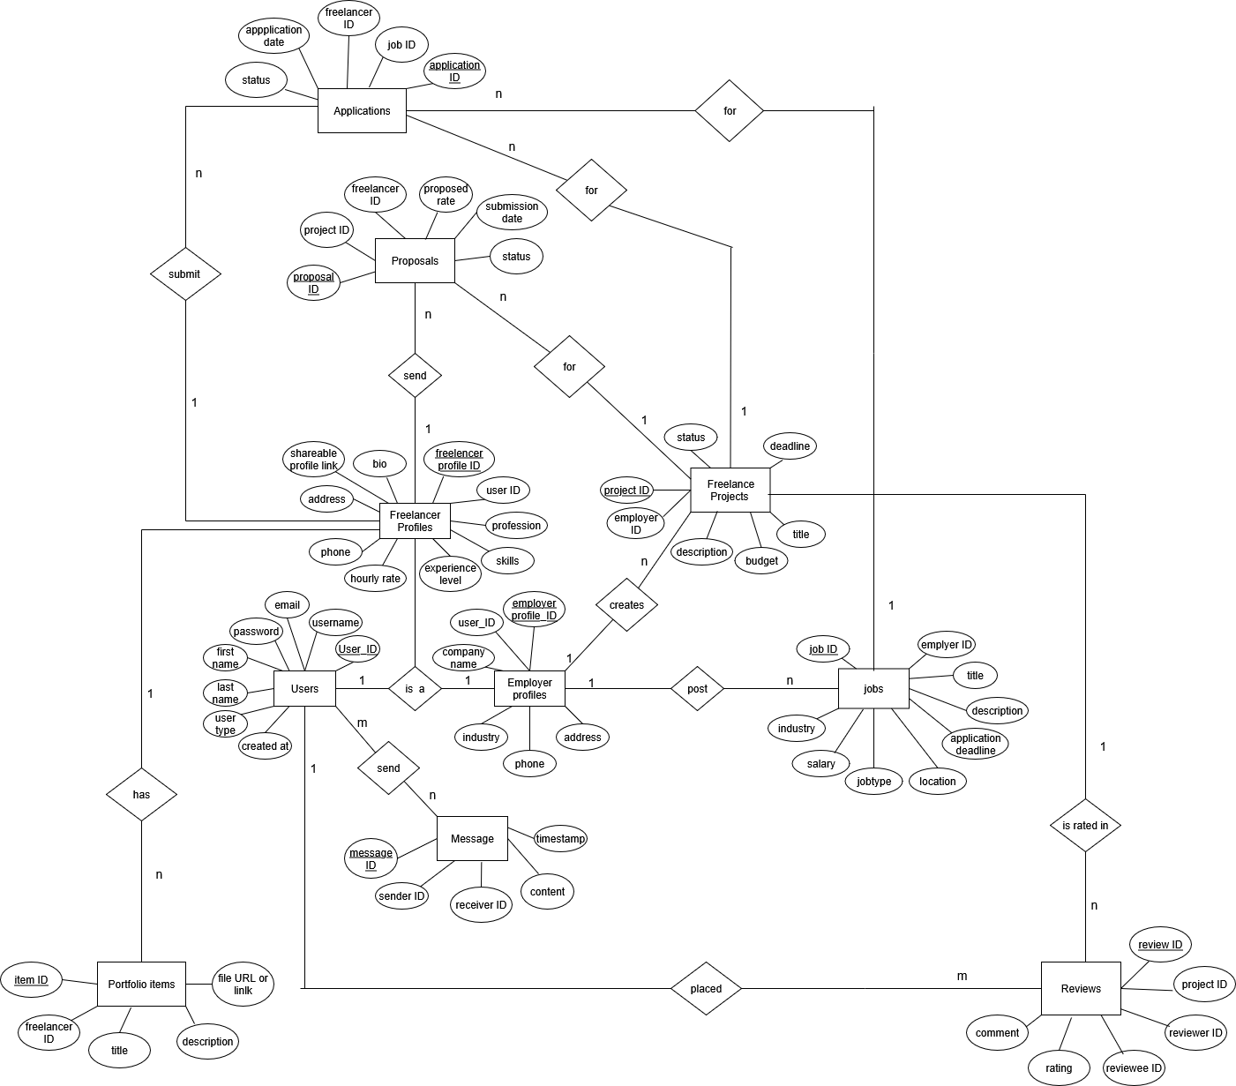

This ER diagram represents the structure of **Freedly,** a freelancing platform. It connects **Users** (both freelancers and employers) with profiles, projects, and jobs. Freelancers can create profiles, showcase **portfolio items**, and submit **proposals** or **applications** for posted projects and jobs. Employers create profiles, **post jobs/projects**, and interact with freelancers. The system supports **messaging** between users, tracking of **applications**, and **reviews** with ratings and comments after work is completed. Overall, it models the relationships between freelancers, employers, jobs, projects, proposals, portfolios, messages, and reviews in the platform.

**Normalized relational schema**

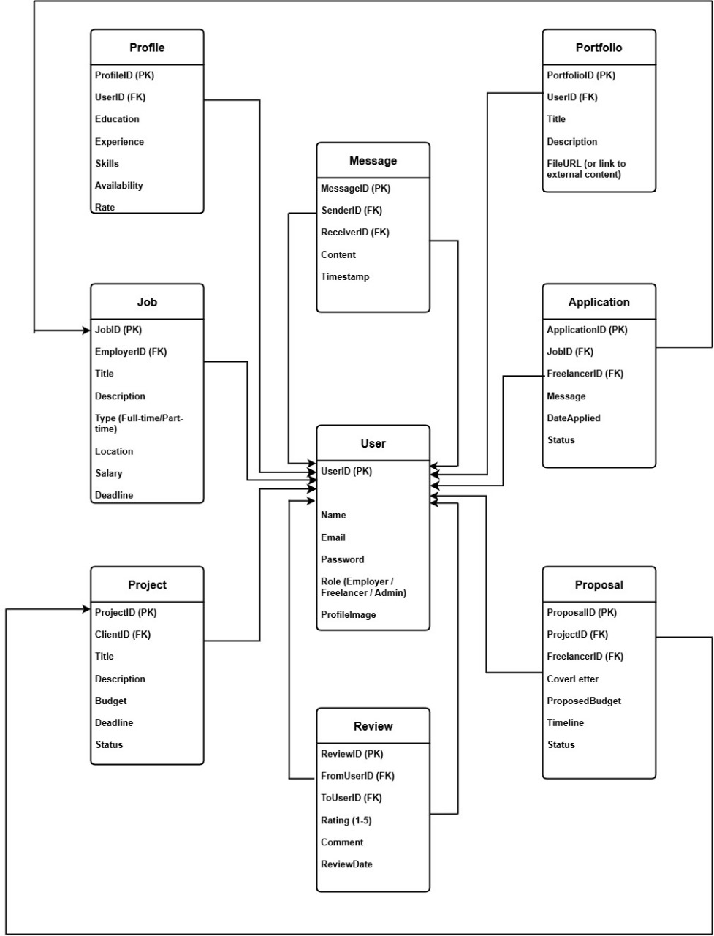

This schema defines the structured database design for the **Freedly freelancing platform**. The central entity is **User**, which can represent freelancers, employers, or admins. Other entities manage platform functions:

* **Profile** stores freelancer details (skills, experience, rates).
* **Portfolio** showcases freelancer work.
* **Job** and **Project** are created by employers for hiring or contracting.
* **Application** and **Proposal** capture freelancer interest in jobs/projects.
* **Message** enables communication between users.
* **Review** allows feedback and ratings.

Overall, the schema ensures data is well-organized, avoids redundancy, and clearly represents relationships between freelancers, employers, and their interactions.

**Context diagram**

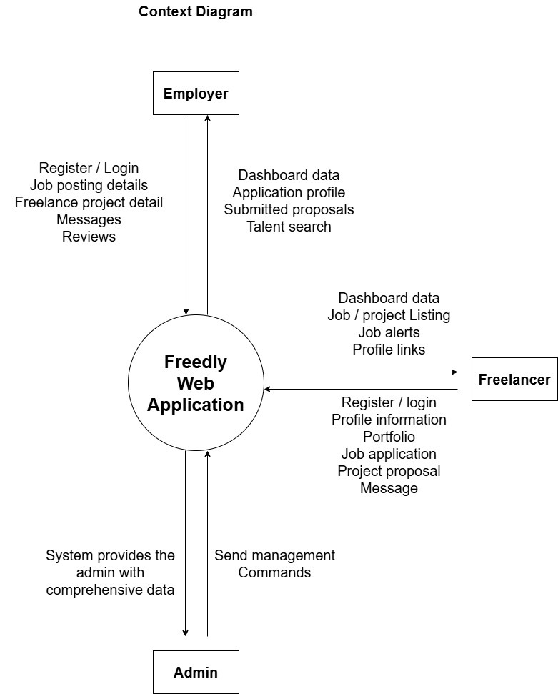

The context diagram shows how the **Freedly web application** interacts with its main users: **Employers, Freelancers, and Admins**. Employers can post jobs, manage projects, review proposals, and search for talent. Freelancers can register, build profiles, submit portfolios, apply for jobs, and send proposals. Admins oversee the system by managing commands and accessing comprehensive data. This highlights the overall flow of information between users and the platform.

**Level 1 diagram UML diagram**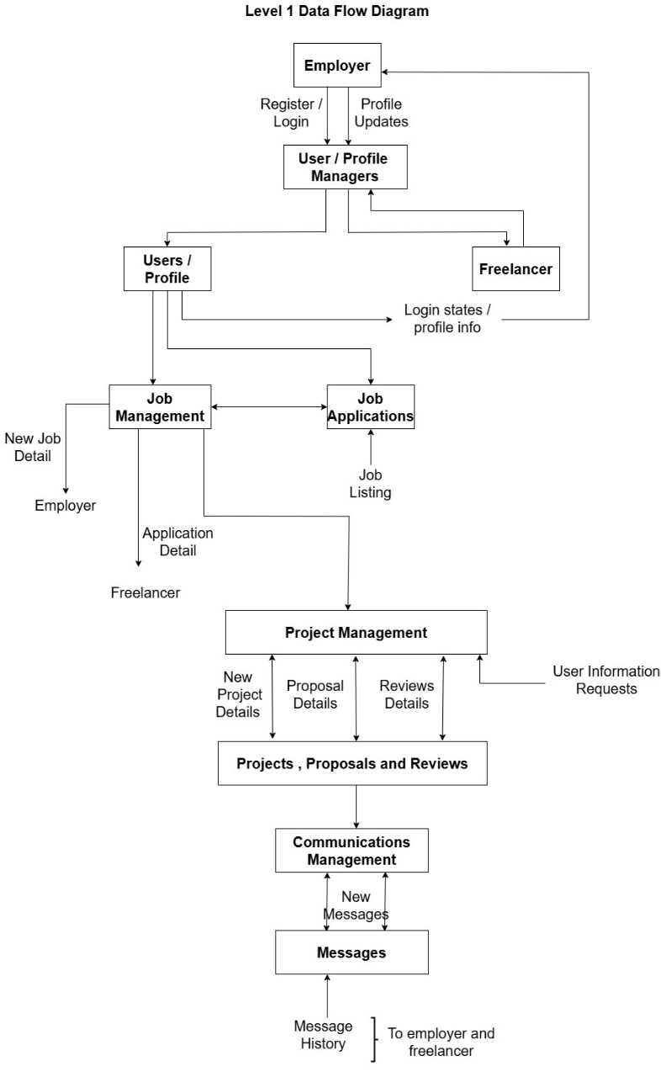

Freedly is a platform with four core functions:

1. **User/Profile Management:** Handles registration, login, and profile updates for both Employers and Freelancers.
2. **Job Management:** Allows Employers to create job listings and Freelancers to submit applications.
3. **Project Management:** Manages ongoing projects, proposals, reviews, and information requests after a job is accepted.
4. **Communications Management:** Facilitates all messaging between users, storing the conversation history.

Freedly connects Employers and Freelancers to post jobs, apply, manage projects, and communicate.

**Use case diagram**

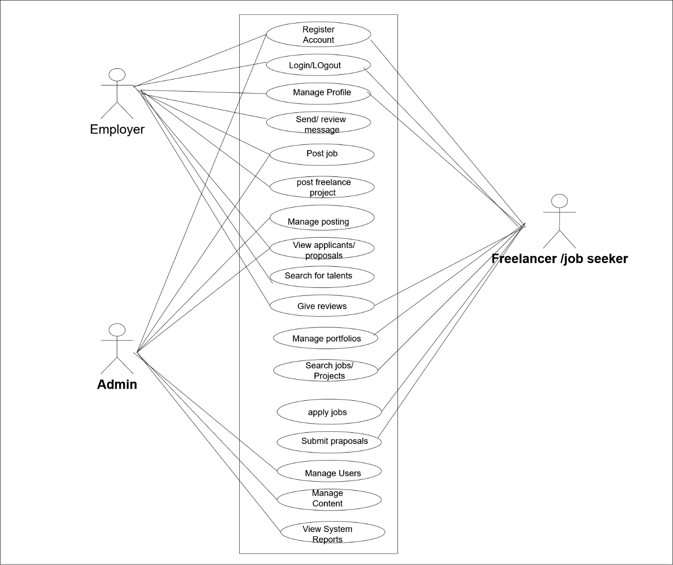

Freedly is a three-user platform where **Employers** post jobs and manage projects, **Freelancers** search and apply for work, and an **Admin** manages all users, content, and system data.

**Class diagram**

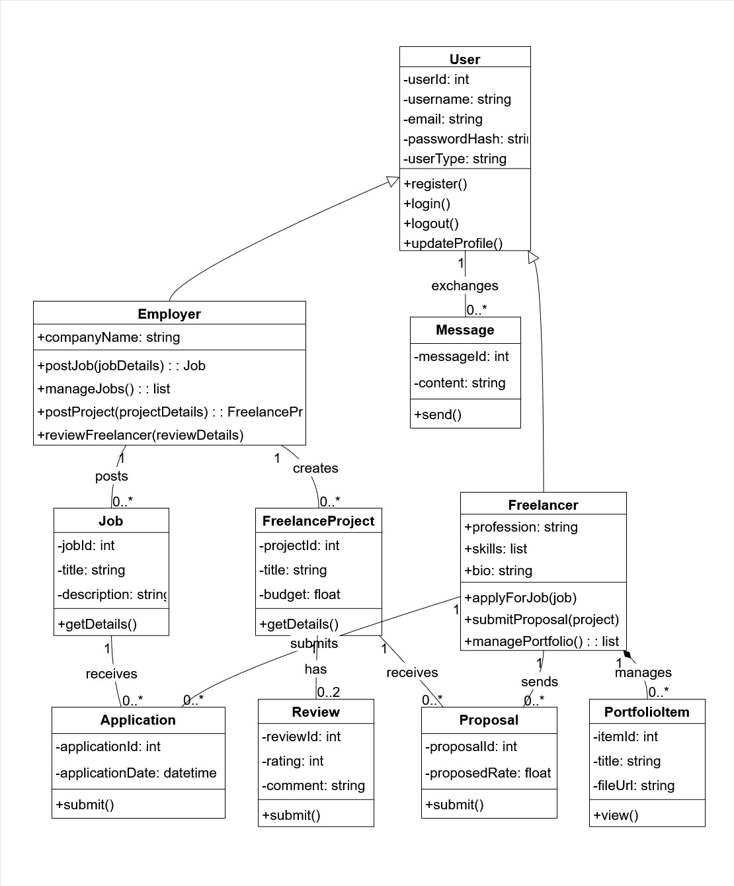

The Freedly system is built around three core user classes that inherit from a central **User** class, which handles common functions like login and profiles.

* An **Employer** user can create **Job** and **FreelanceProject** listings.
* A **Freelancer** user can respond to these by submitting an **Application** for a job or a **Proposal** for a project, and can also manage their **Portfolio**.
* The interaction between these users is captured through supporting classes like **Message** for communication and **Review** for feedback.

In essence, the diagram shows how Employers create work opportunities and Freelancers bid on them, facilitating the core marketplace functionality.

**Sequence Diagram**

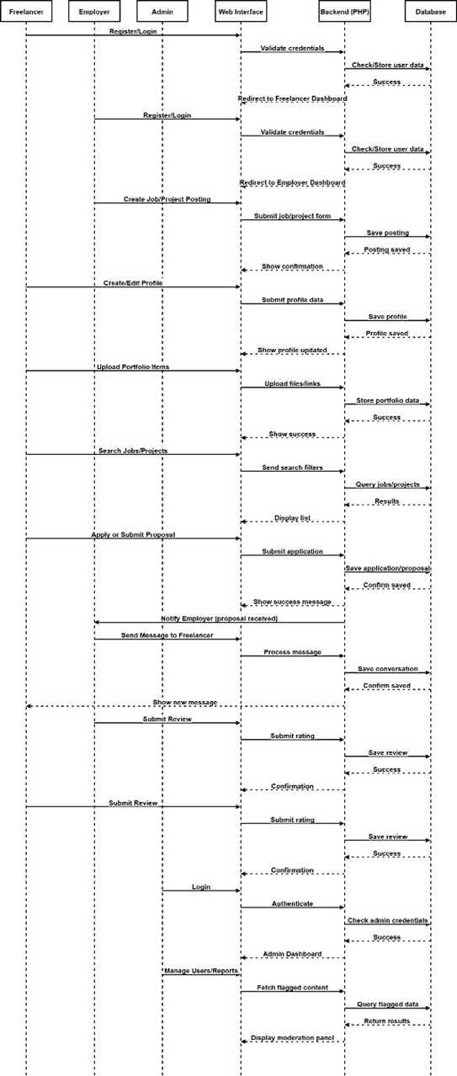

**3.3 Pseudo code**

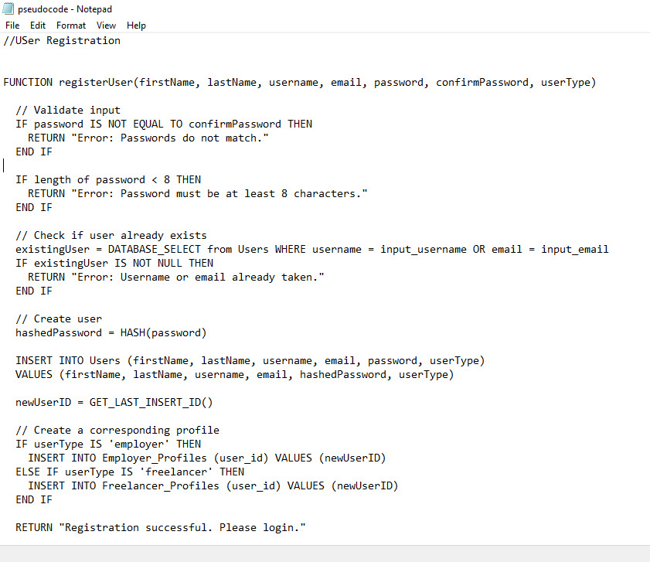

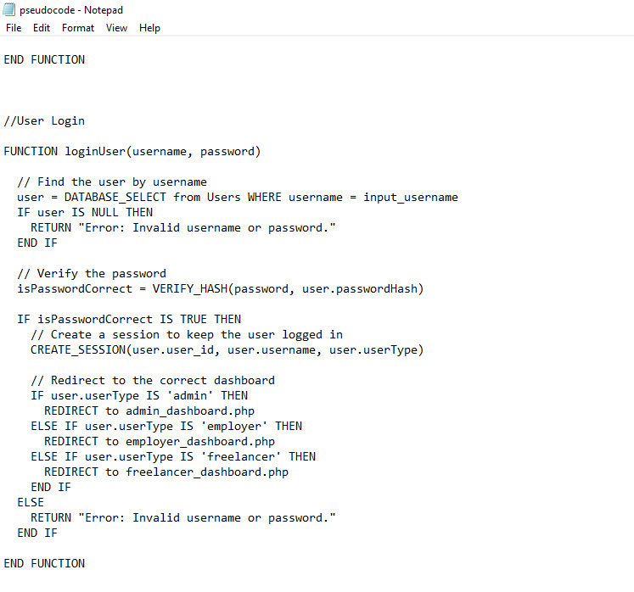

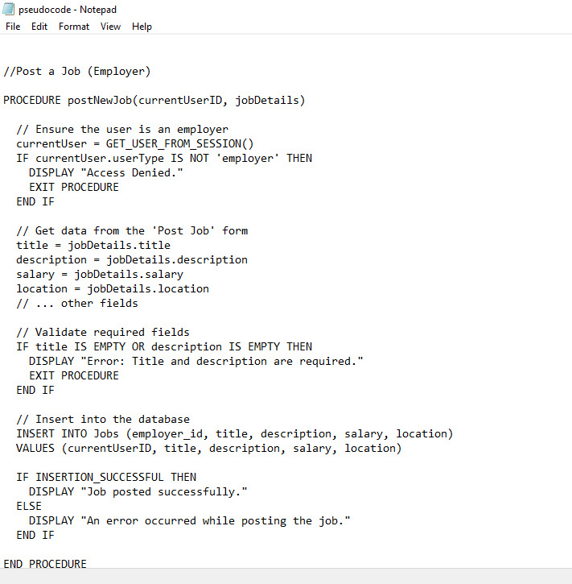

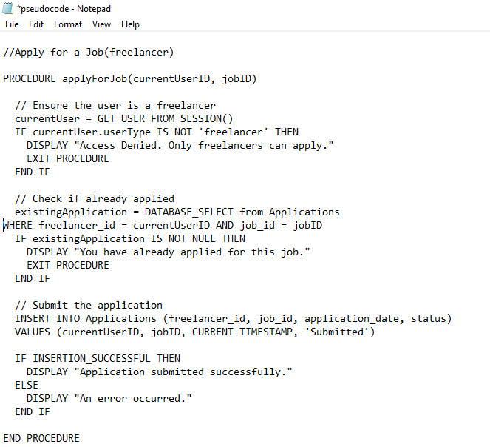

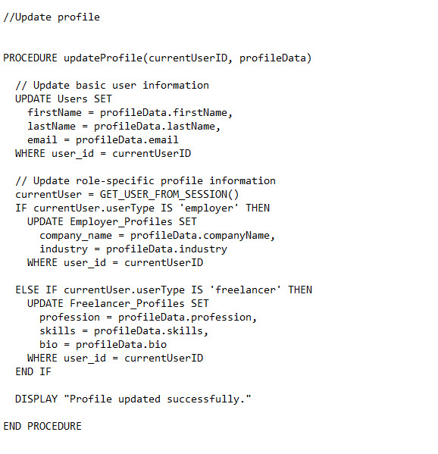

**UI**

**Home Page**

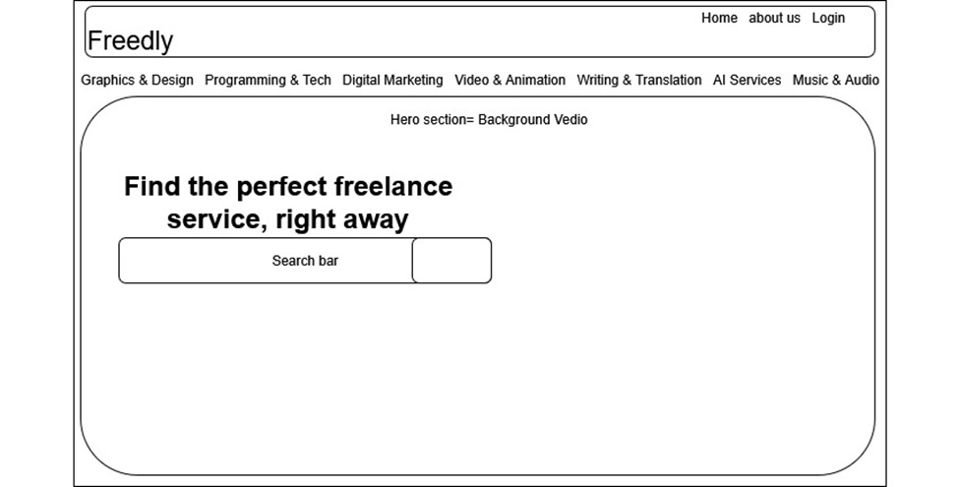

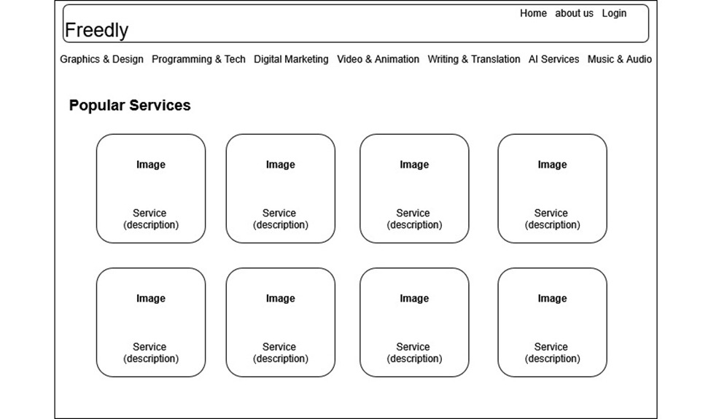

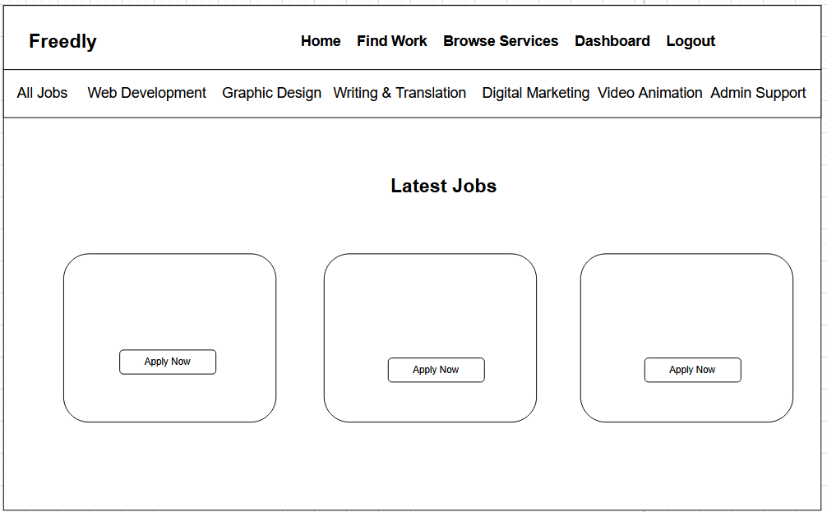

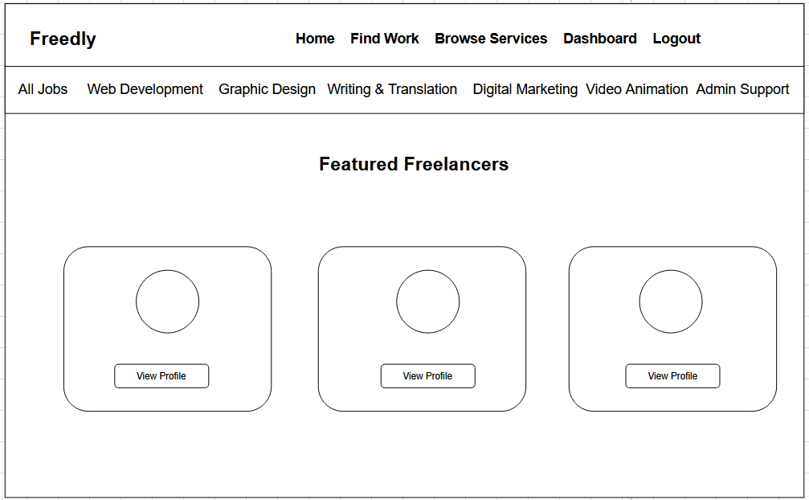

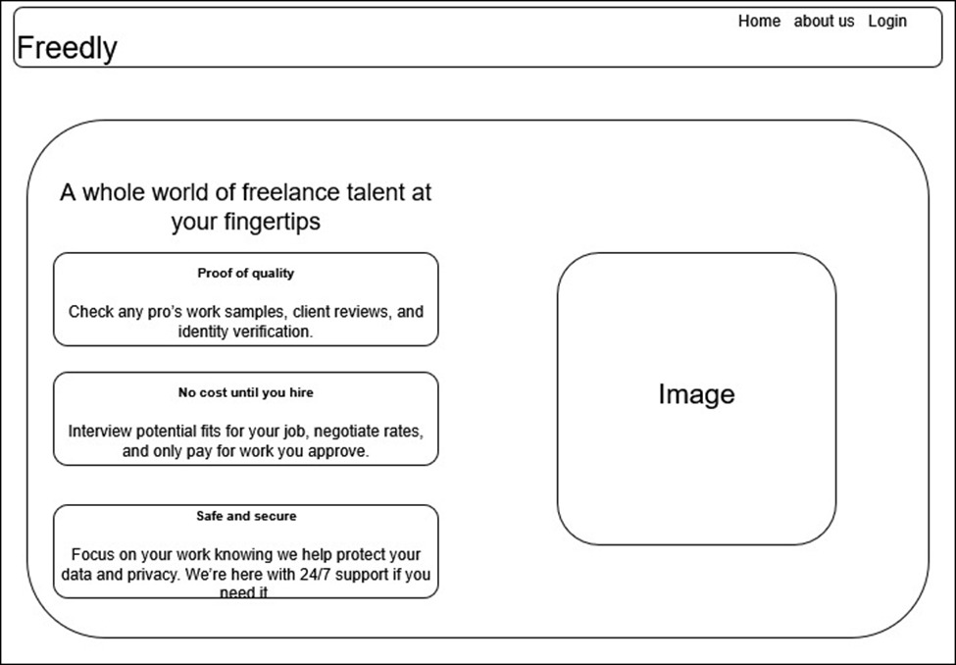

**Other Pages**

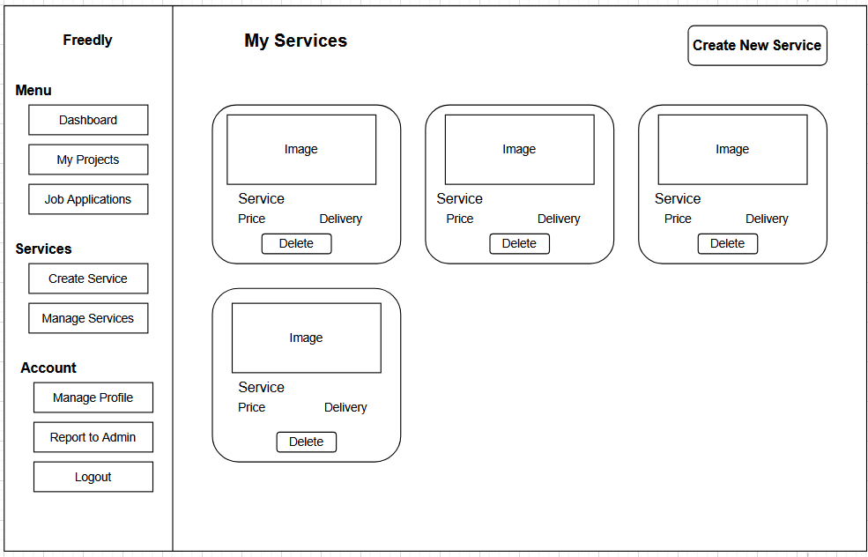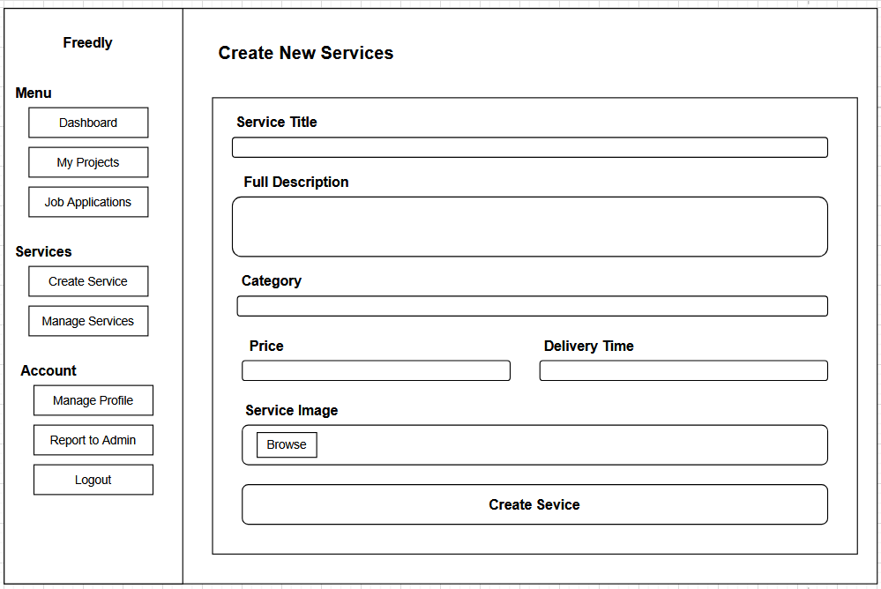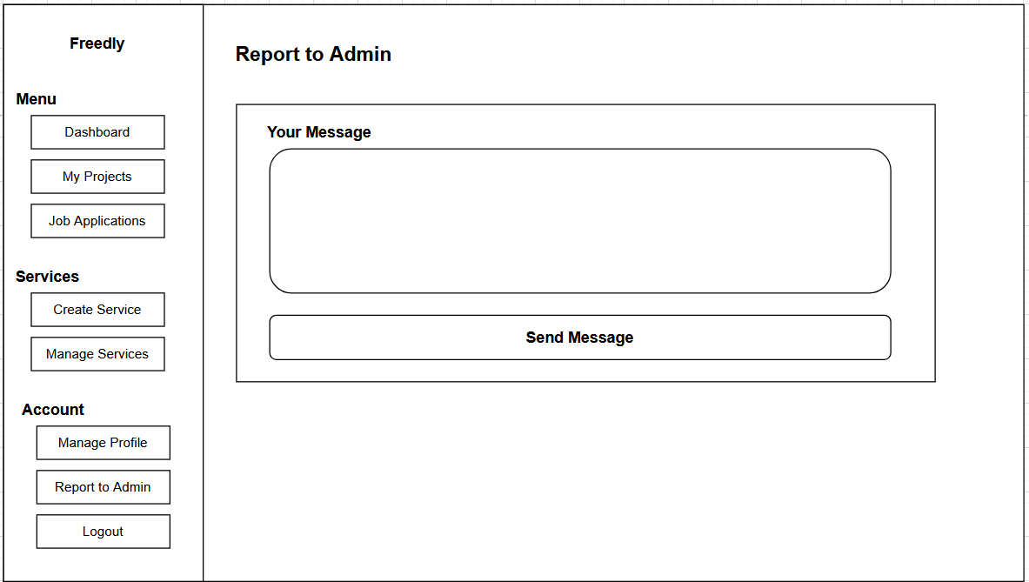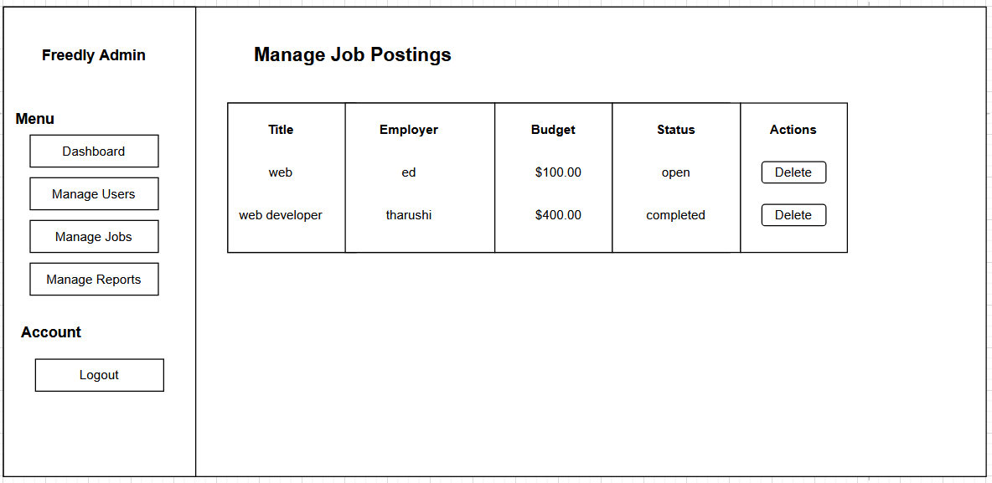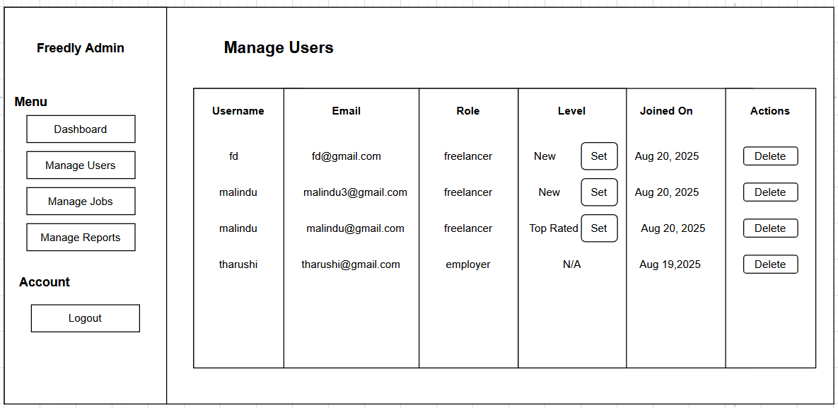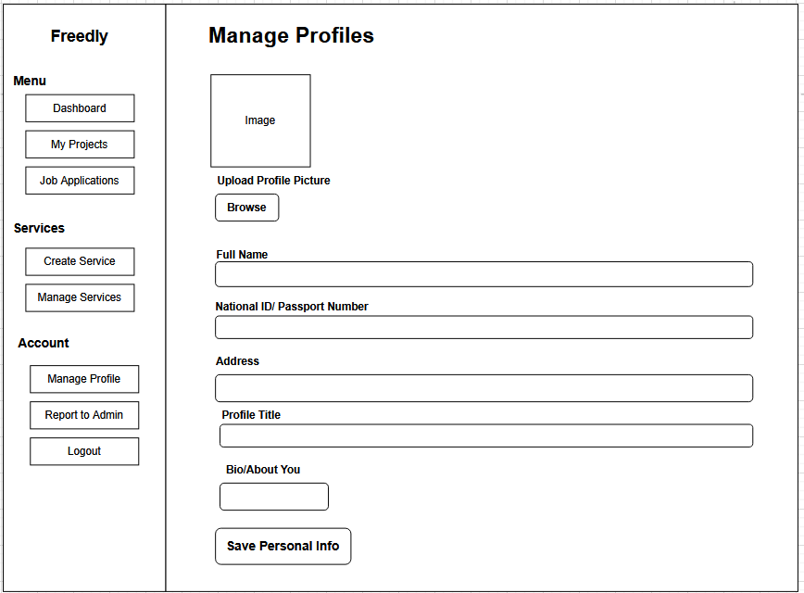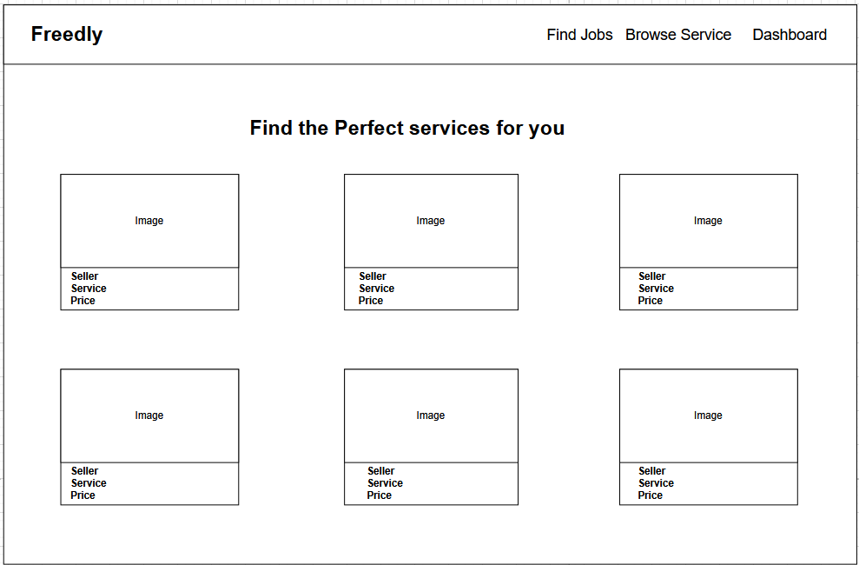

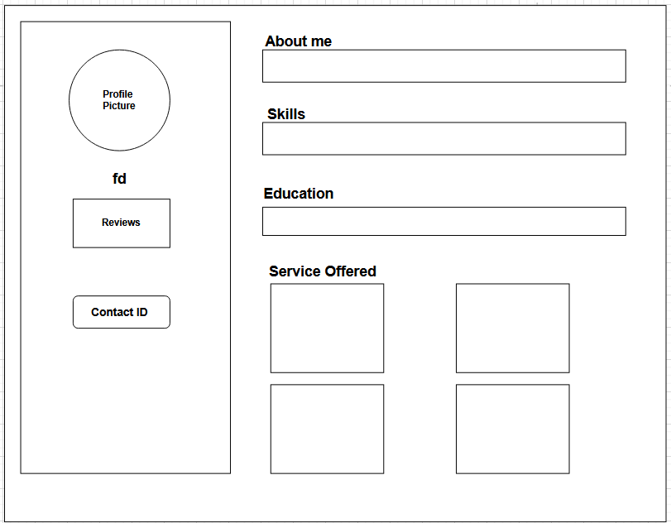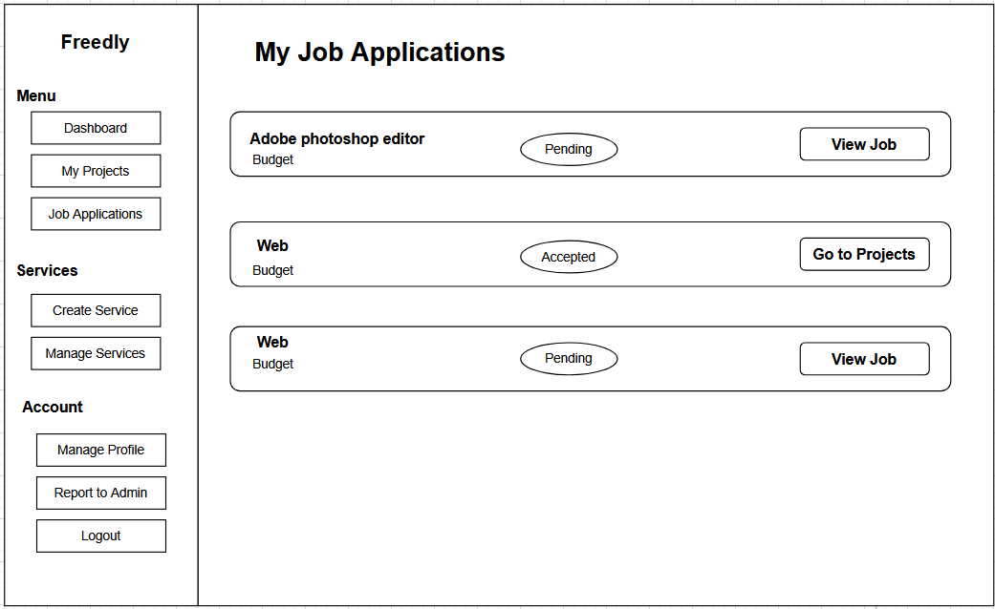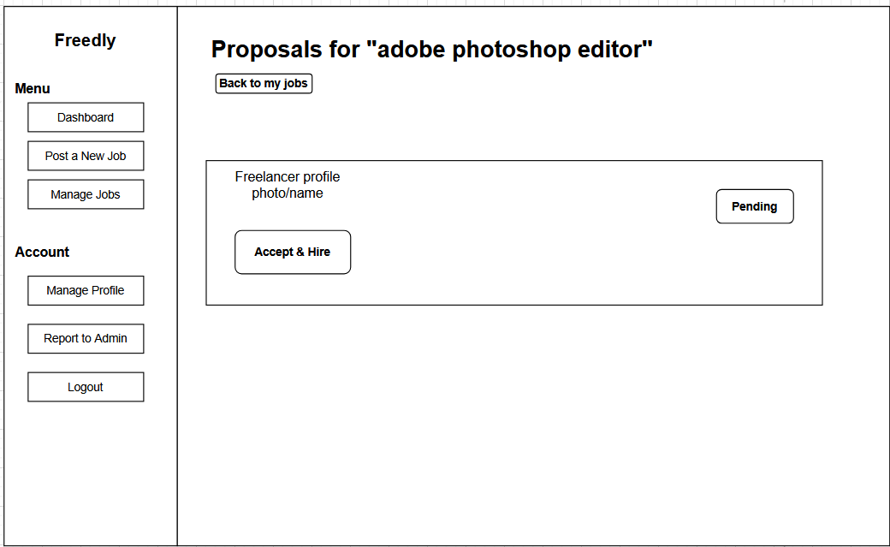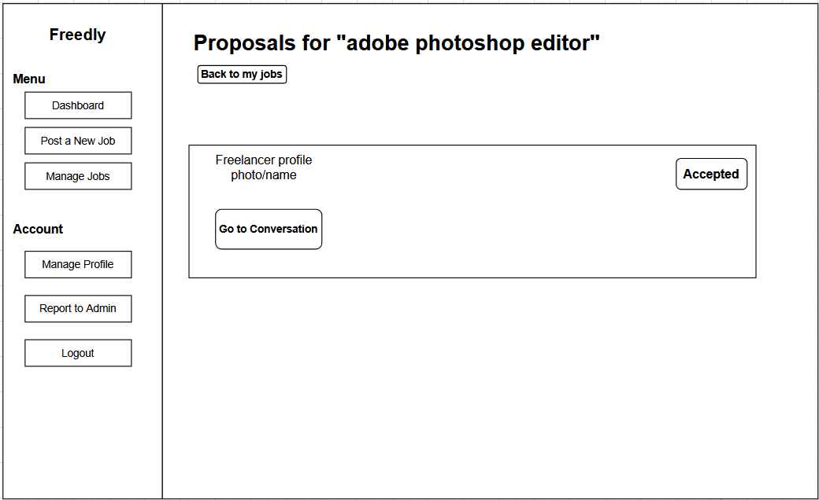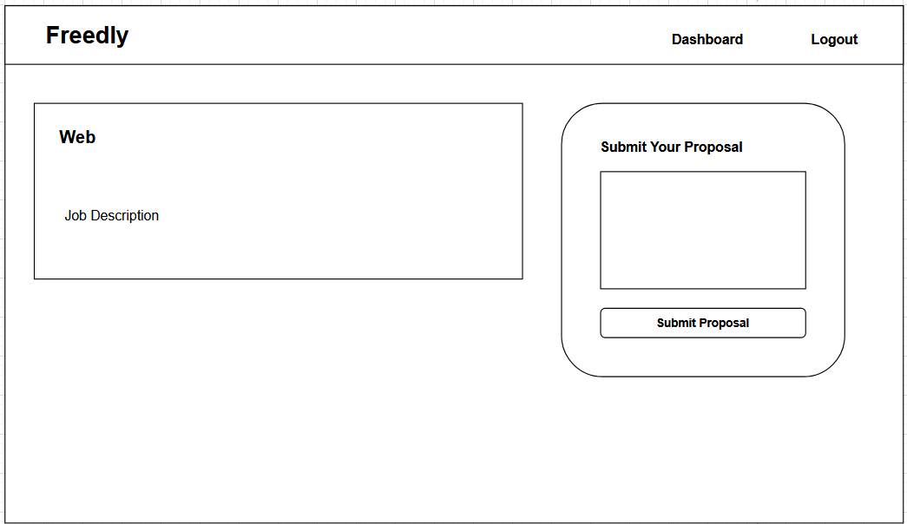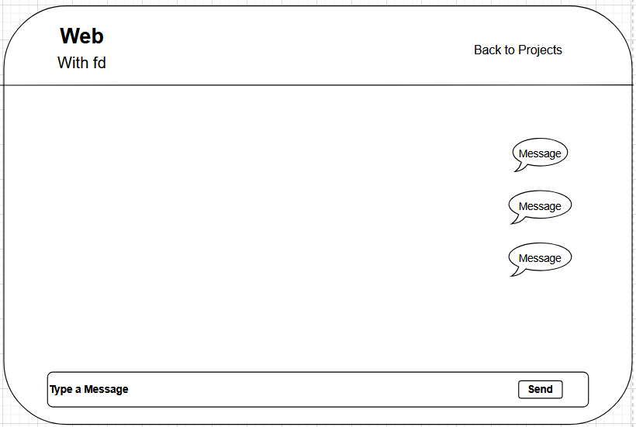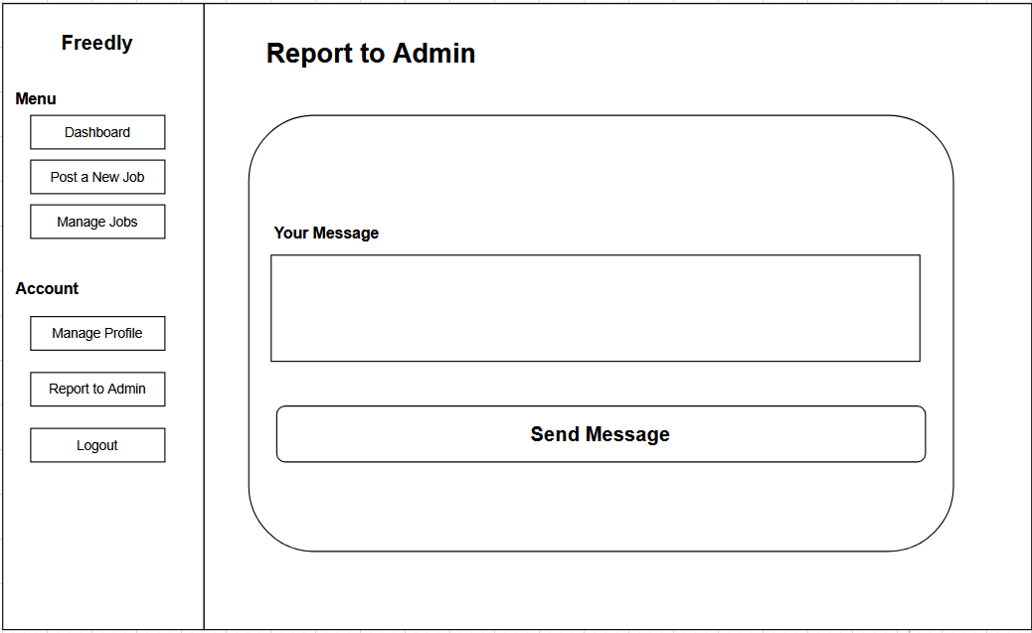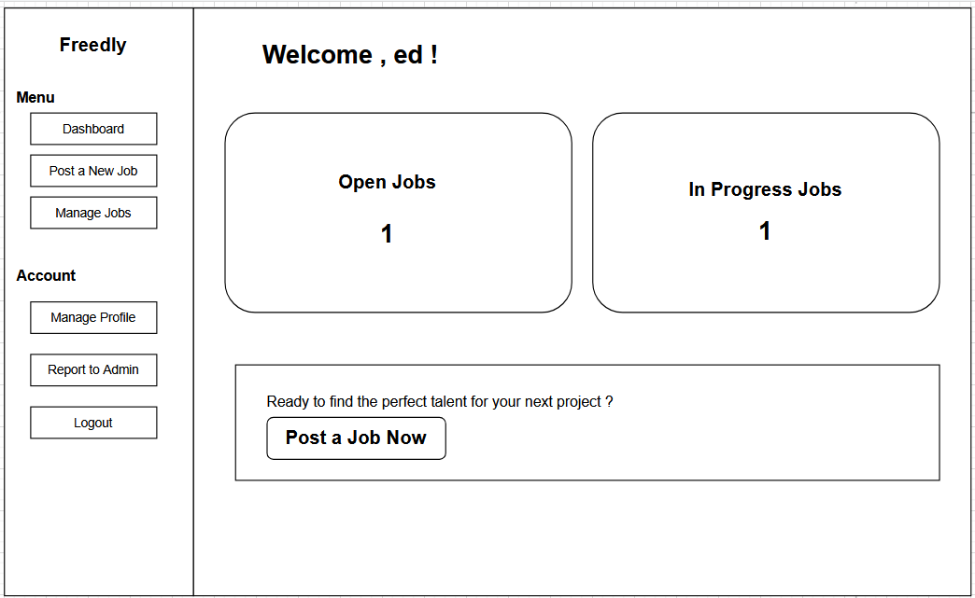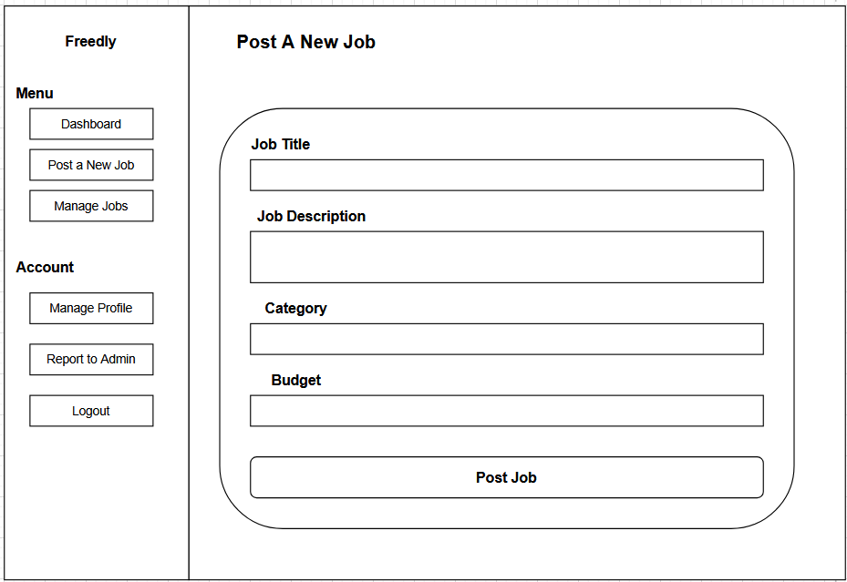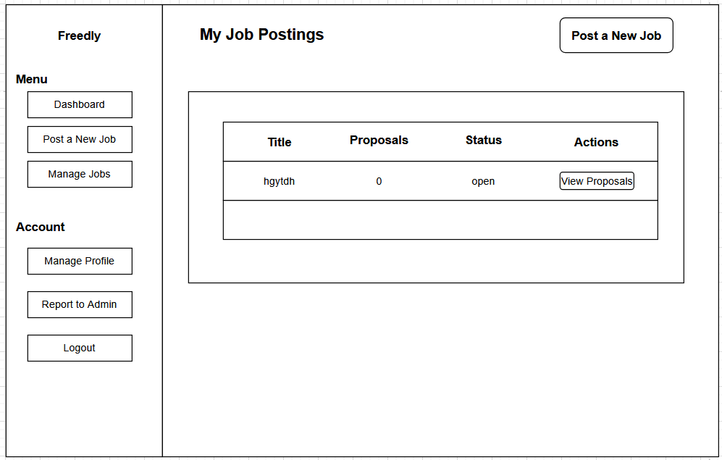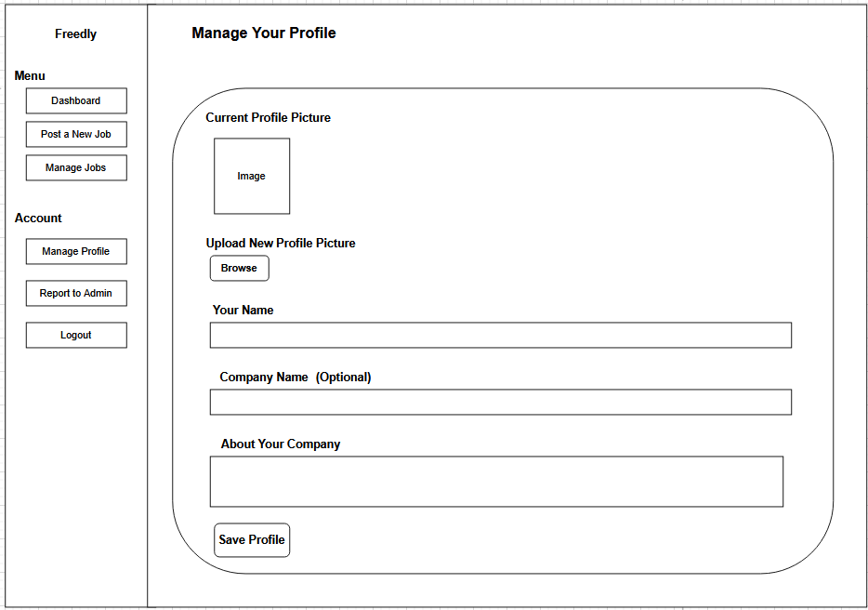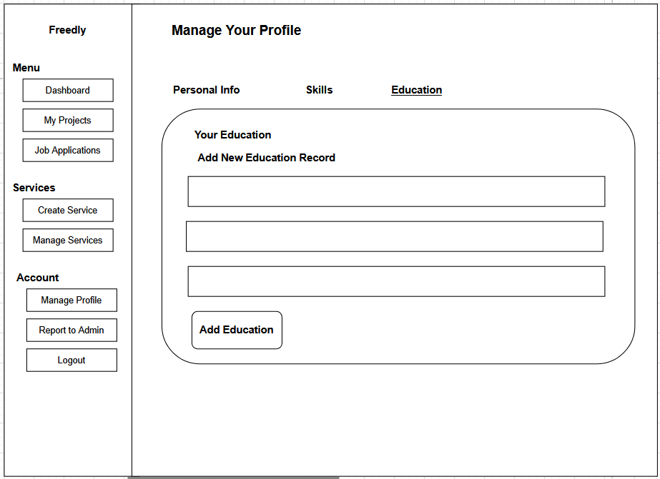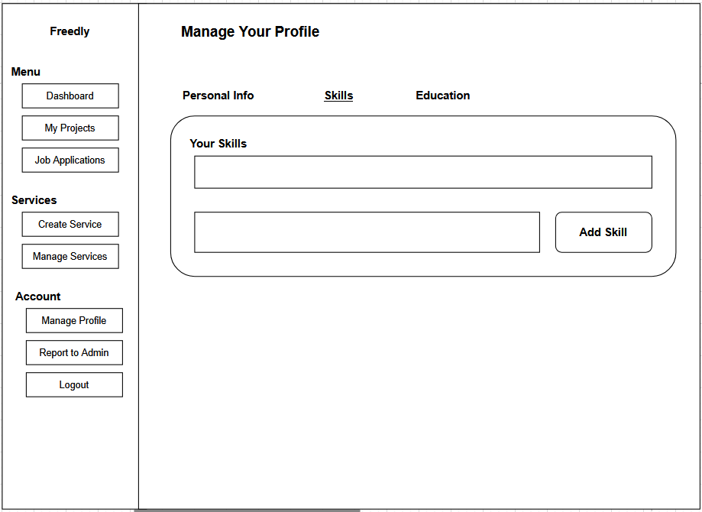

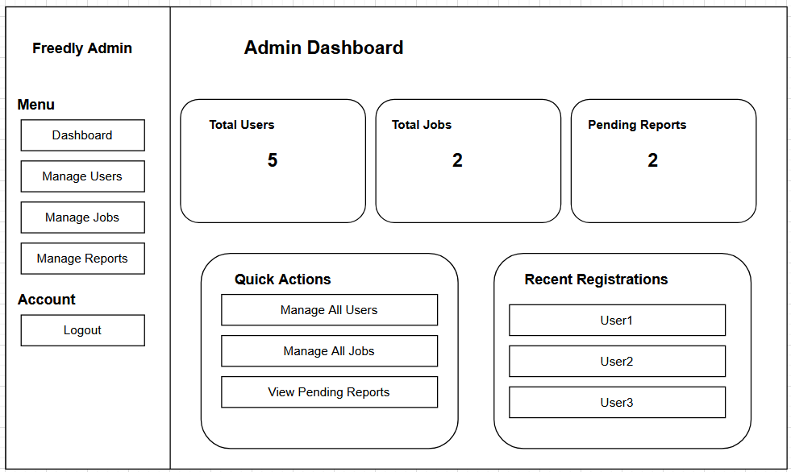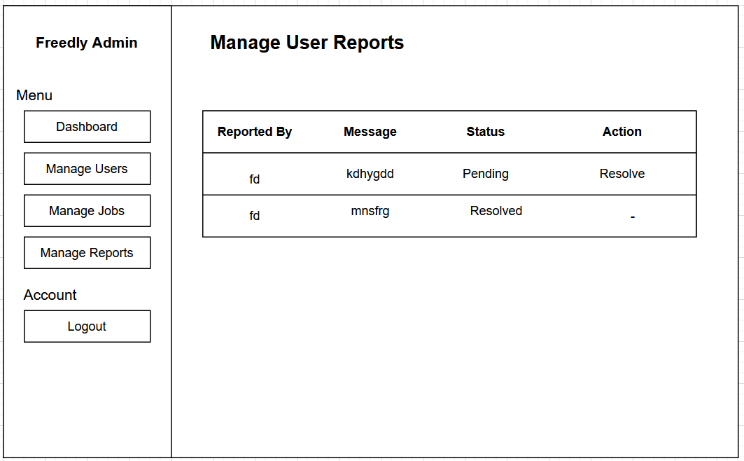

**Chapter 04**

**Co-functionalities in Freedly (with Evidence)**

Below are the key co-functionalities from your proposal, categorized and explained with evidence from the document:

**1. User Authentication and Account Recovery**

* **Evidence**: "Login / Registration – Allows new users (Employers/Clients and Freelancers/Job Seekers) to create accounts and existing users to log in securely. Includes options for password recovery."
* **Purpose**: This co-functionality ensures secure access to core features such as dashboards, job posting, and messaging. Without login mechanisms, core features would be inaccessible or insecure.

**2. Dashboards for Each User Role**

* **Evidence**:
  + "Employer/Client Dashboard – Personalized overview showing job postings, freelance projects, applicant lists, and messages."
  + "Freelancer/Job Seeker Dashboard – Personalized overview showing active applications, project proposals, messages, and profile status."
* **Purpose**: Dashboards are **co-functional**, not core features themselves, but they aggregate and manage access to core activities like job posting or project bidding, improving navigation and usability.

**3. Profile Sharing and Viewing**

* **Evidence**:
  + "Share Profile Link – Generates a unique, publicly accessible URL for a freelancer/job seeker's profile."
  + "View User Profile – Enables employers to view comprehensive professional profiles of freelancers."
* **Purpose**: These support visibility and discovery, enhancing the **talent acquisition and job-seeking process** by enabling easier sharing and reviewing of qualifications.

**4. Portfolio Management**

* **Evidence**: "Allows freelancers/job seekers to upload and manage a portfolio of their past work..."
* **Purpose**: This supports the **profile system** by providing verifiable evidence of work, helping in the vetting process. It's not a core feature like job posting, but **crucial for credibility and differentiation.**

**5. Internal Messaging System**

* **Evidence**: "Provides a basic, text-based messaging system... to facilitate direct communication between employers and freelancers."
* **Purpose**: Messaging enables project negotiation and clarification, which supports the **application and project engagement process.** It is not the core function but a vital **communication enhancer**.

**6. Rating and Review System**

* **Evidence**: "Allows clients to rate and leave reviews for freelancers upon project completion, and vice versa..."
* **Purpose**: Encourages quality work and builds **user reputation** over time. It's a **trust-building mechanism** that supports ongoing platform use.

**7. Search and Filter Tools**

* **Evidence**:
  + "Job Search & Filter – Allows job seekers to search using keywords and filters..."
  + "Freelance Project Discovery – Enables freelancers to browse and search projects..."
* **Purpose**: These are co-functional features that make job discovery **efficient and personalized**, which supports the main functionality of job seeking.

**8. Password Reset Functionality**

* **Evidence**: "Password reset functionality" under Functional Requirements.
* **Purpose**: This supports account management and system access recovery, improving **user control and system resilience.**

**9. Public Profile URL Generation**

* **Evidence**: "Generate a unique, shareable public profile URL..."
* **Purpose**: This **extends the reach** of users’ professional identities beyond the platform and supports self-marketing, enhancing engagement.

**10. My Applications/Proposals Tracker**

* **Evidence**: "Freelancers/job seekers can view the status of their submitted job applications and project proposals."
* **Purpose**: Helps users manage their job-seeking activity efficiently, improving **user experience and transparency.**

**11. Notification System (Implied through Dashboards)**

* **Evidence**: "Message notifications" mentioned in dashboard descriptions.
* **Purpose**: Although not elaborated, this co-functionality keeps users informed in real-time, which supports engagement and responsiveness.

**Chapter 05**

**Testings**

Testing methodology and justification

Methodology:

* Unit Testing: Individual components (auth functions, database operations) were tested in isolation
* Integration Testing: Verified interactions between modules (registration flow, login process)
* System Testing: Full end-to-end testing of all user workflows
* User Acceptance Testing: Real users validated the system against requirements
* Security Testing: Focused on authentication, authorization, and data protection

Justification:

* Manual testing was essential for UI/UX validation and complex user flows
* Automated scripts were used for regression testing of core functionality
* Security testing was prioritized due to handling sensitive user data
* Real user testing ensured the platform meets actual user needs

Test Plan

|  |  |
| --- | --- |
| **Section** | **Details** |
| Test Objectives | - Verify core functionalities of Employer, Freelancer, and Admin modules.  - Ensure only authorized users access restricted features.  - Confirm database integrity after CRUD operations.  - Validate usability, security, and performance. |
| Test Scope | In Scope: User registration/login, job posting, job applications, proposal management, service creation, profile management, admin controls, reporting.  Out of Scope: Payment gateway integration, stress/load testing. |
| Test Items | Authentication, Job Management, Service Management, Profile Management, Admin Panel, Reports, Messaging |
| Test Environment | Platform: Web (PHP/MySQL)  Server: XAMPP/LAMP  Database: MySQL (freelance_db)  Browsers: Chrome, Firefox, Edge |
| Testing Types | Unit Testing, Integration Testing, Functional Testing, User Acceptance Testing (UAT), Security Testing |
| Entry Criteria | - Development completed.  - Database configured (freelance_db).  - Application deployed on localhost/server. |
| Exit Criteria | - All critical/high-priority defects resolved.  - 100% of major test cases passed.  - System stable for deployment. |
| Deliverables | Test Plan, Test Case Document, Test Execution Report, Defect Log |

**Test Cases**

1.Authentication Module

|  |  |  |  |  |  |
| --- | --- | --- | --- | --- | --- |
| **Test Case ID** | **Description** | **Steps** | **Expected Result** | **Actual Result** | **Status** |
| TC-AUTH-01 | Successful User Registration (Freelancer) | 1. Navigate to Register page  2. Select "Freelancer" role  3. Fill valid details (username, email, password)  4. Submit form | Account created, Registration successful | As expected | Pass |
| TC-AUTH-02 | Successful User Registration (Employer) | 1. Navigate to Register page  2. Select "Employer" role  3. Fill valid details  4. Submit form | Account created, Registration successful | As expected | Pass |
| TC-AUTH-03 | Duplicate Username Registration | 1. Register with username "testuser"  2. Try registering again with same username | Error: "Username already exists" | As expected | Pass |
| TC-AUTH-04 | Login with Valid Credentials | 1. Enter correct username & password  2. Click Login | Successful login, session created | As expected | Pass |
| TC-AUTH-05 | Login with Invalid Password | 1. Enter correct username but wrong password  2. Click Login | Error: "Invalid credentials" | As expected | Pass |
| TC-AUTH-06 | Access Dashboard Without Login | Login 1. Try accessing / freelancer_dashboard.php without login | Redirected to login page | As expected | Pass |
| TC-AUTH-07 | Logout Functionality | 1. Log in  2. Click "Logout" | Session destroyed, redirected to login page | As expected | Pass |
| TC-AUTH-08 | Employer Cannot Apply for Job | 1. Log in as employer  2. Try to apply for a job | Error: "You are logged in as an employer" | As expected | Pass |
| TC-AUTH-09 | Freelancer Cannot Post Job | 1. Log in as freelancer  2. Try to post a job | Redirected to freelancer dashboard | As expected | Pass |
| TC-AUTH-10 | Empty Form Submission (Register) | 1. Navigate to Register page.  2. Click "Register" without entering any data. | Error messages prompting user to fill all required fields. | As expected | Pass |
| TC-AUTH-11 | Invalid Email Format (Register) | 1. Navigate to Register page.  2. Enter a username and an invalid email (e.g., user@ or user.com).  3. Enter a password and submit. | Error: "Invalid email format." | As expected | Pass |
| TC-AUTH-12 | Weak Password (Register) | 1. Navigate to Register page.  2. Enter a username and valid email.  3. Enter a weak password (e.g., 123).  4. Submit form. | Error: "Password must be at least 8 characters and numbers long." | As expected | Pass |
| TC-AUTH-13 | Password Confirmation Mismatch | 1. Navigate to Register page.  2. Enter a username, email, and password.  3. Enter a different password in a "Confirm Password" field (if you have one).  4. Submit form. | Error: "Passwords do not match." | As expected | Pass |
| TC-AUTH-14 | Duplicate Email Registration | 1. Register with email test@example.com.  2. Log out.  3. Try to register again with the same email but a different username. | Error: "Email already registered." | As expected | Pass |
| TC-AUTH-15 | Login with Non-Existent Email | 1. Navigate to Login page.  2. Enter an email that is not registered.  3. Enter any password.  4. Click Login. | Generic error: "Invalid email or password." (Does not reveal if the email exists). | As expected | Pass |

TC-AUTH-01 :

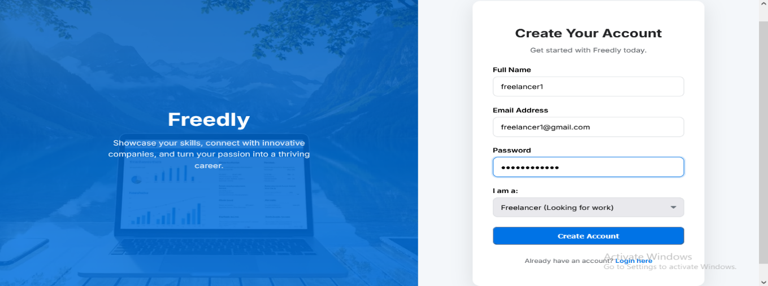

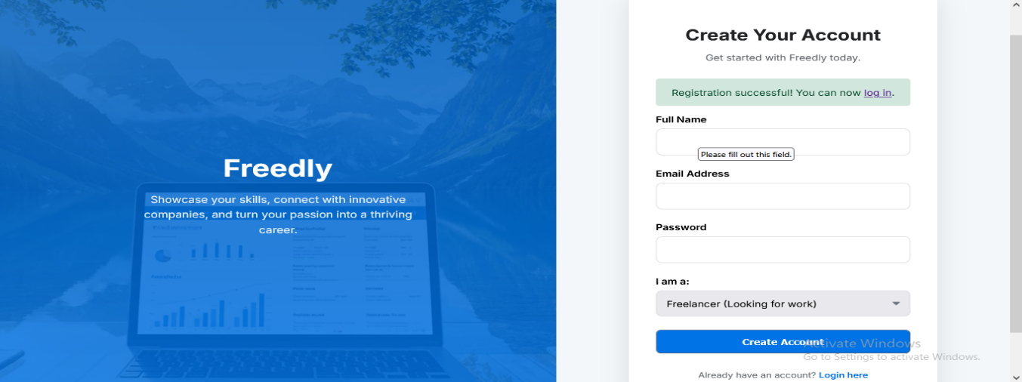

TC-AUTH-02 :

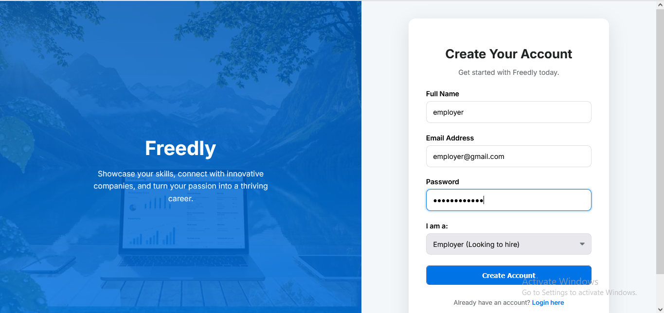

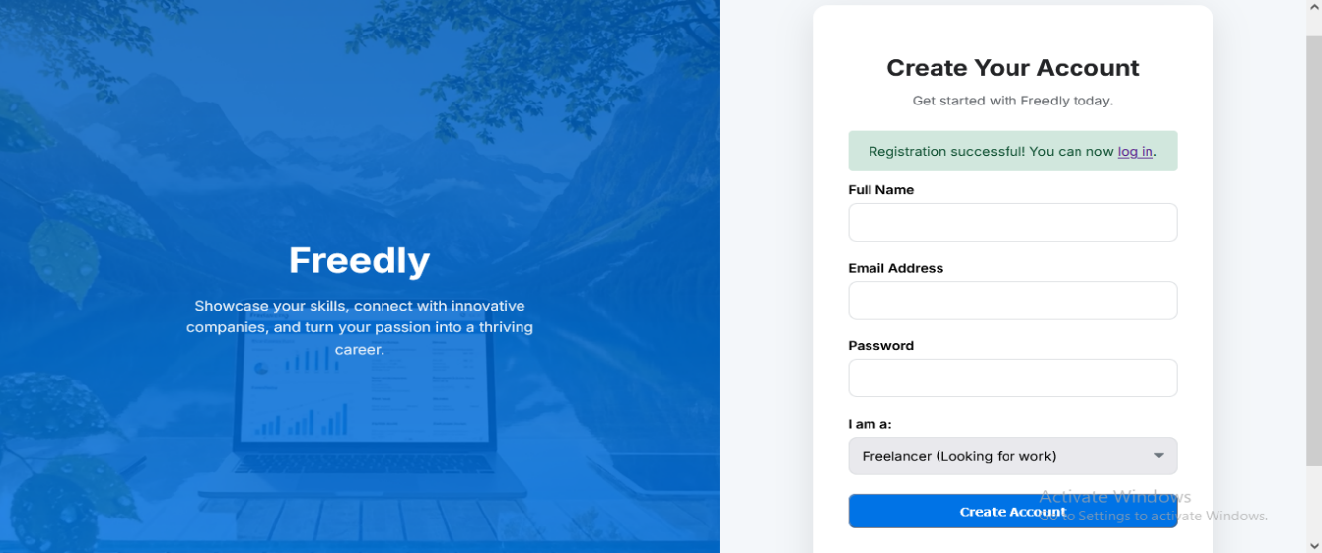

TC-AUTH-03 :

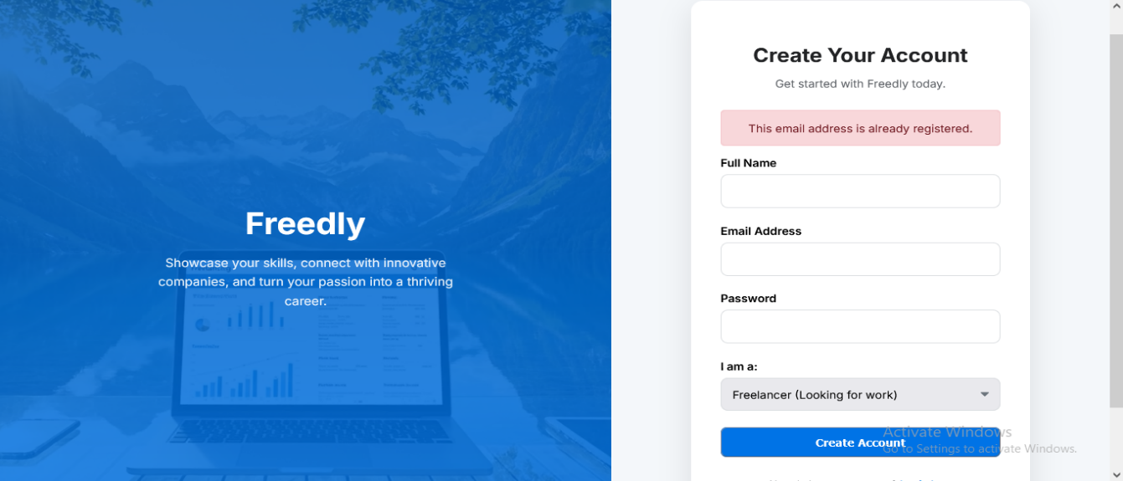

TC-AUTH-04 :

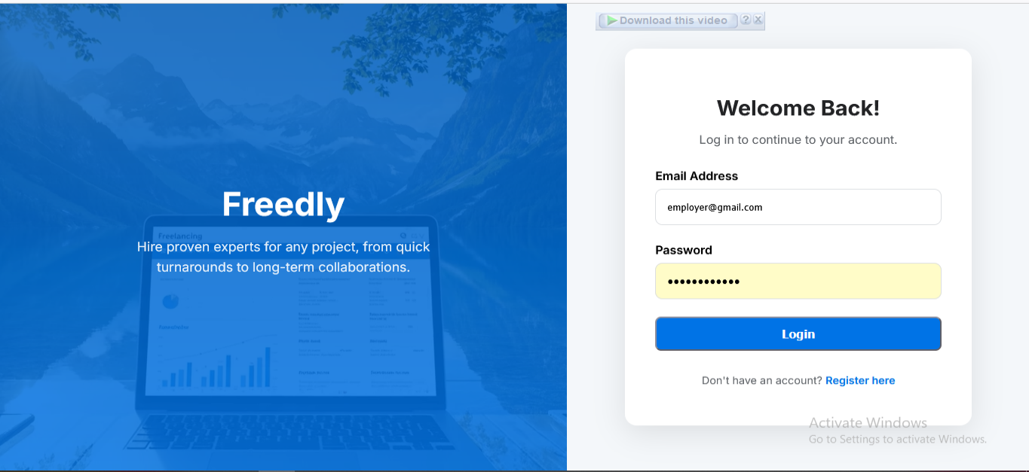

TC-AUTH-05 :

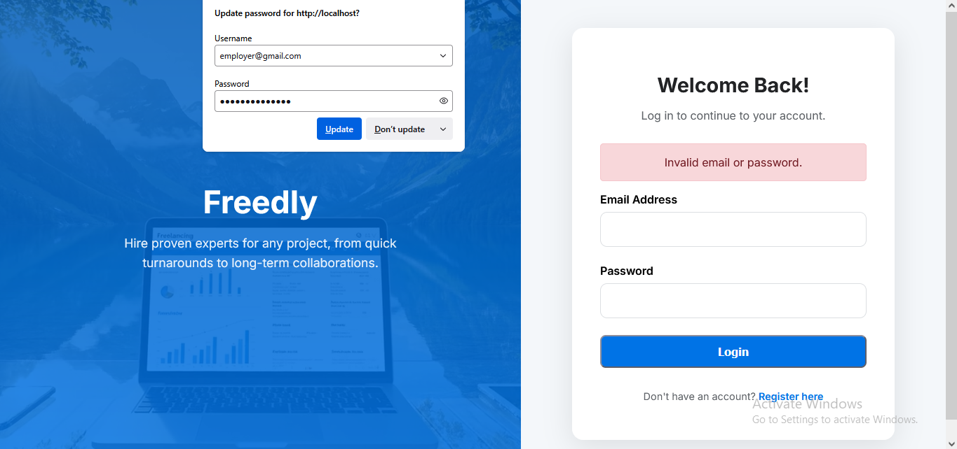

TC-AUTH-06 :

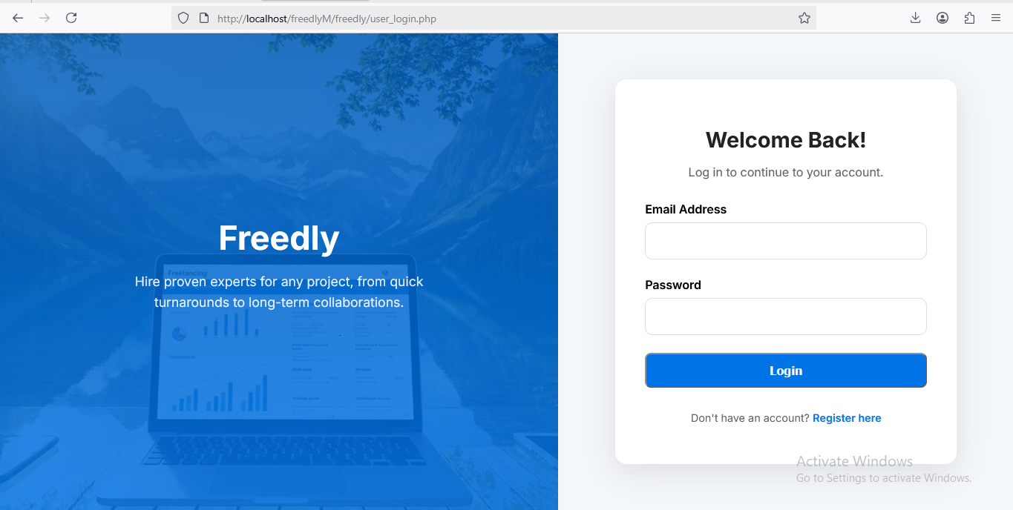

TC-AUTH-07 :

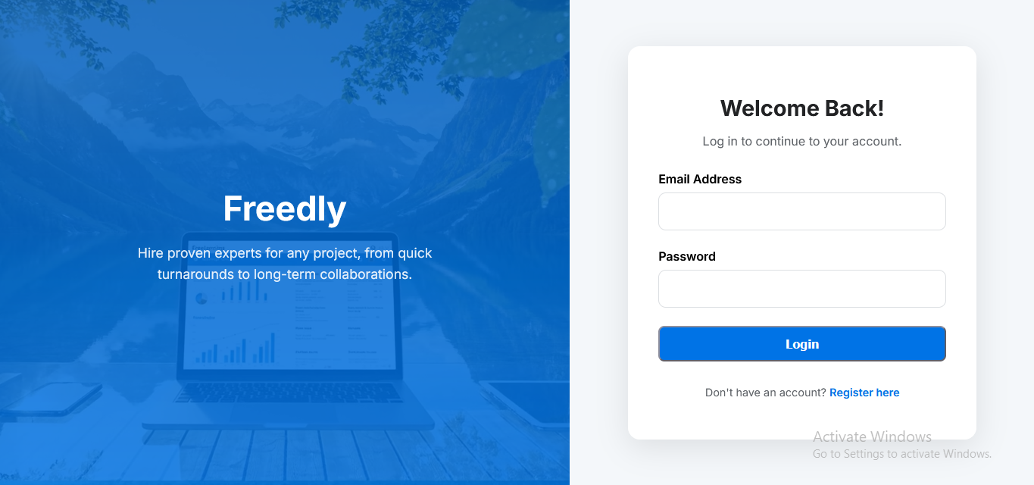

TC-AUTH-09 :

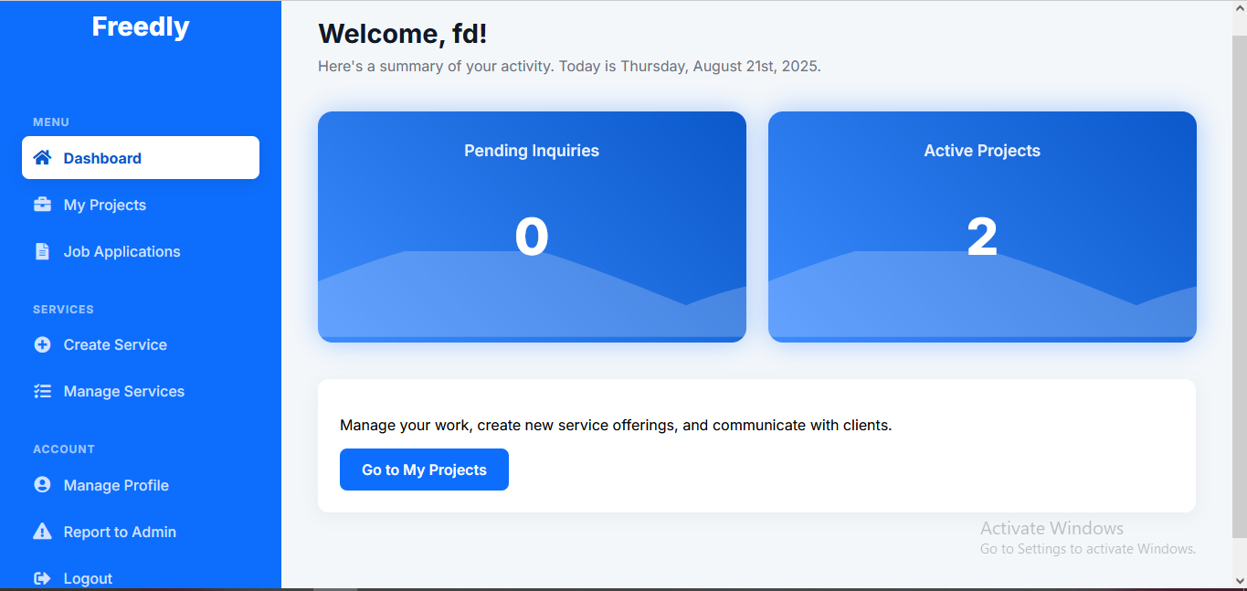

TC-AUTH-10:

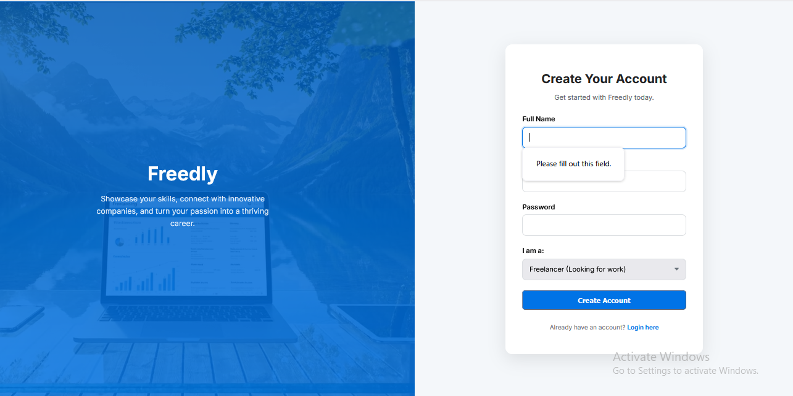

TC-AUTH-11 :

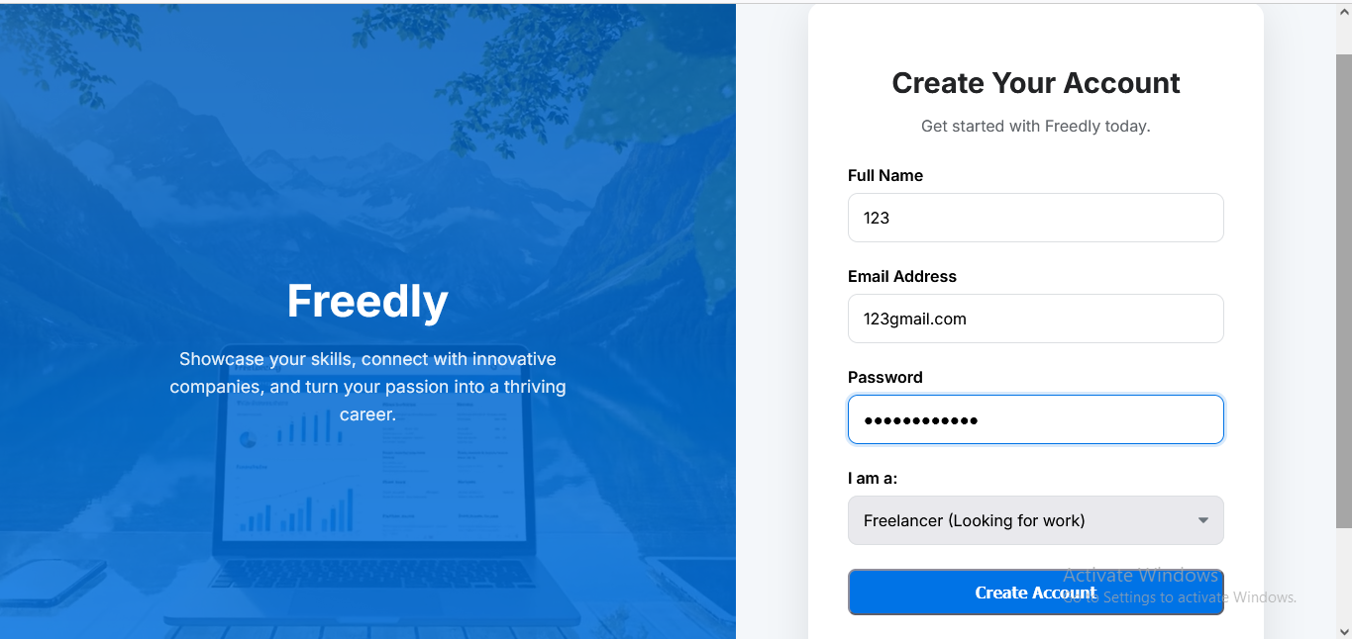

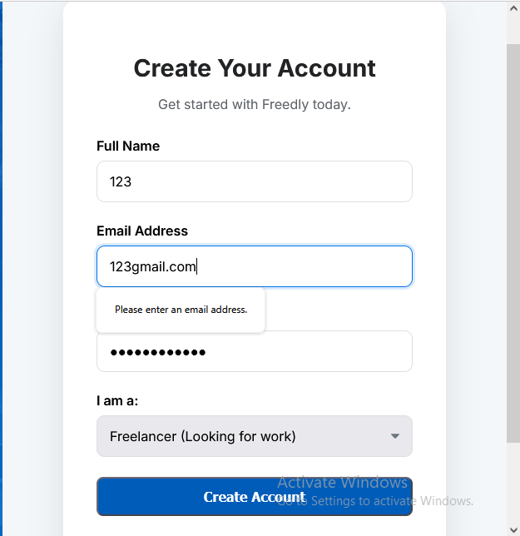

TC-AUTH-12 :

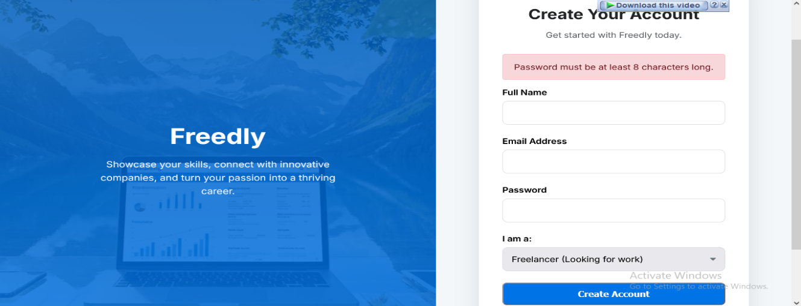

TC-AUTH-13 :

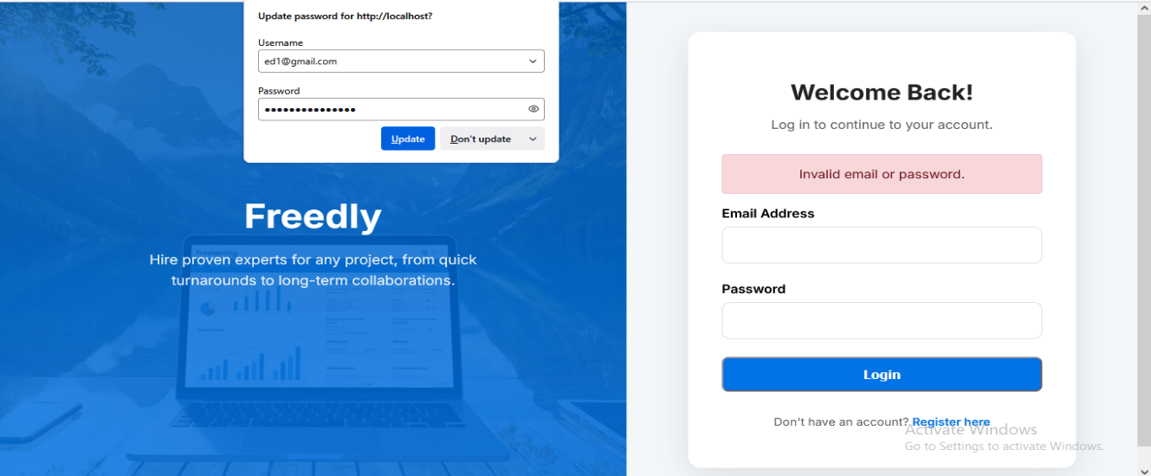

TC-AUTH-14 :

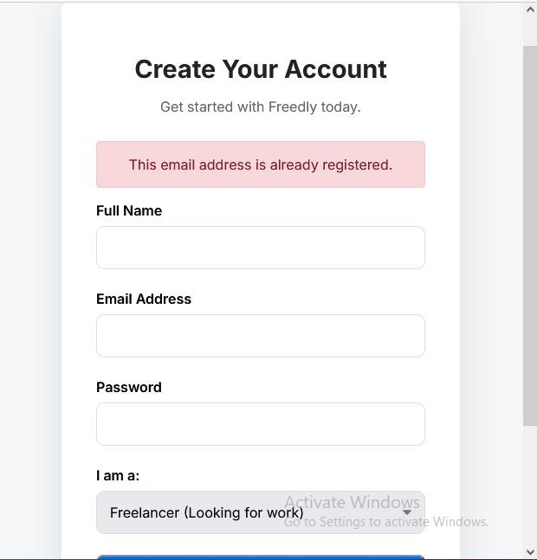

TC-AUTH-15 :

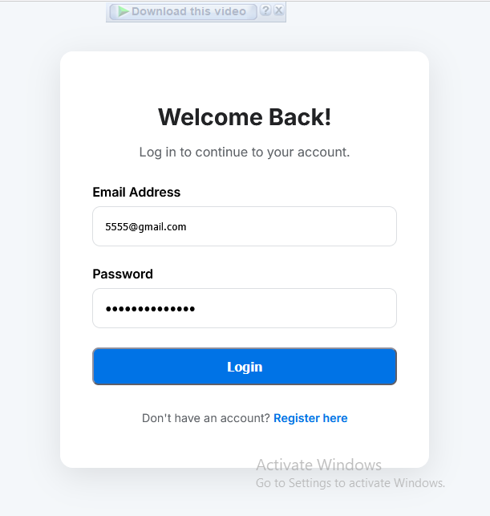

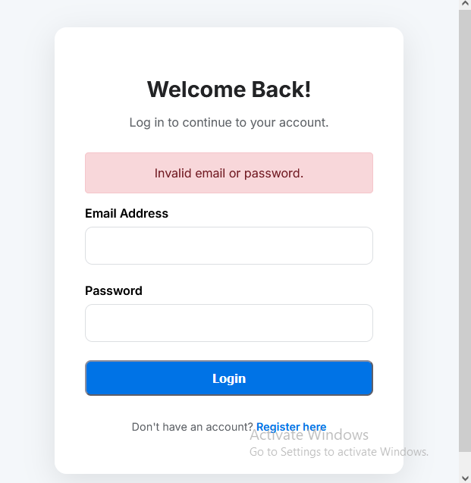

2. Freelancer Dashboard

|  |  |  |  |  |  |
| --- | --- | --- | --- | --- | --- |
| **Test Case ID** | **Description** | **Steps** | **Expected Result** | **Actual Result** | **Status** |
| TC-FL-01 | View Active Projects | 1. Log in as freelancer  2. Go to "My Projects" | Displays list of active projects | As expected | Pass |
| TC-FL-02 | Apply for a Job | 1. Search for jobs  2. Click "Apply"  3. Submit proposal | Application sent, appears in "My Projects" | As expected | Pass |
| TC-FL-03 | Update Profile | Profile 1. Go to "Profile"  2. Edit skills/bio  3. Save changes | Profile updated successfully | As expected | Pass |
| TC-FL-04 | Upload Portfolio Item | 1. Go to "Portfolio"  2. Click "Add New"  3. Upload image/description | Item appears in portfolio | As expected | Pass |
| TC-FL-05 | Send Message to Employer | 1. Open chat with employer  2. Type message  3. Send | Message appears in conversation As expected | As expected | Pass |
| TC-FL-06 | Create a New Service | 1. Go to "Create a New Service"  2. Fill in title, description, price, category, delivery days, upload image  3. Submit | Service is created and appears in "Manage Services" | As expected | Pass |
| TC-FL-07 | Delete a Service | 1. Go to "Manage Services"  2. Click "Delete" on a service | Service is removed from the list | As expected | Pass |
| TC-FL-08 | View Own Services | 1. Go to "Manage Services"  2. Check list | All freelancer's services are displayed | As expected | Pass |
| TC-FL-09 | Create Service - Empty Form Submission | 1. Go to "Create a New Service".  2. Click "Create Service" without entering any data. | Error messages appear for all required fields (title, description, price, category, delivery days). | As expected | Pass |
| TC-FL-10 | Create Service - Invalid Price Values | 1. Go to "Create a New Service".  2. Enter a negative number (e.g., -10) or zero (0) for the price.  3. Fill other required fields and submit. | Error: "Price must be greater than 0." | As expected | Pass |
| TC-FL-11 | Update Profile - Empty Required Fields | 1. Go to "Manage Profile".  2. Clear the "Full Name" field.  3. Click "Save Personal Info". | Error: "Full Name is required." | As expected | Pass |
| TC-FL-12 | Update Profile - Invalid Profile Picture Upload | 1. Go to "Manage Profile".  2. Attempt to upload a non-image file as a profile picture.  3. Click save. | Error: "Only image files are allowed for the profile picture." | As expected | Pass |
| TC-FL-13 | Add Skill - Empty Skill Name | 1. Go to "Manage Profile".  2. In the "Add Skill" form, click "Add Skill" without typing anything. | Error: "Skill name cannot be empty." OR the button is disabled. | As expected | Pass |
| TC-FL-14 | Apply for Job - Empty Proposal | 1. Find a job and click "Apply".  2. Click "Submit Proposal" without writing anything in the textarea. | Error: "Your proposal cannot be empty." | As expected | Pass |
| TC-FL-15 | Logout from Dashboard | 1. While on any freelancer dashboard page (e.g., /freelancer_dashboard.php), click the "Logout" link in the navigation. | The user is successfully logged out and redirected to the login page or homepage. | As expected | Pass |
| TC-FL-16 | Successful Service Creation with Image | 1. Go to "Create a New Service".  2. Fill all fields correctly and upload a valid image file.  3. Submit the form. | Service is created successfully. The image is displayed correctly on the service listing and browse page. | As expected | Pass |
| TC-FL-17 | View Job Details Before Applying | 1. Find a job listing on the main page.  2. Click on the job title to view more details before clicking "Apply". | The user is taken to a detailed job page with the full description, employer name, and budget. The "Apply" button is available on this page. | As expected | Pass |

TC-FL-01:

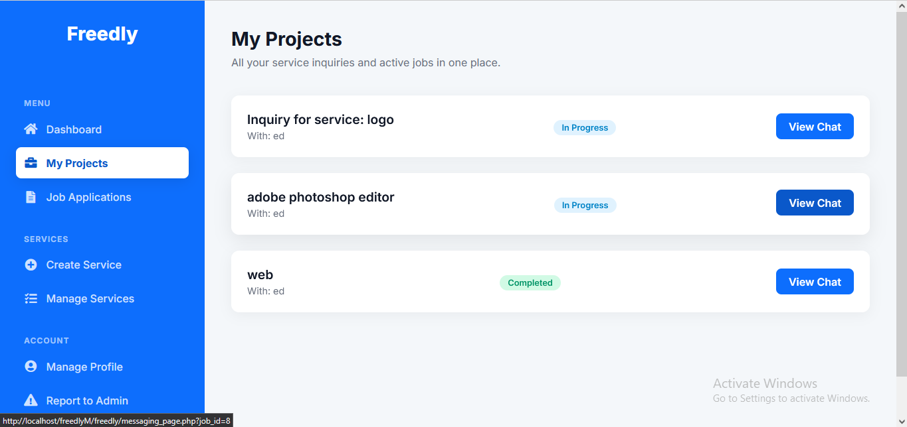

TC-FL-02:

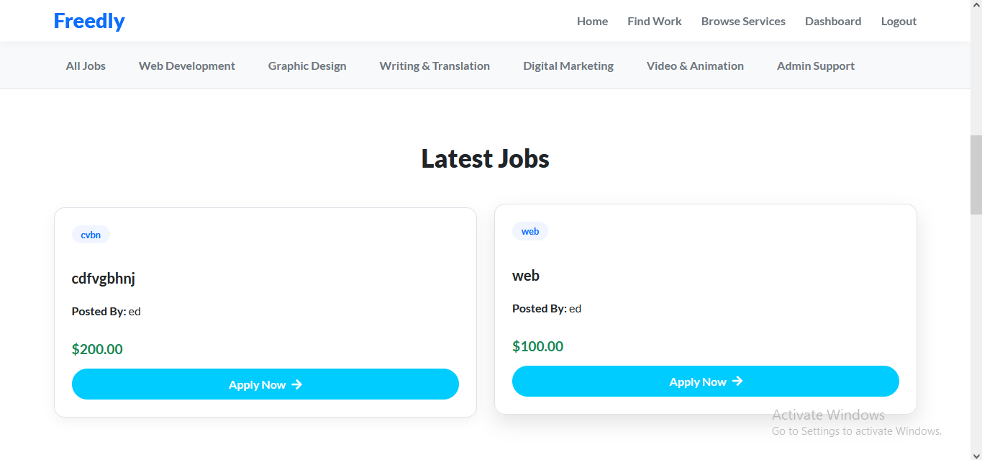

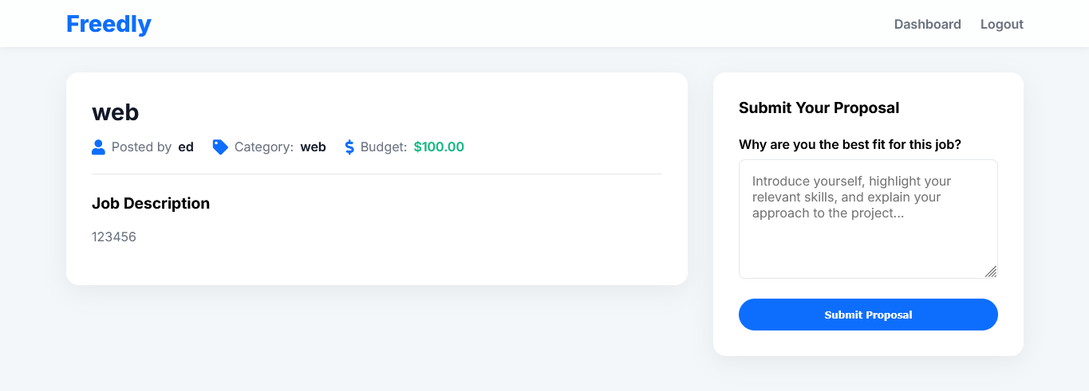

TC-FL-03:

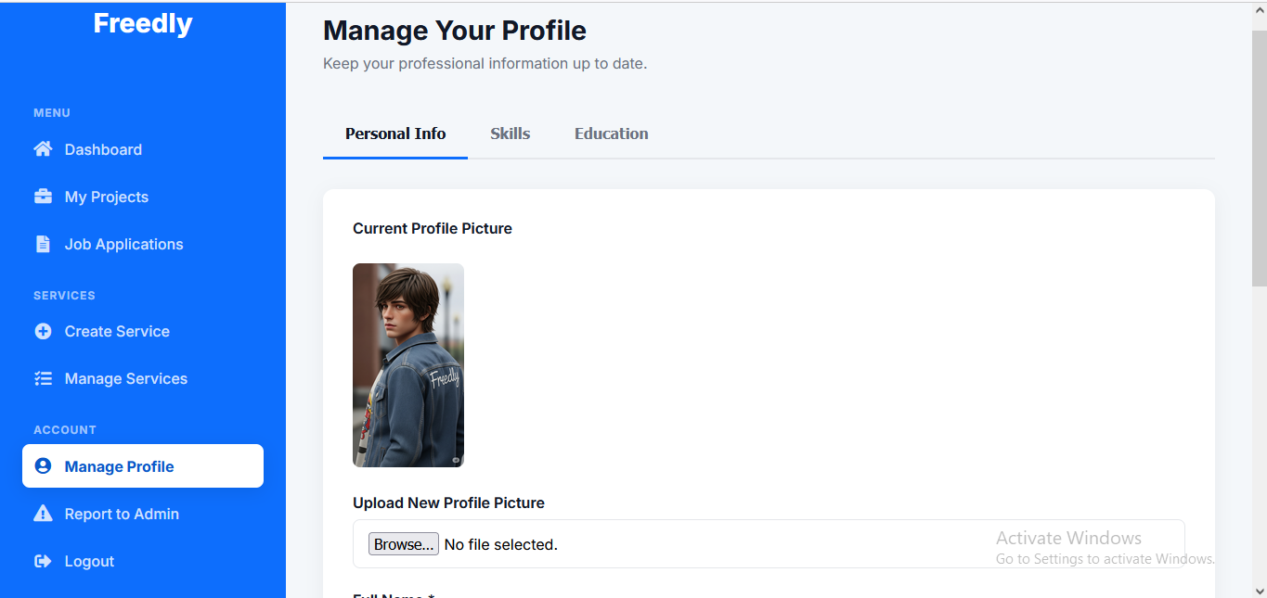

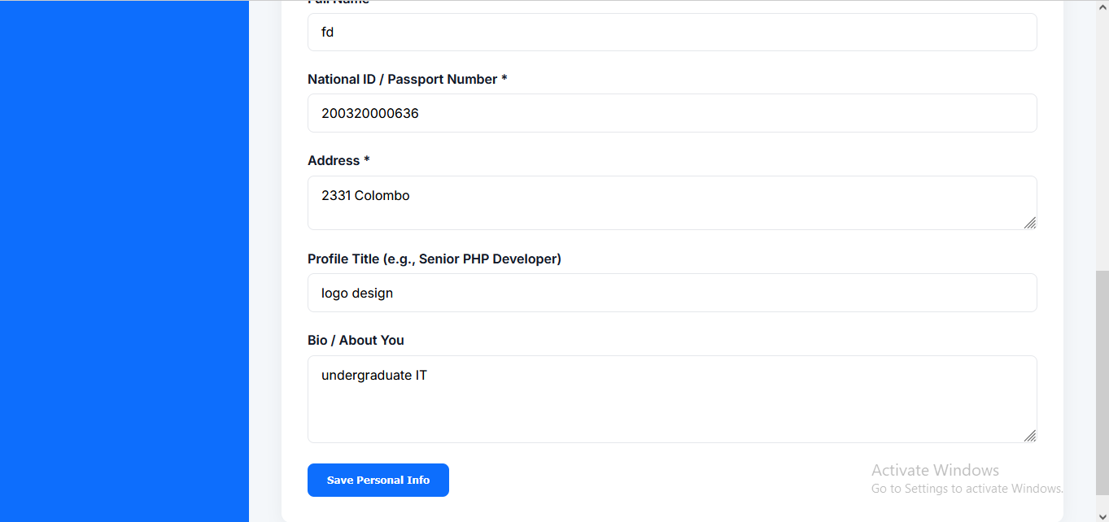

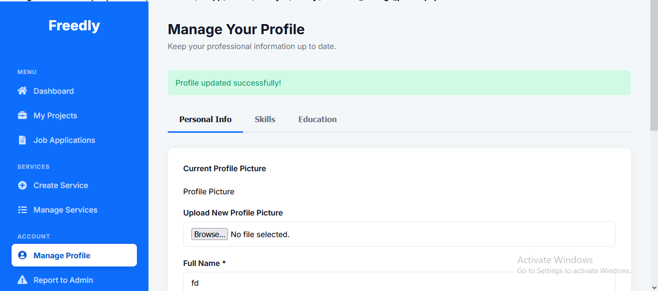

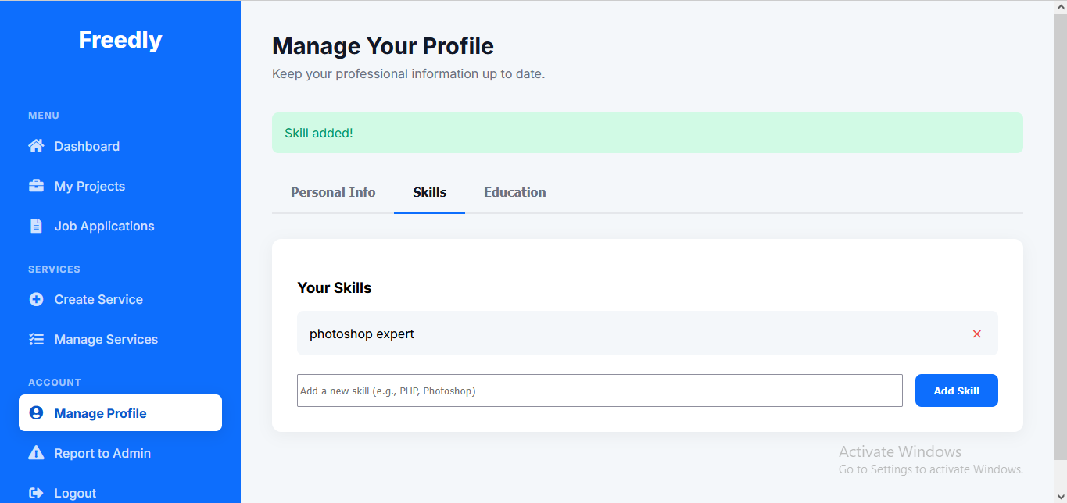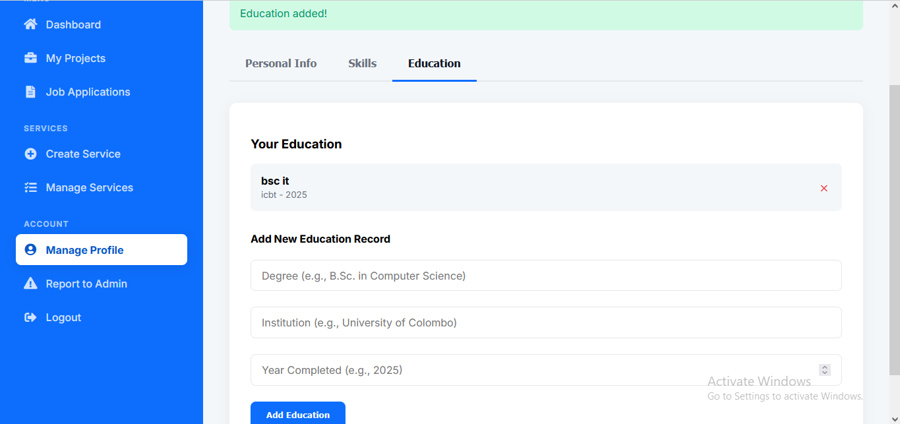

TC-FL-04:

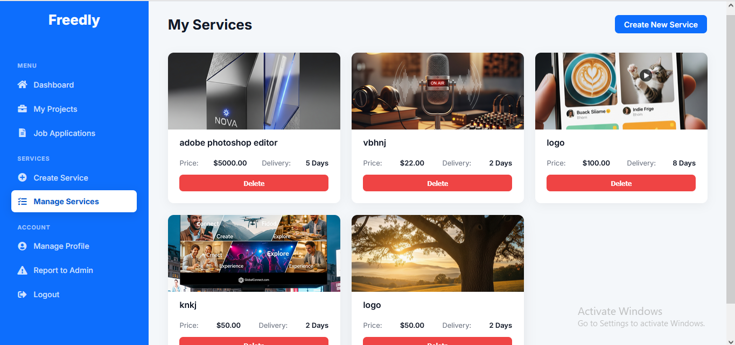

TC-FL-05:

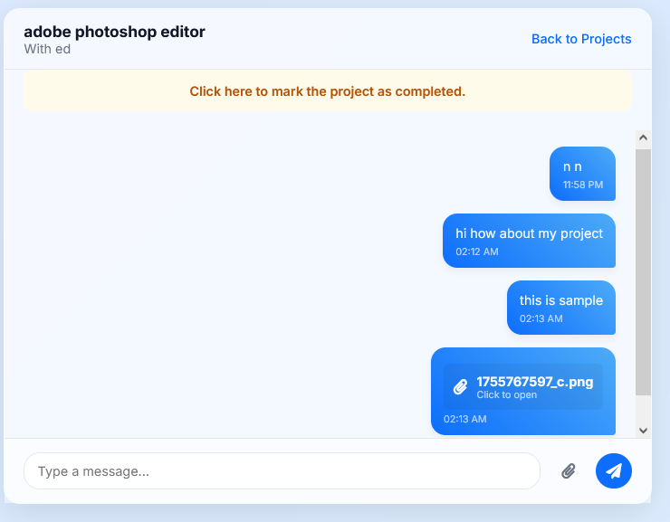

TC-FL-06:

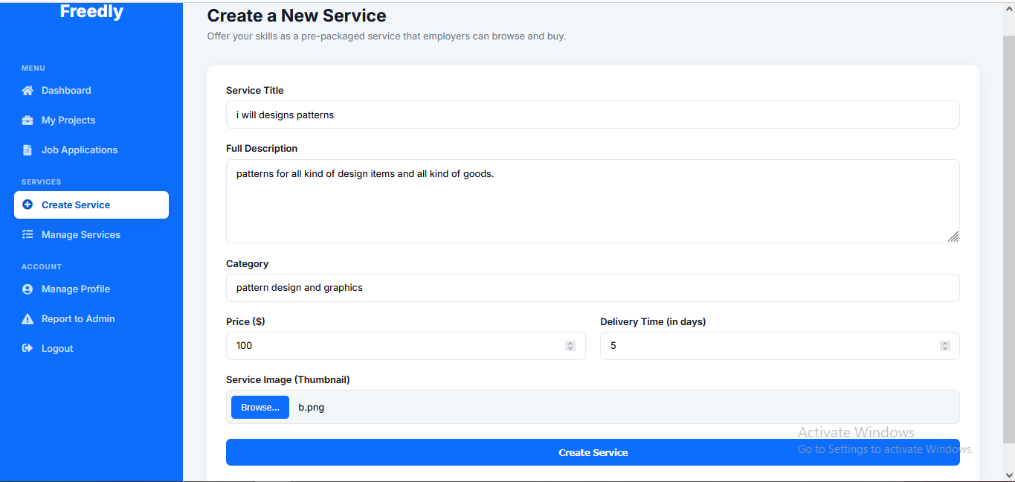

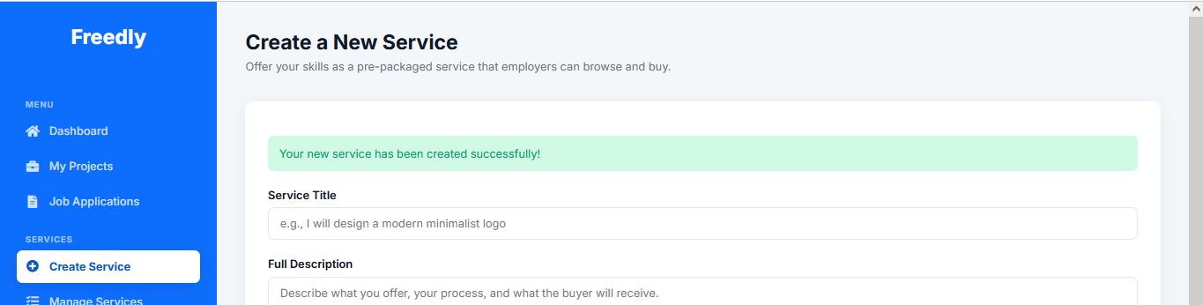

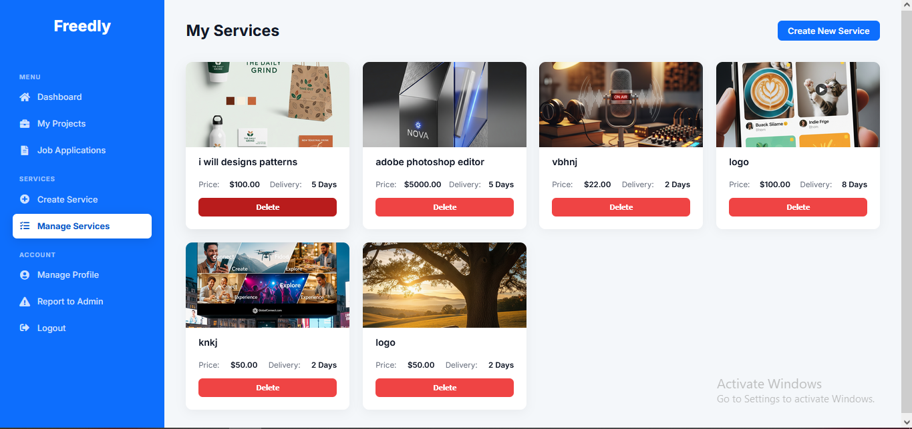

TC-FL-07:

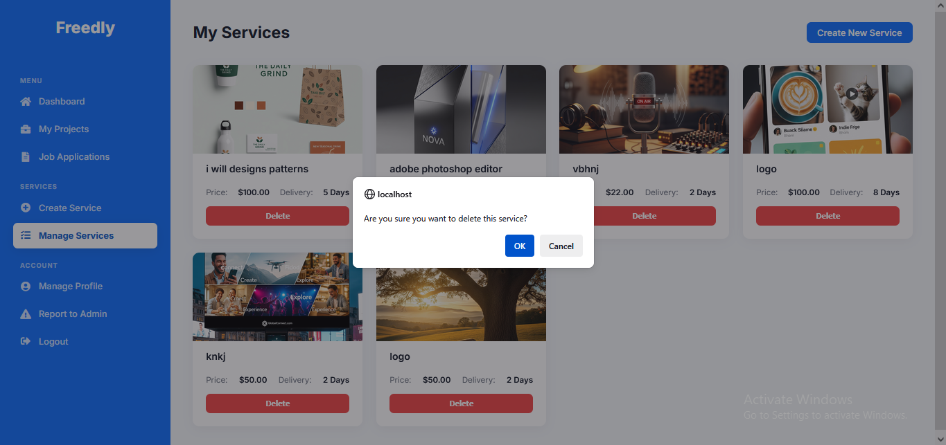

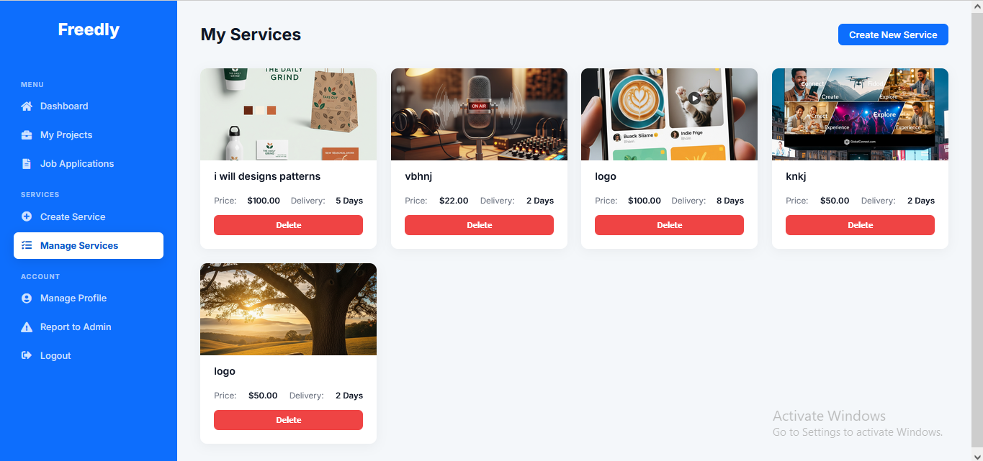

TC-FL-08:

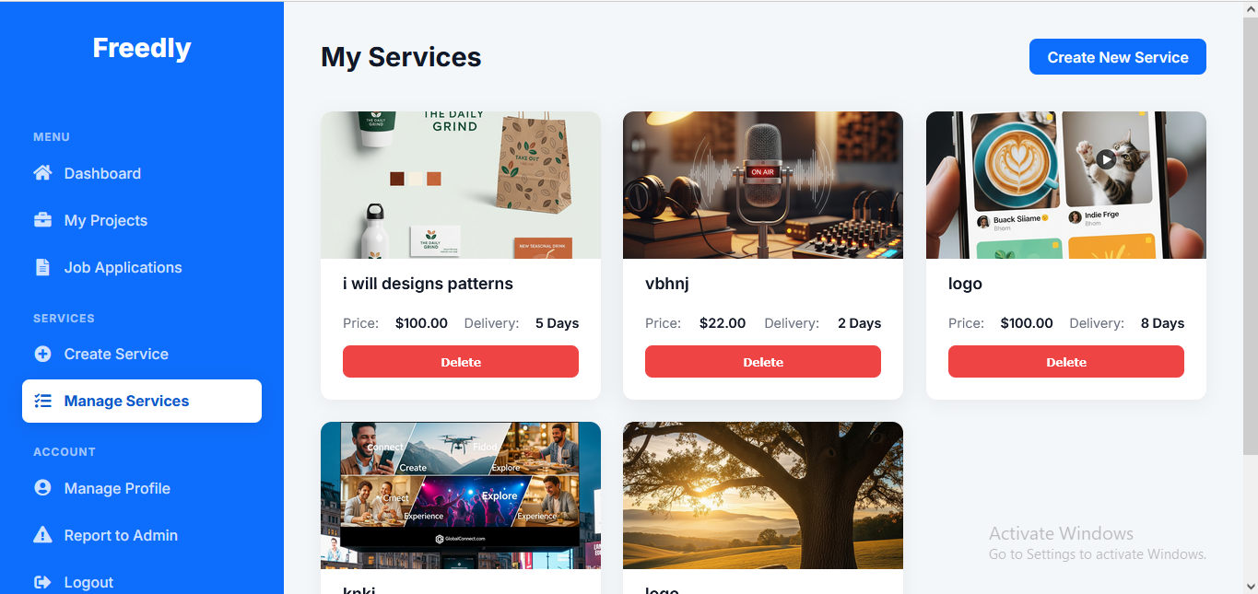

TC-FL-09:

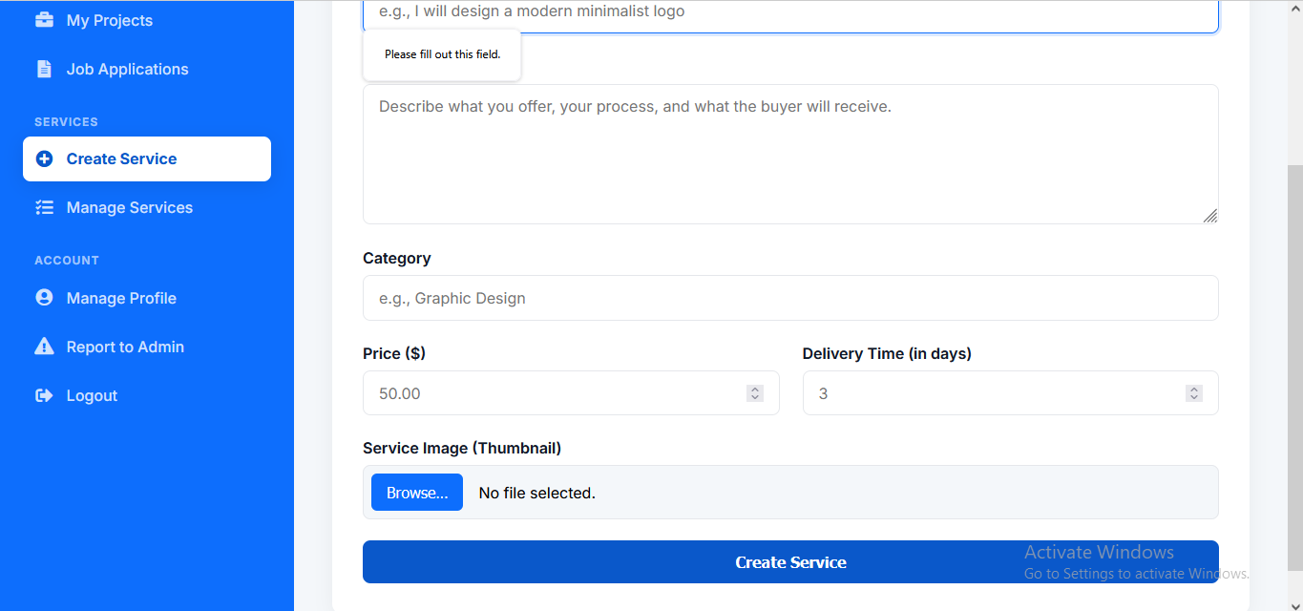

TC-FL-10:

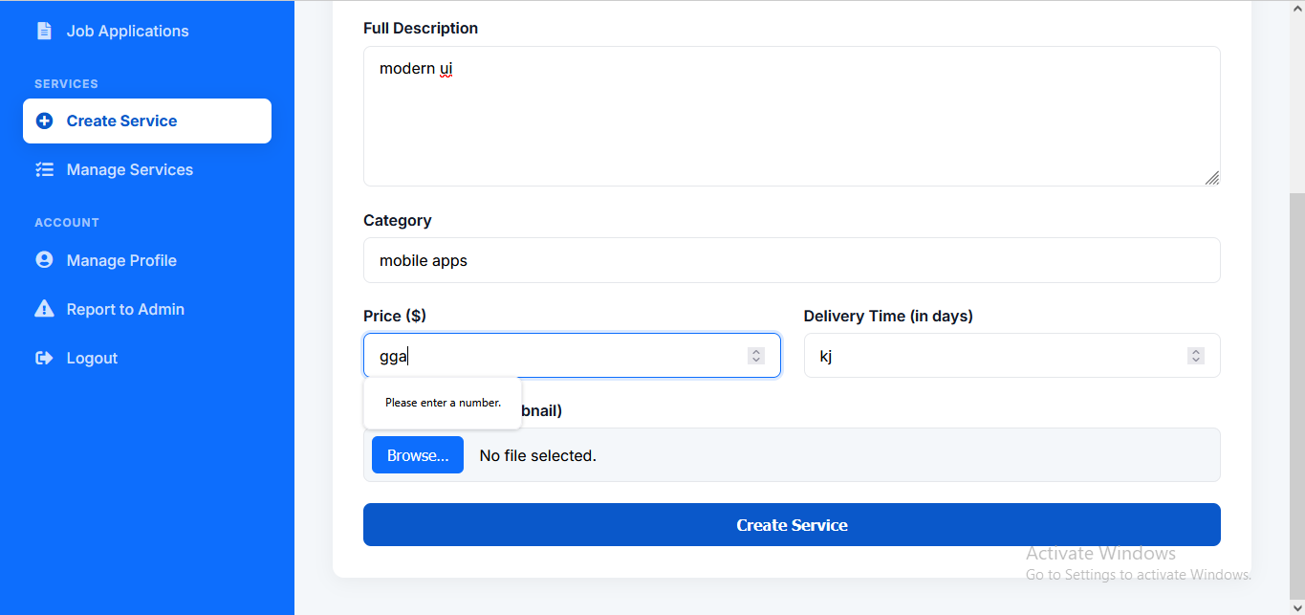

TC-FL-11:

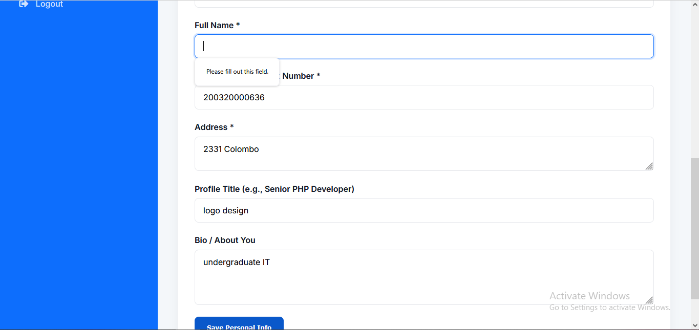

TC-FL-12:

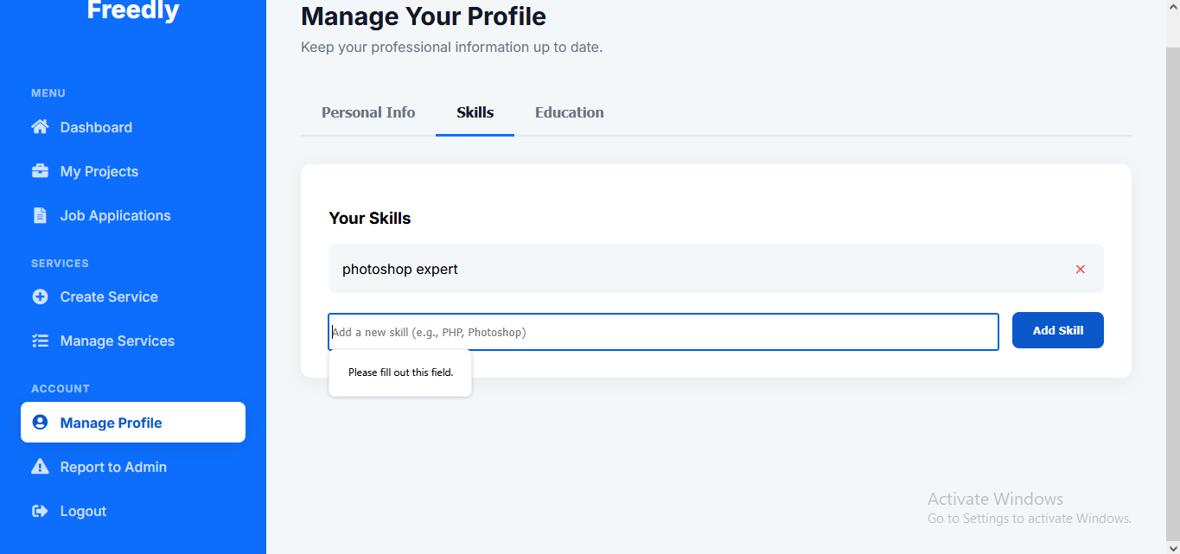

TC-FL-13:

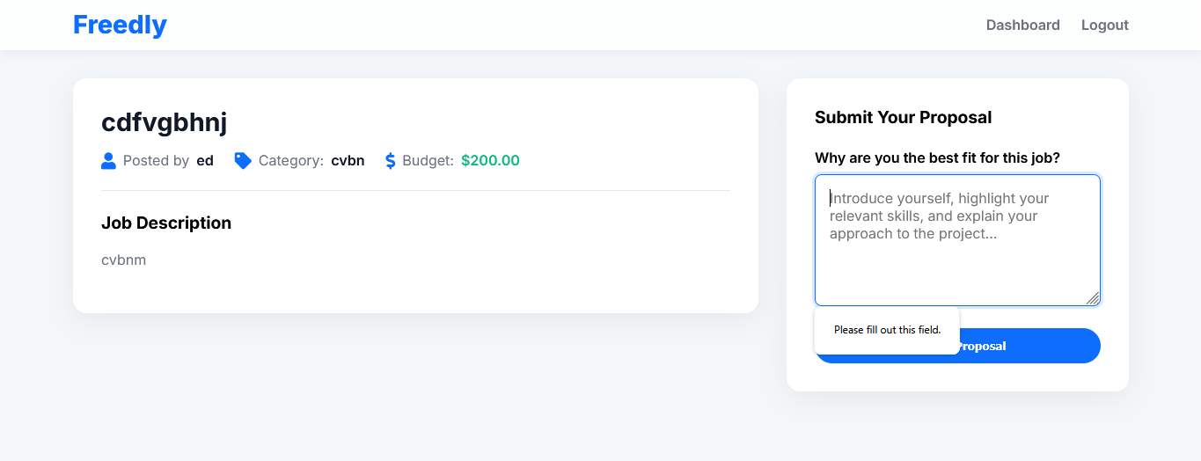

TC-FL-14:

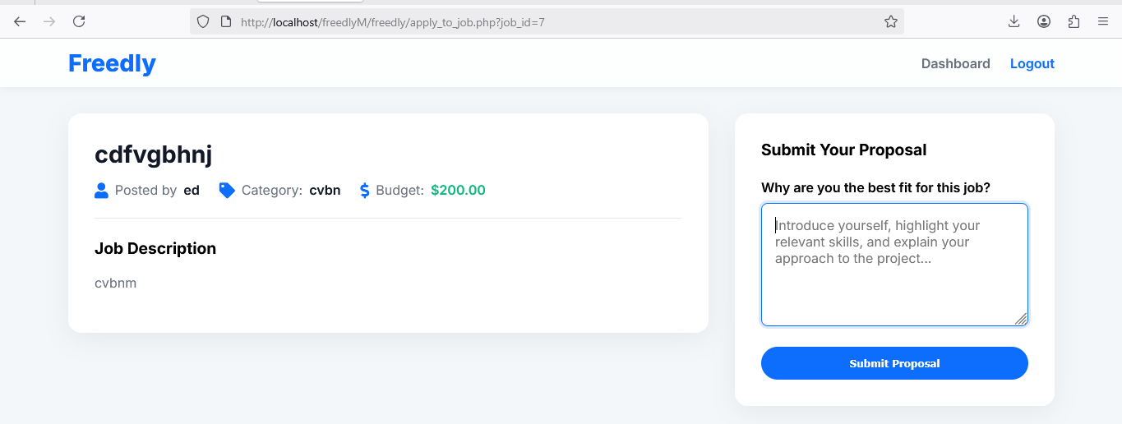

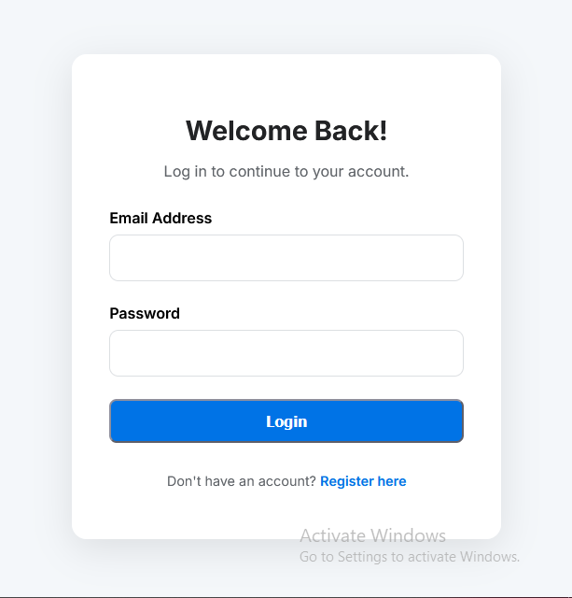

TC-FL-16:

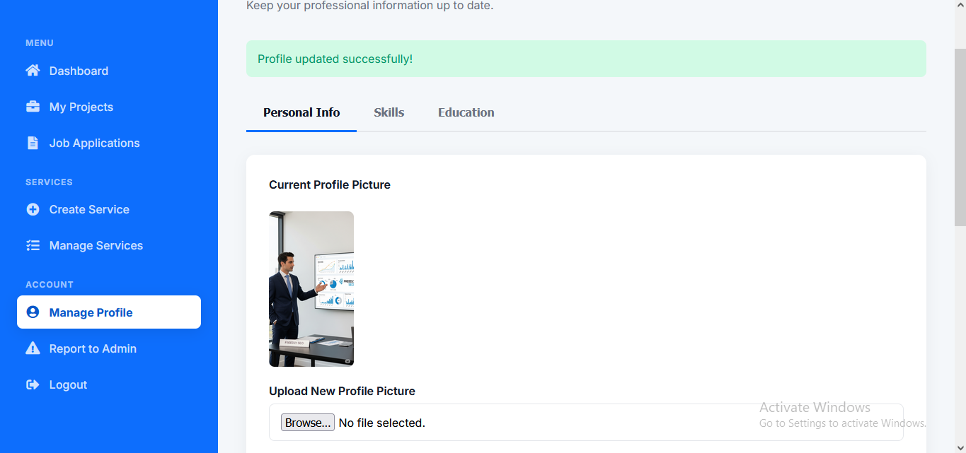

TC-FL-17:

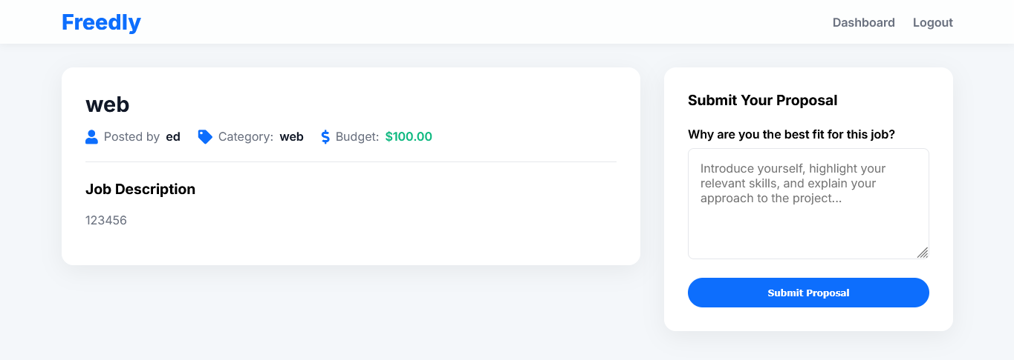

3. Employer Dashboard

|  |  |  |  |  |  |
| --- | --- | --- | --- | --- | --- |
| **Test Case ID** | **Description** | **Steps** | **Expected Result** | **Actual Result** | **Status** |
| TC-EMP-01 | Post a New Job | 1. Go to "Post a Job"  2. Fill job details  3. Submit | Job appears in "Manage Jobs" | As expected | Pass |
| TC-EMP-02 | View Freelancer Proposals | 1. Go to "My Jobs"  2. Click on a job | Displays list of proposals | As expected | Pass |
| TC-EMP-03 | Hire a Freelancer | 1. Review proposals  2. Click "Hire" on a freelancer | Freelancer notified, project status updates | As expected | Pass |
| TC-EMP-04 | Update Company Profile | 1. Go to "Profile"  2. Edit company details  3. Save | Changes reflected in profile | As expected | Pass |
| TC-EMP-05 | Browse Services | 1. Go to "Browse Services"  2. Filter by category or search | Services are displayed correctly | As expected | Pass |
| TC-EMP-06 | View Service Details | 1. Click on a service  2. Check details, freelancer info, price | All service details are shown | As expected | Pass |
| TC-EMP-07 | Initiate Contact for Service | 1. Click "Contact to Order"  2. Log in as employer (if not)  3. Confirm | Redirected to messaging page with freelancer | As expected | Pass |
| TC-EMP-08 | Post Job - Empty Form Submission | 1. Go to "Post a New Job".  2. Click "Post Job" without entering any data. | Error messages appear for all required fields (title, description, category, budget). | As expected | Pass |
| TC-EMP-09 | Post Job - Invalid Budget Values | 1. Go to "Post a New Job".  2. Enter a negative number (e.g., -100) or zero (0) for the budget.  3. Fill other required fields and submit. | Error: "Budget must be greater than 0." | As expected | Pass |
| TC-EMP-10 | Complete Job - Without Confirming Payment | 1. Go to the job completion page for a finished job.  2. Leave the "Confirm Payment" checkbox unchecked.  3. Try to submit the review. | Error: "Please confirm that the payment has been sent." | As expected | Pass |
| TC-EMP-11 | Send Message - Empty Message with Attachment | 1. In a message thread, do not type any text but attach a file.  2. Click "Send Message". | The message is sent successfully, containing only the file attachment. | As expected | Pass |
| TC-EMP-12 | Post Job - Successful with Special Characters | 1. Go to "Post a New Job".  2. Use a title/description with special characters (e.g., accents: àéî, symbols: &, $, #).  3. Submit the form. | Job is posted successfully, and all characters are displayed correctly on the job listing. | As expected | Pass |
| TC-EMP-13 | Navigation Consistency | 1. Click through all main menu items in the employer sidebar (Dashboard, Post Job, Manage Jobs, Manage Profile). | Navigation is smooth and always keeps the correct menu item highlighted as "active". | As expected | Pass |
| TC-EMP-14 | Clear Messaging Interface | 1. Open a message thread with a long history.  2. Scroll up and down the conversation. | The interface is clean, messages are clearly differentiated (sent/received), and it's easy to follow the conversation. | As expected | Pass |
| TC-EMP-15 | Complete Job & Leave Review | 1. For a job marked "completed" by the freelancer, go to the completion page.  2. Select a 5-star rating, write a positive comment, confirm payment, and submit. | The job status is set to "completed", the review is saved, and appears on the freelancer's public profile. | As expected | Pass |
| TC-EMP-16 | Hire from Service Page | 1. Find a service you like and click "Contact to Order".  2. Discuss details in the messaging page.  3. Click "Hire Now" to officially start the project. | The project status changes from "pending_agreement" to "in_progress". A system message confirms the hire. | As expected | Pass |

TC-EMP-01:

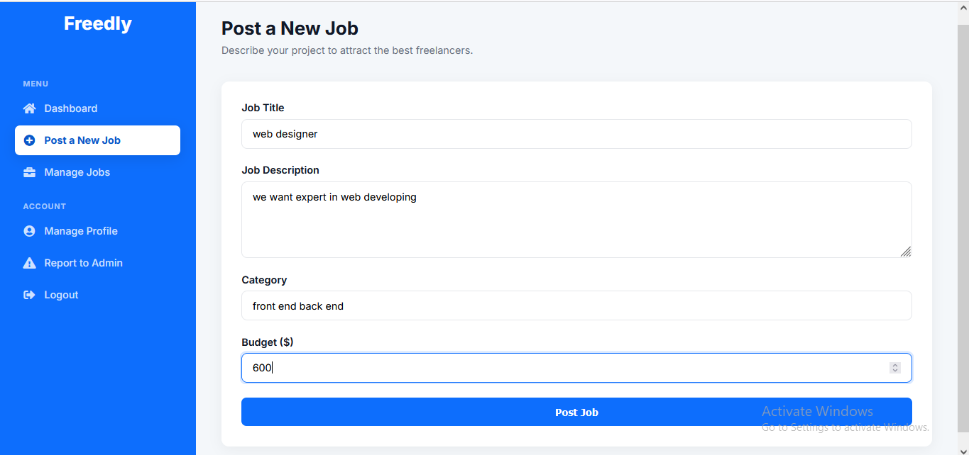

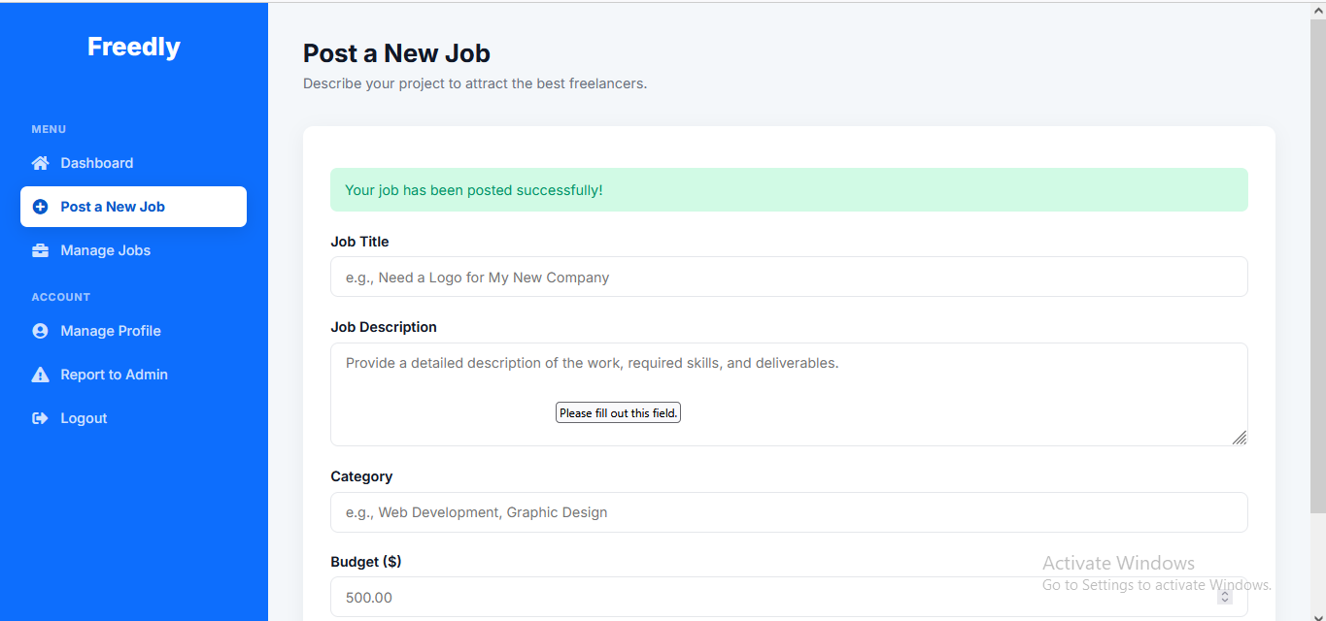

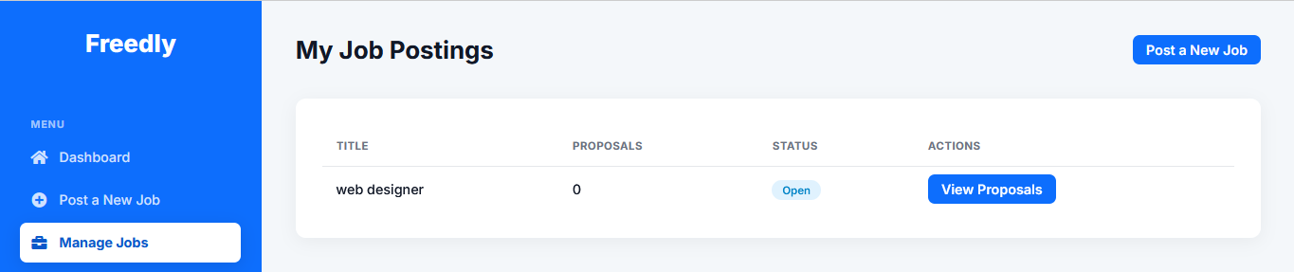

TC-EMP-02:

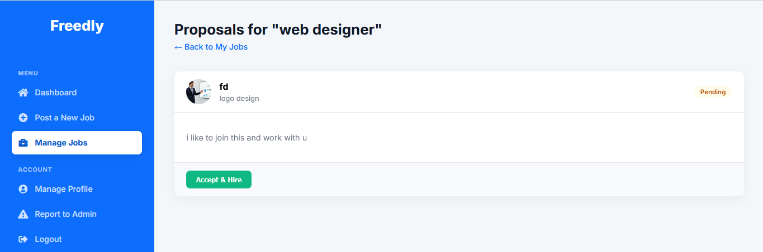

TC-EMP-03:

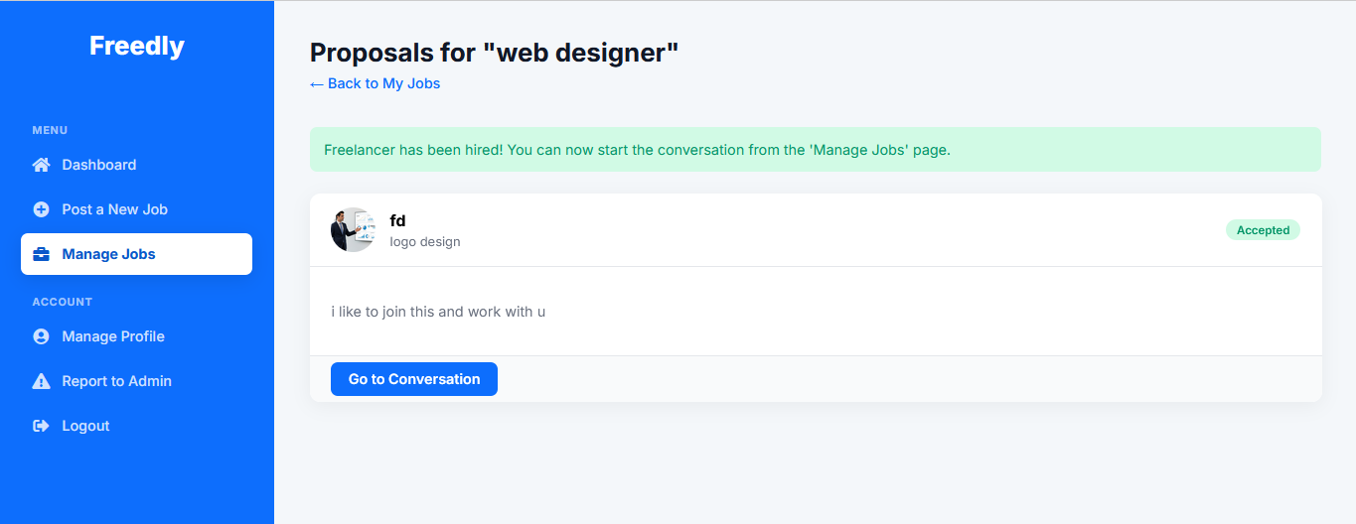

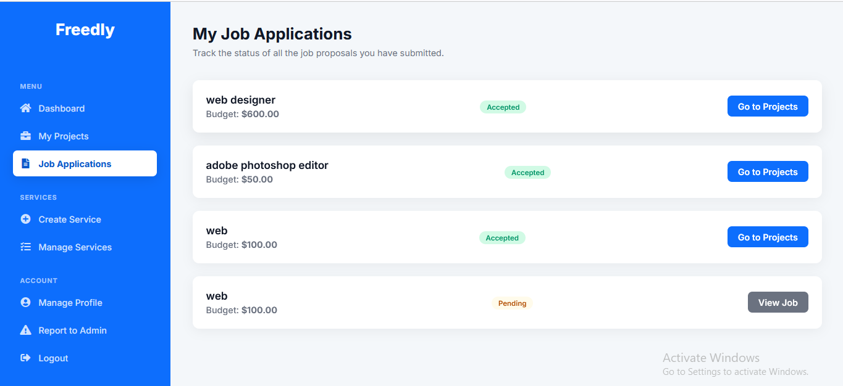

TC-EMP-04:

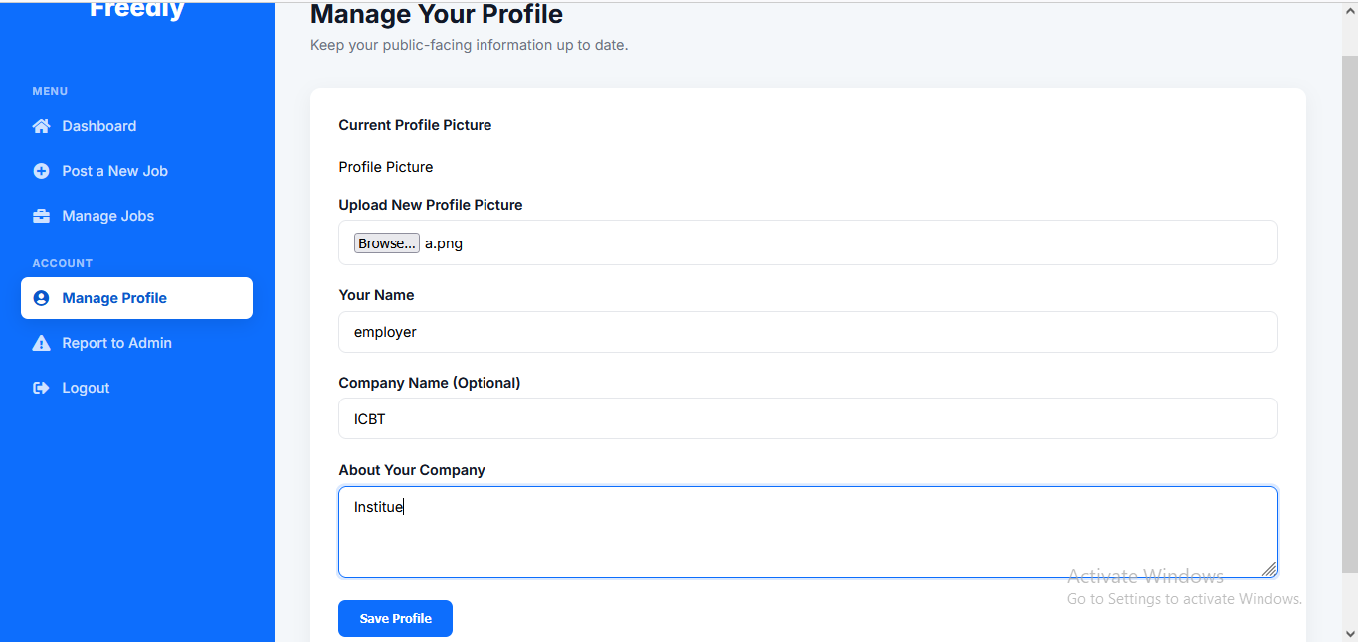

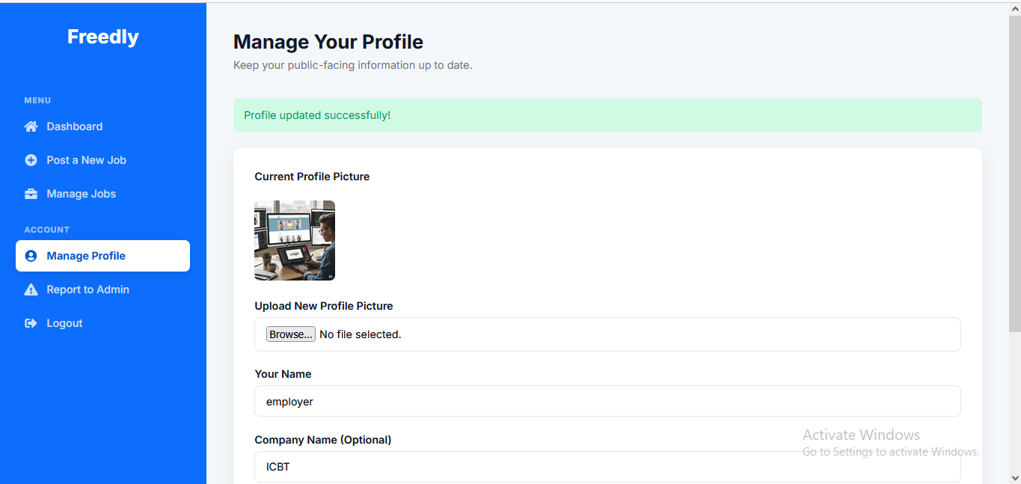

TC-EMP-05:

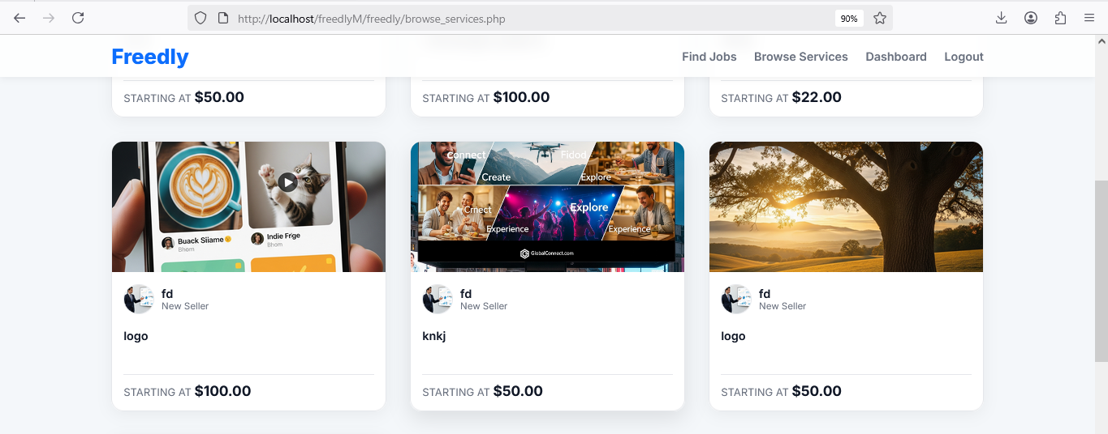

TC-EMP-06:

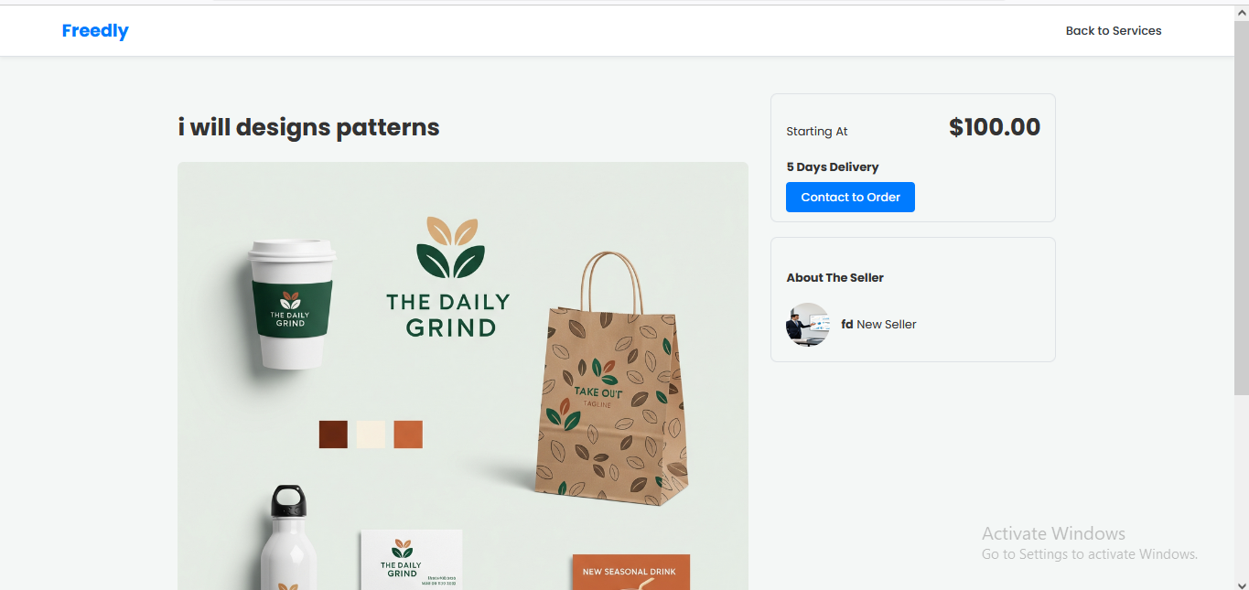

TC-EMP-07:

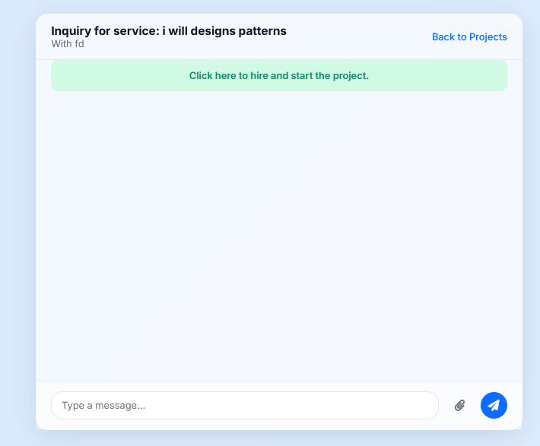

TC-EMP-08:

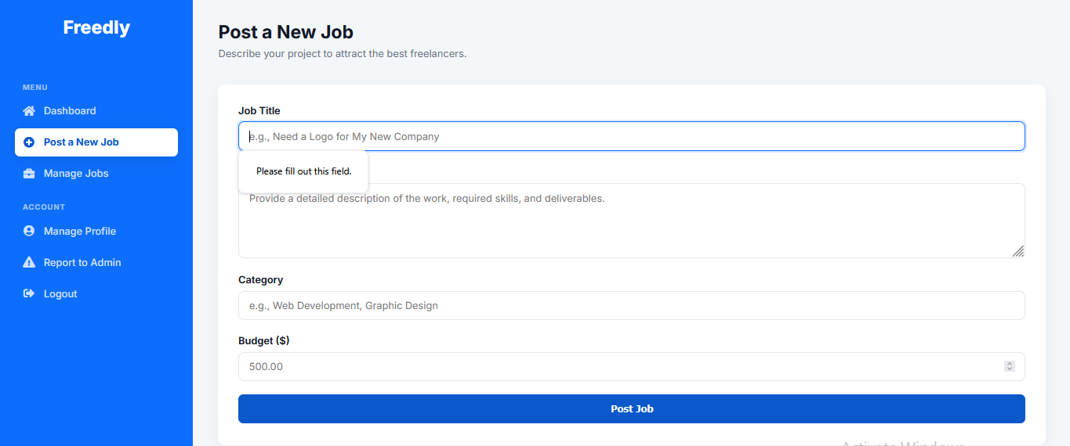

TC-EMP-09:

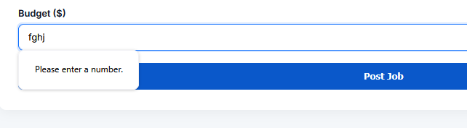

TC-EMP-10:

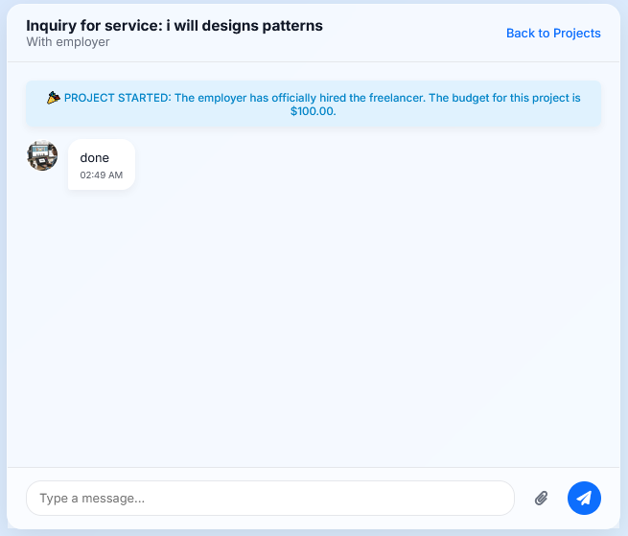

TC-EMP-11:

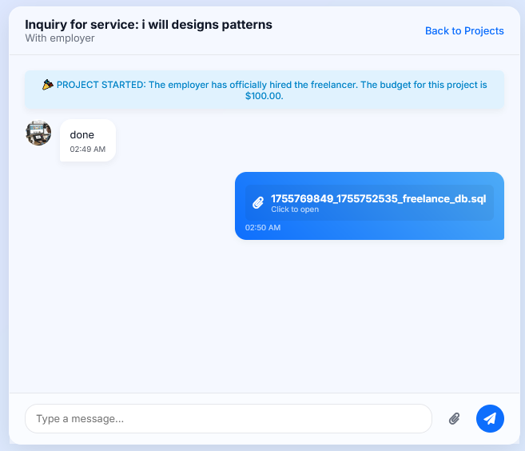

TC-EMP-12:

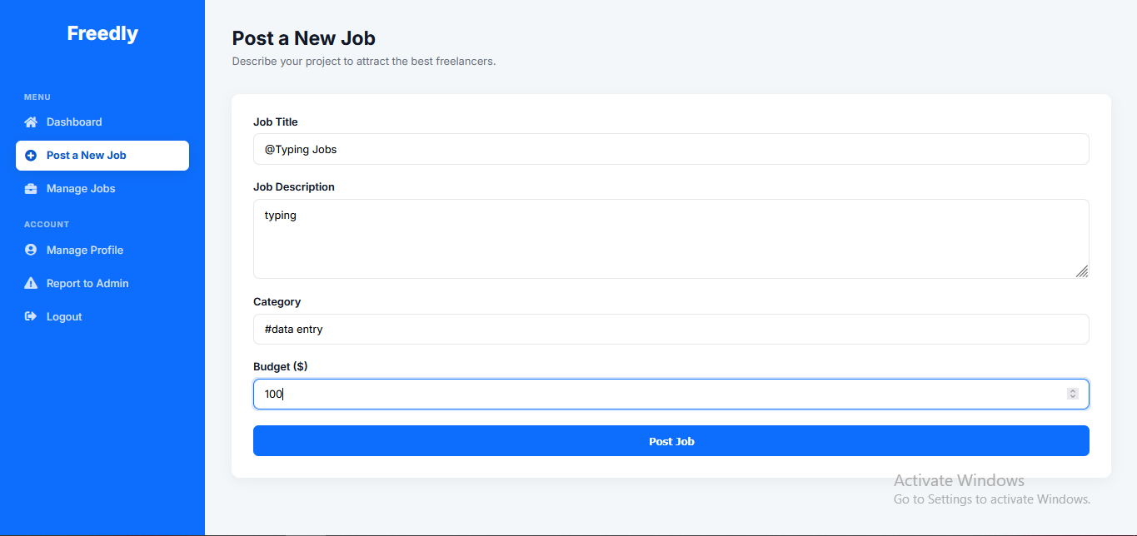

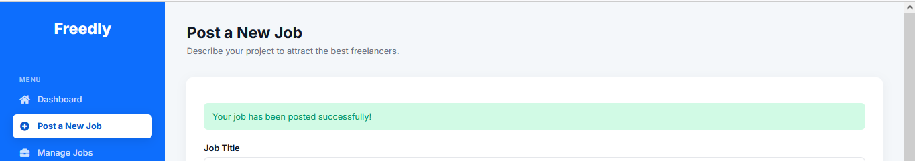

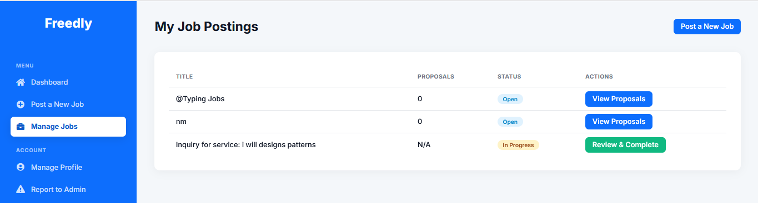

TC-EMP-13:

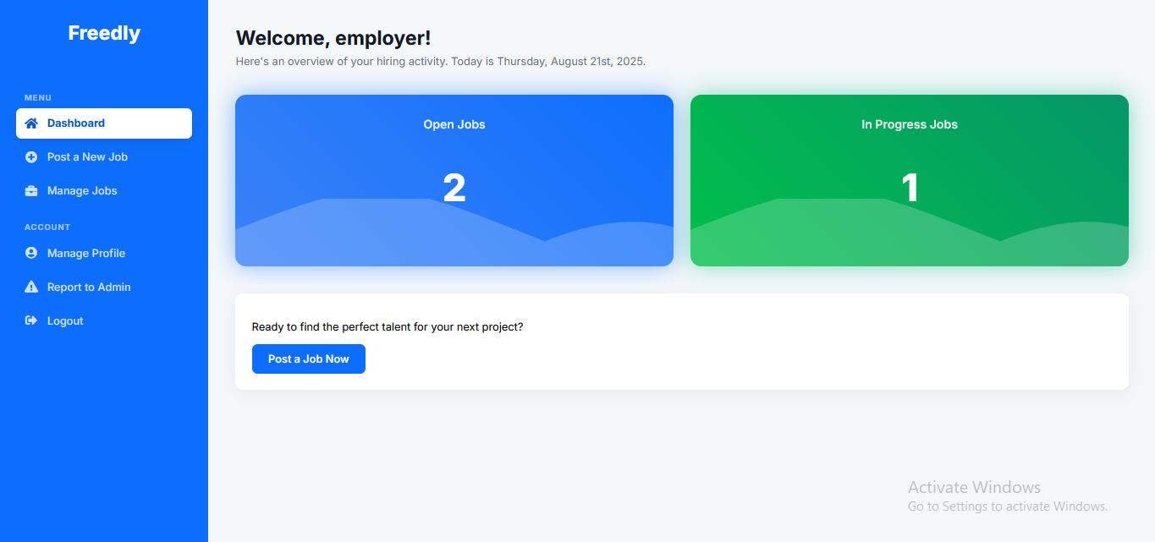

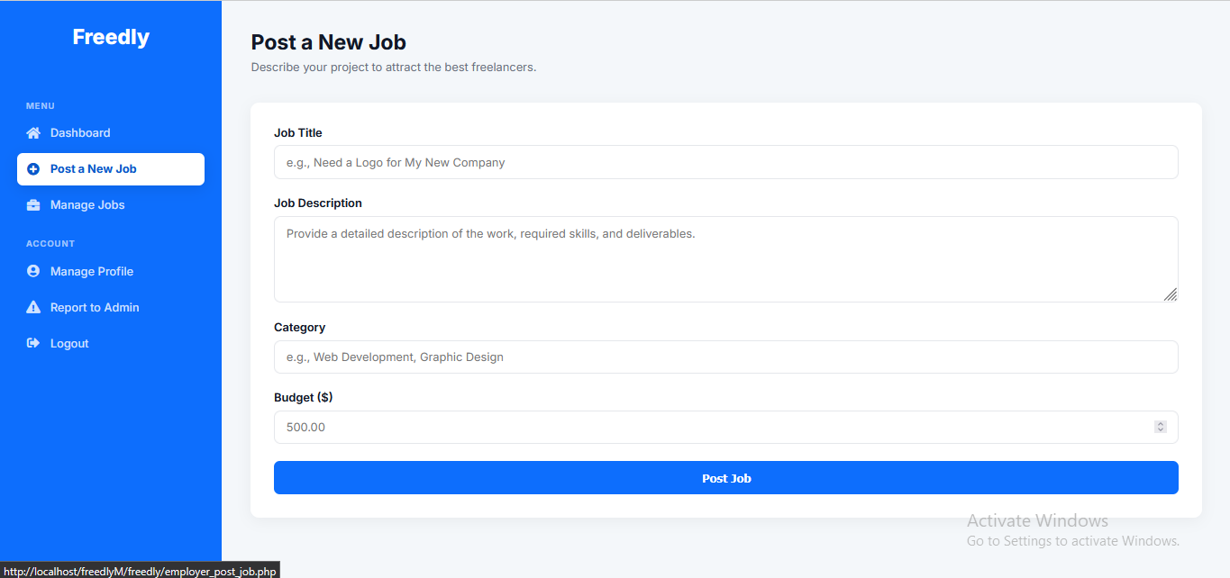

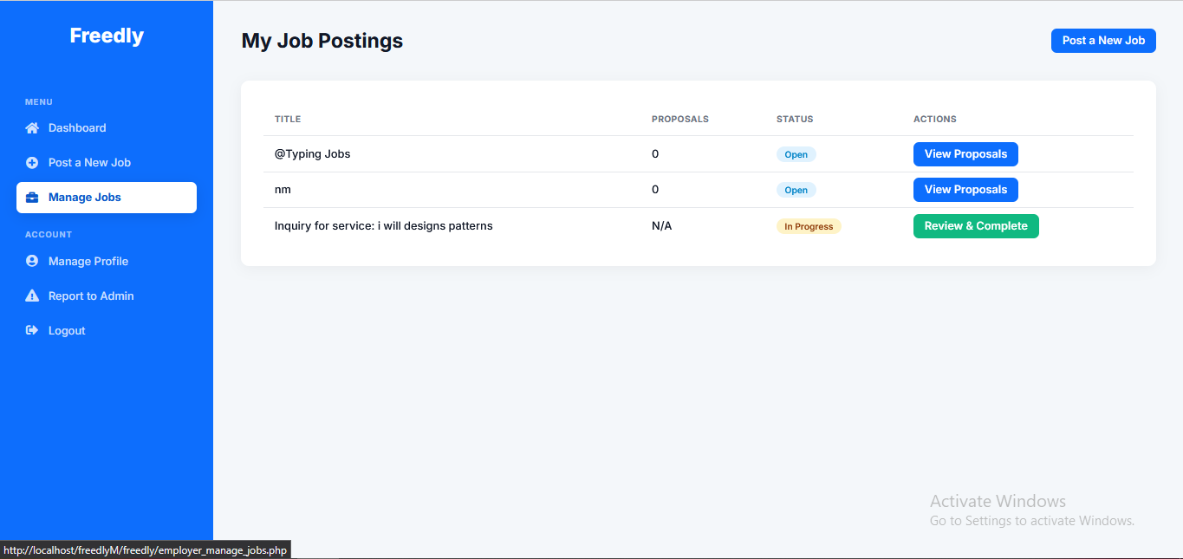

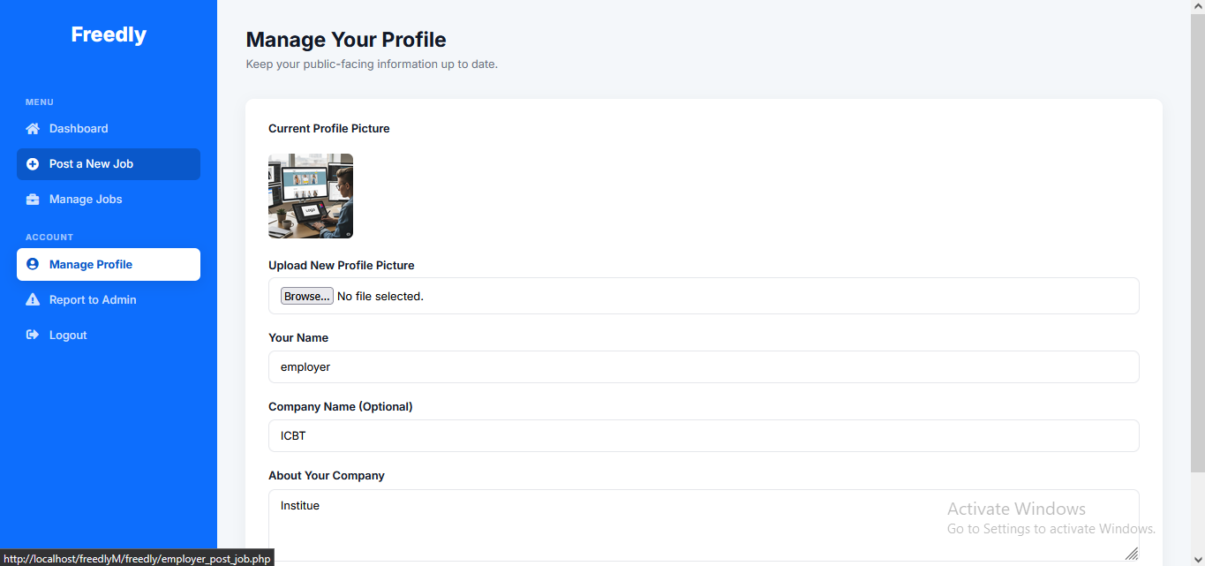

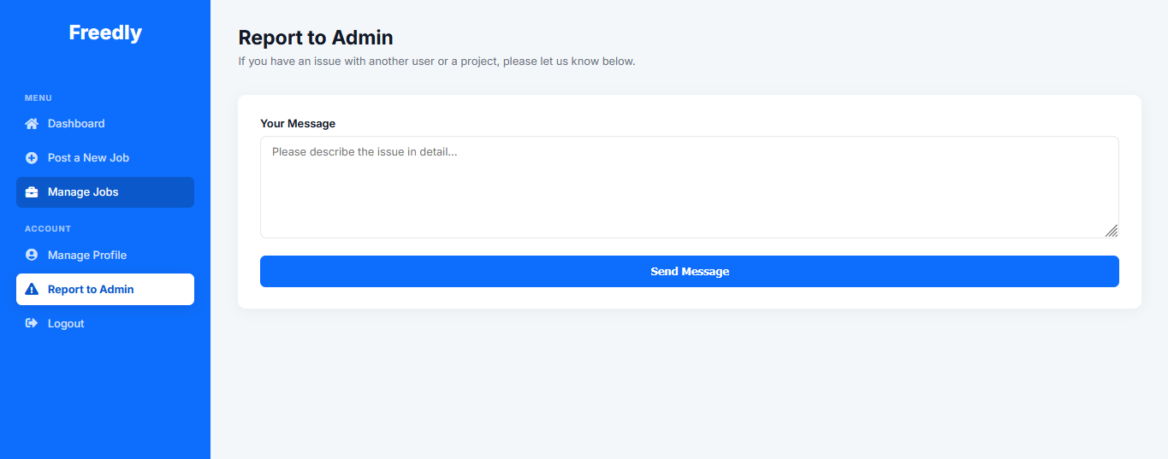

TC-EMP-14:



TC-EMP-15:

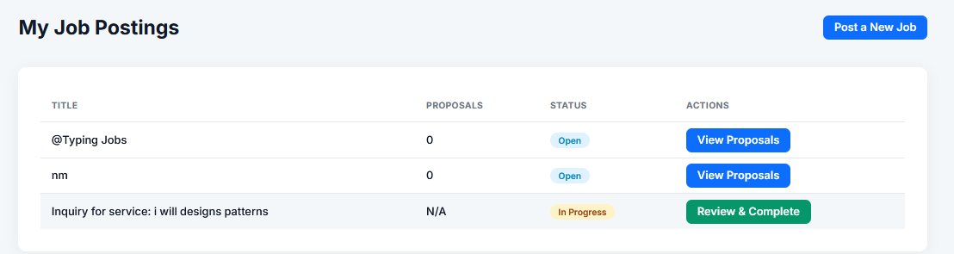

TC-EMP-16:

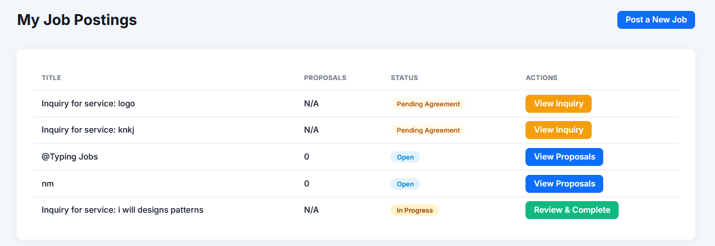

4. Admin Dashboard

|  |  |  |  |  |  |
| --- | --- | --- | --- | --- | --- |
| **Test Case ID** | **Description** | **Steps** | **Expected Result** | **Actual Result** | **Status** |
| TC-ADM-01 | View All Users | 1. Log in as admin  2. Go to "Users" | Displays list of all users | As expected | Pass |
| TC-ADM-02 | Delete a User | 1. Select a user  2. Click "Delete" | User removed from system | As expected | Pass |
| TC-ADM-03 | View Statistics | 1. Go to "Dashboard" | Shows total users, jobs, freelancers | As expected | Pass |
| TC-ADM-04 | Manage User Reports | 1. Go to "Manage Reports"  2. View pending reports  3. Mark as resolved | Report status updates to "resolved" | As expected | Pass |
| TC-ADM-05 | Set Freelancer Level | 1. Go to "Manage Users"  2. Select freelancer  3. Set level (New, Level 1, Top Rated) | Level is updated in database and profile | As expected | Pass |
| TC-ADM-06 | Dashboard Statistics Reflect Real-Time Data | 1. In a separate browser, register a new user or post a new job.  2. In the admin dashboard, refresh the page. | The statistics for "Total Users" or "Total Jobs" update in real-time to reflect the new count. | As expected | Pass |
| TC-ADM-07 | View User Details from Management Page | 1. In "Manage Users", click on a username. | The admin is taken to a detailed view of the user's profile, showing all their information, posted jobs, services, etc. (An admin-specific user detail page). | As expected | Pass |
| TC-ADM-08 | View Job Details from Management Page | 1. In "Manage Jobs", click on a job title. | The admin is taken to a detailed view of the job, including the full description, employer info, and any proposals received. | As expected | Pass |
| TC-ADM-09 | View Full Report Message | 1. In "Manage Reports", click on a truncated report message (if truncated). | The full report message is displayed, either in a modal popup or on a separate page. | As expected | Pass |

TC-ADM-01:

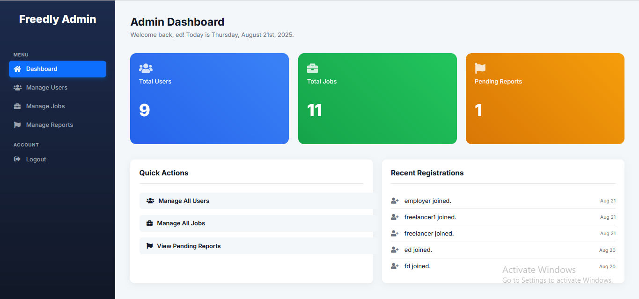

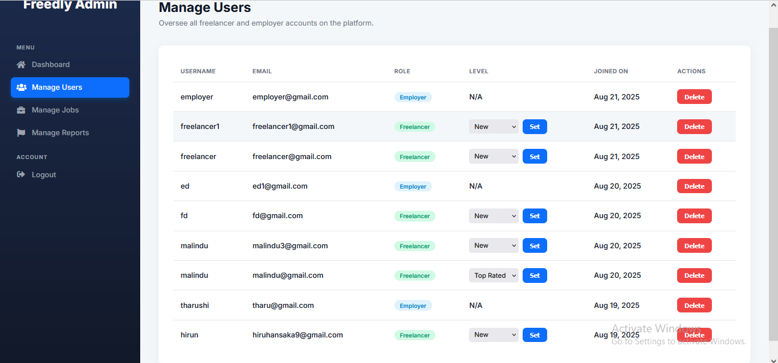

TC-ADM-02:

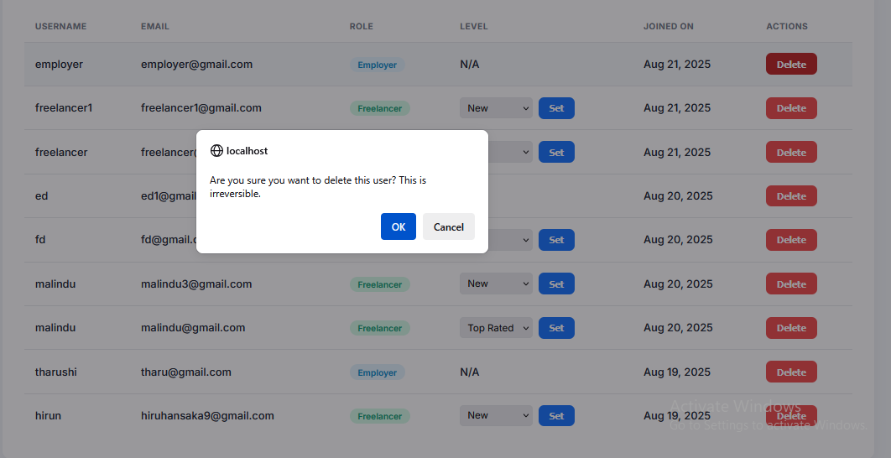

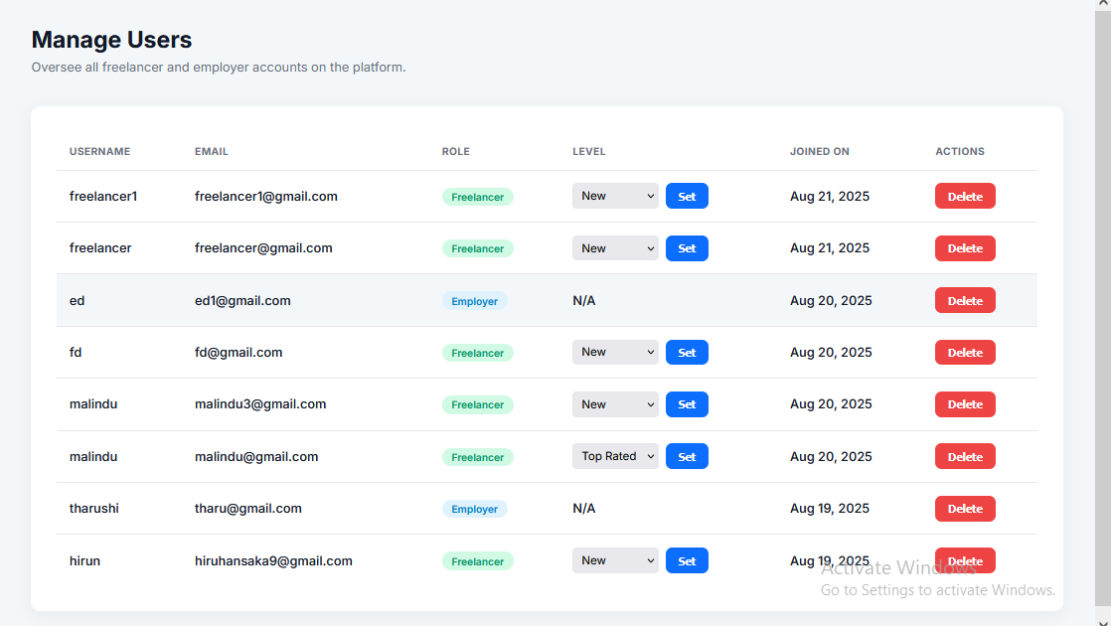

TC-ADM-03:

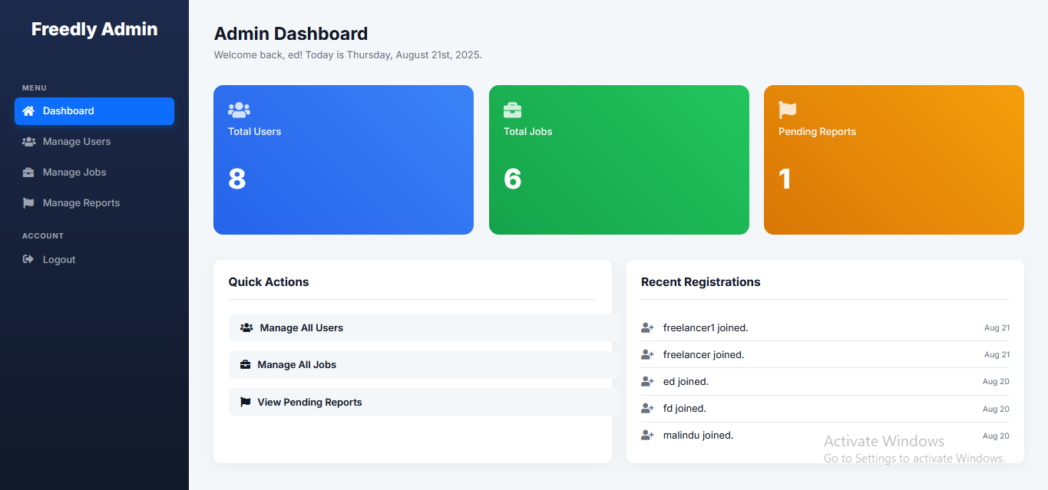

TC-ADM-04:

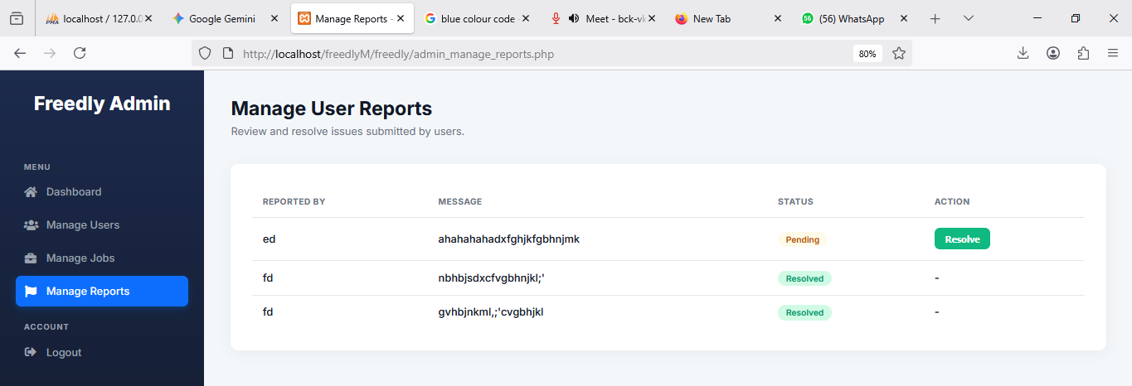

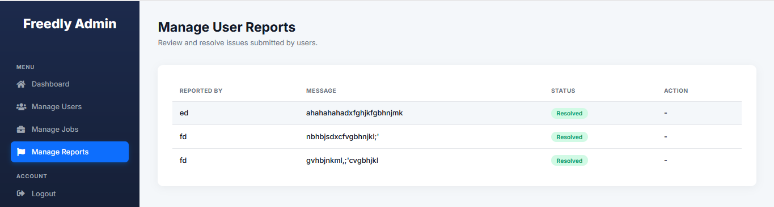

TC-ADM-05:

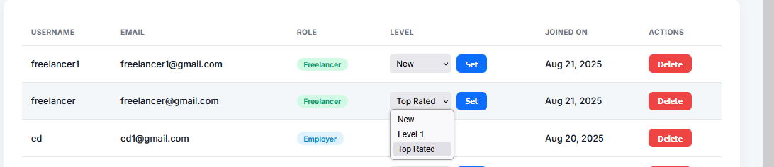

TC-ADM-06:

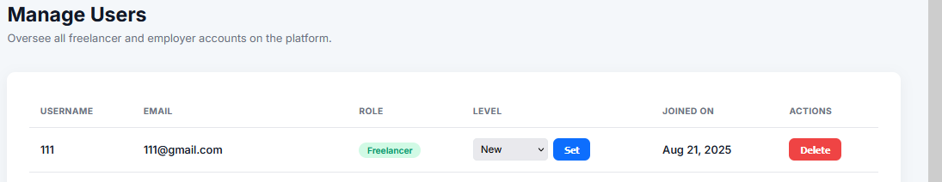

TC-ADM-07:

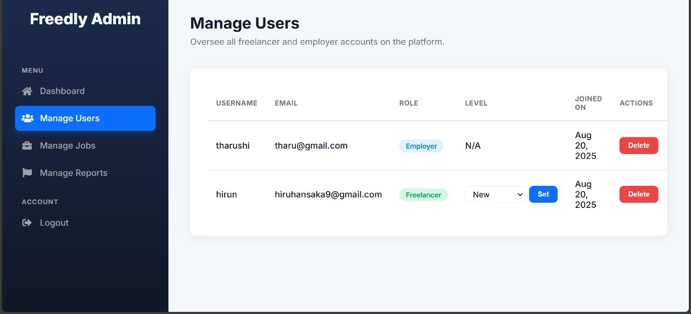

TC-ADM-08:

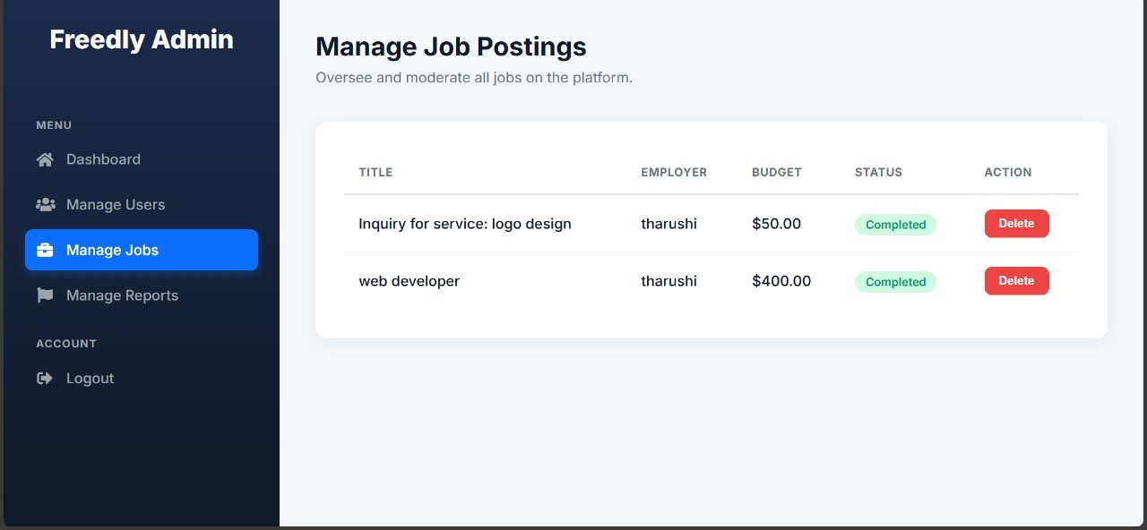

TC-ADM-09:

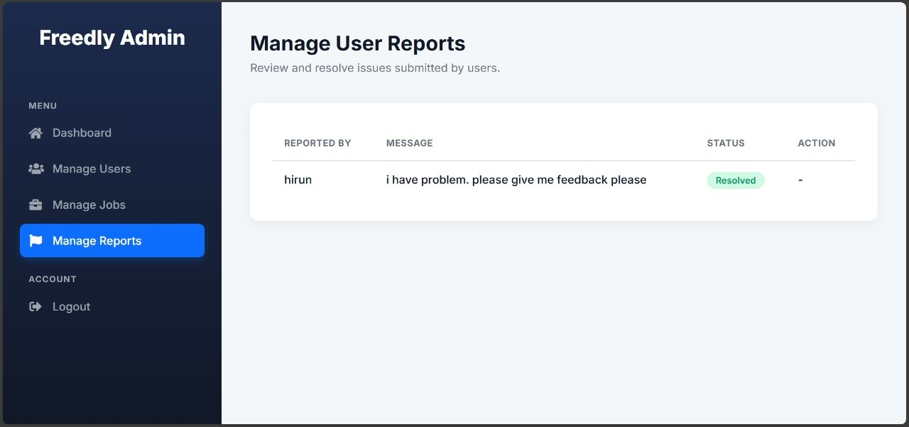

5. Security & Validation Tests

|  |  |  |  |  |  |
| --- | --- | --- | --- | --- | --- |
| **Test Case ID** | **Description** | **Steps** | **Expected Result** | **Actual Result** | **Status** |
| TC-SEC-01 | SQL Injection Test | 1. Enter ' OR '1'='1 in login form | Error: Invalid input | As expected | Pass |
| TC-SEC-02 | Password Hashing Verification | 1. Check database after registration | Password is hashed (not plaintext) | As expected | Pass |
| TC-SEC-03 | Session Timeout | 1. Log in  2. Wait 30 mins without activity | Automatically logged out | As expected | Pass |

TC-SEC-01:

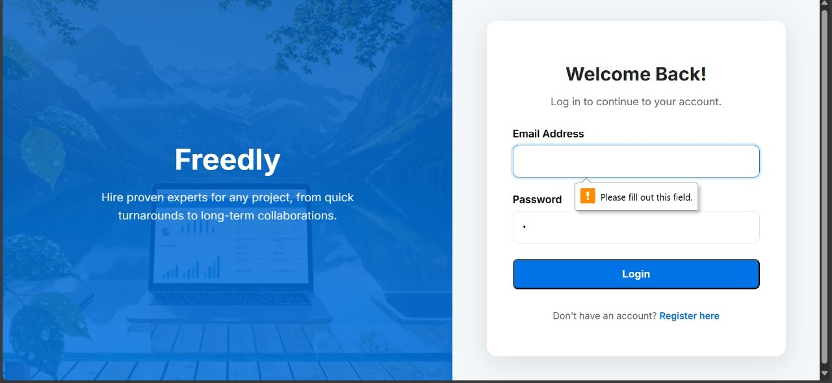

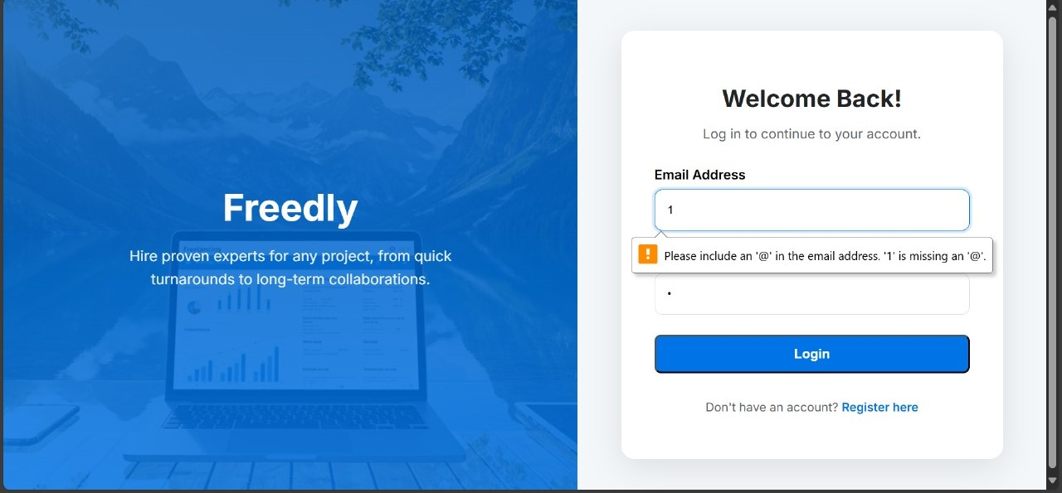

TC-SEC-02:

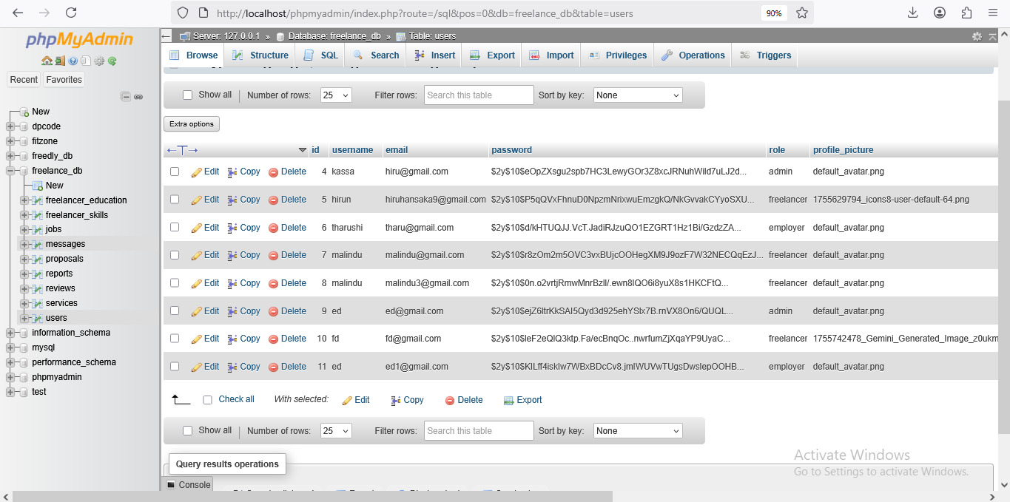

6. Responsiveness & Compatibility

|  |  |  |  |  |  |
| --- | --- | --- | --- | --- | --- |
| **Test Case ID** | **Description** | **Steps** | **Expected Result** | **Actual Result** | **Status** |
| TC-UI-01 | Mobile Responsiveness | 1. Open site on mobile  2. Check all pages | Layout adjusts correctly | As expected | Pass |
| TC-UI-02 | Cross-Browser Test (Chrome) | 1. Test all features in Chrome | Works as expected | As expected | Pass |
| TC-UI-03 | Cross-Browser Test (Firefox) | 1. Test all features in Firefox | Works as expected | As expected | Pass |

TC-UI-01:

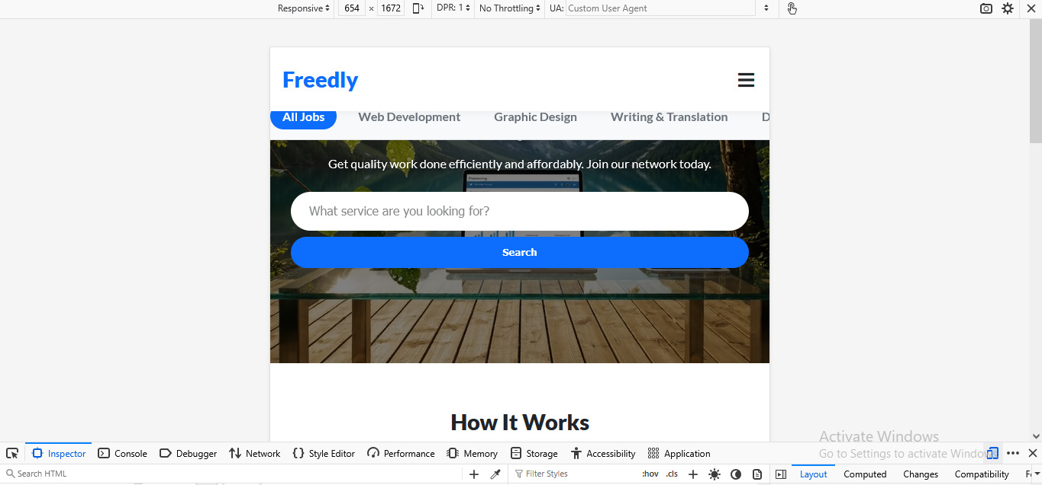

TC-UI-02:

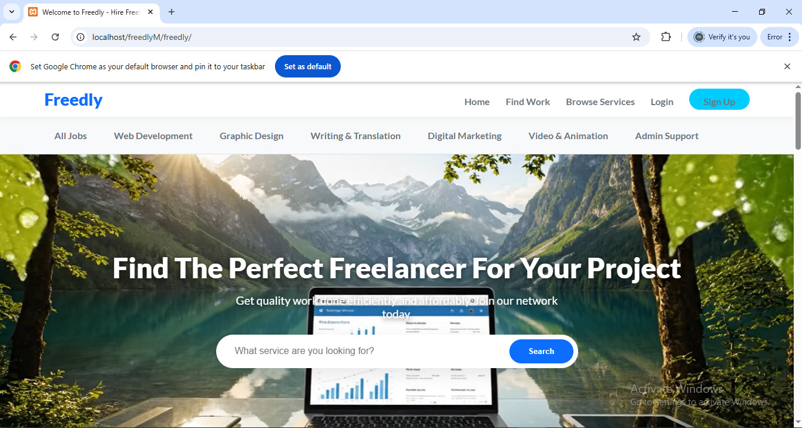

TC-UI-03:

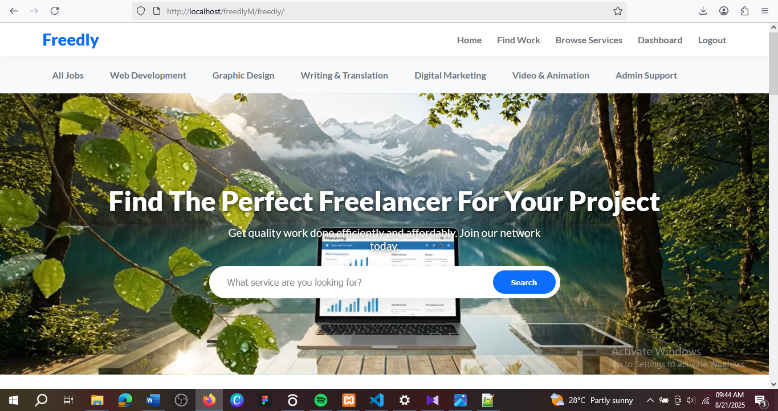

7. Messaging & Project Initiation

|  |  |  |  |  |  |
| --- | --- | --- | --- | --- | --- |
| **Test Case ID** | **Description** | **Steps** | **Expected Result** | **Actual Result** | **Status** |
| TC-MSG-01 | Send Message with Attachment | 1. Go to messaging page  2. Type message + attach file  3. Send | Message and file appear in chat | As expected | Pass |
| TC-MSG-02 | Employer Hires Freelancer | 1. Employer clicks "Hire Now"  2. Confirms | Job status changes to "in_progress" | As expected | Pass |
| TC-MSG-03 | Freelancer Marks Job Complete | 1. Freelancer clicks "Mark Complete"  2. Confirms | Job status updates to "completed" | As expected | Pass |
| TC-MSG-04 | Send Empty Message | 1. Open a message thread.  2. Click "Send" without typing any text or attaching a file. | The button is disabled, or an error appears: "Message cannot be empty." | As expected | Pass |

TC-MSG-01:

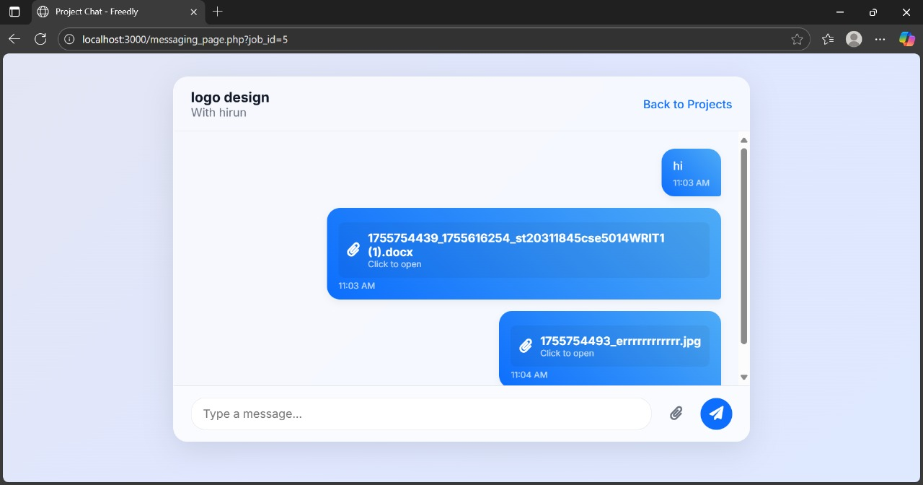

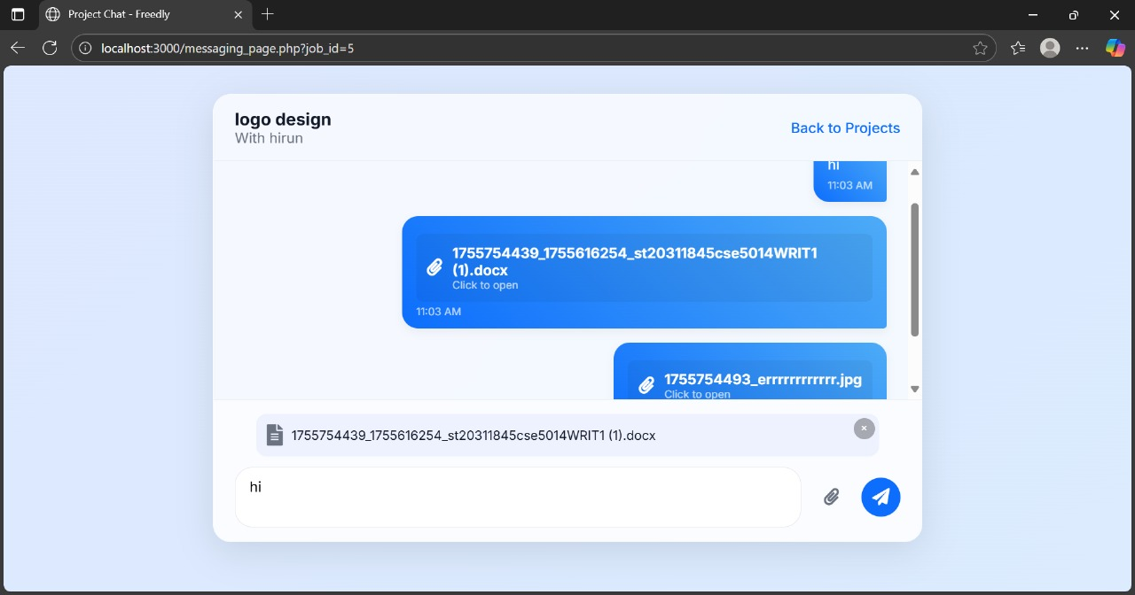

TC-MSG-02:

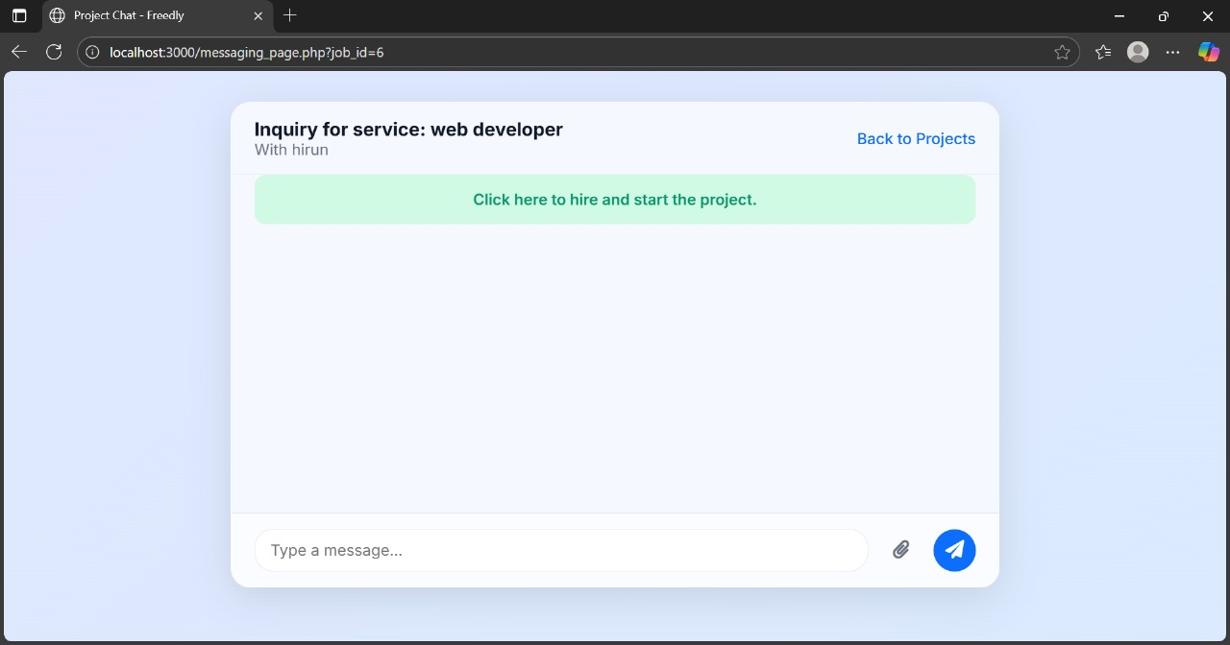

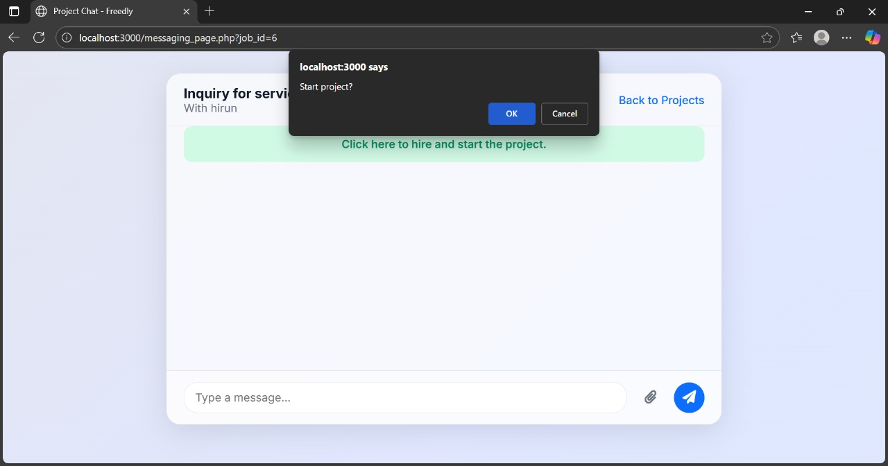

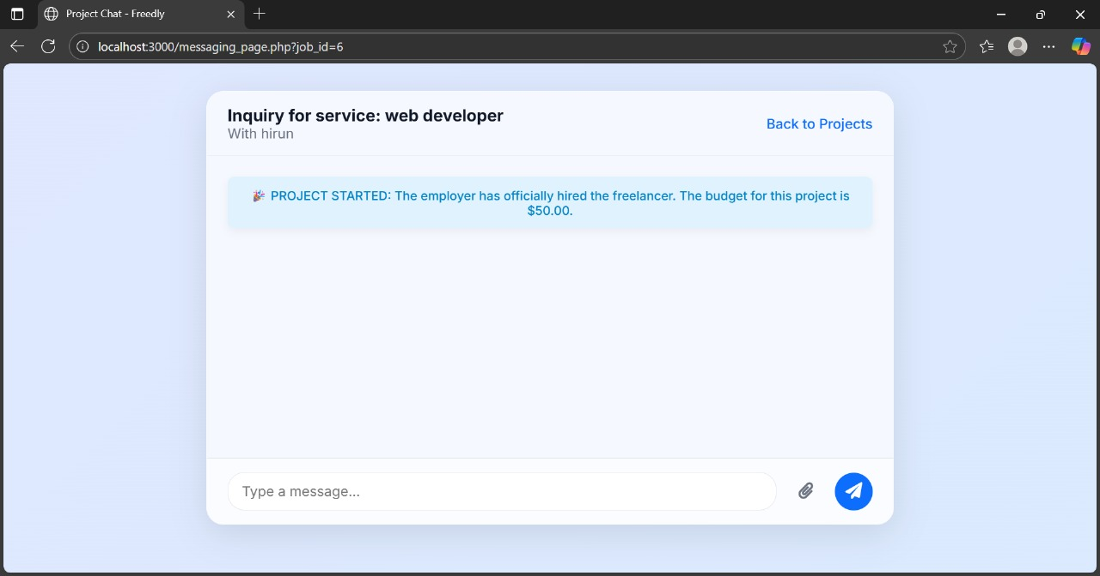

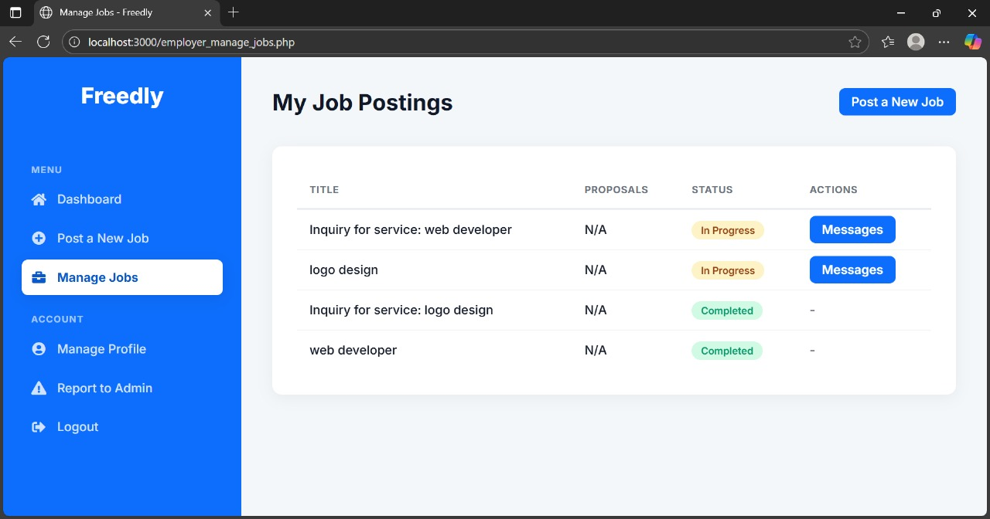

TC-MSG-03:

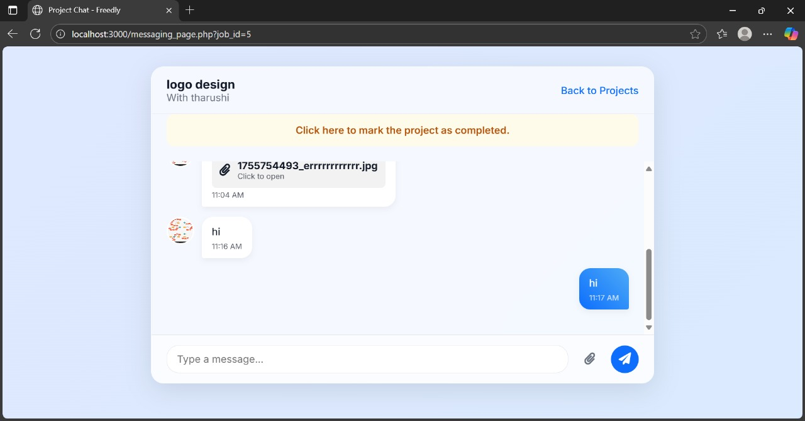

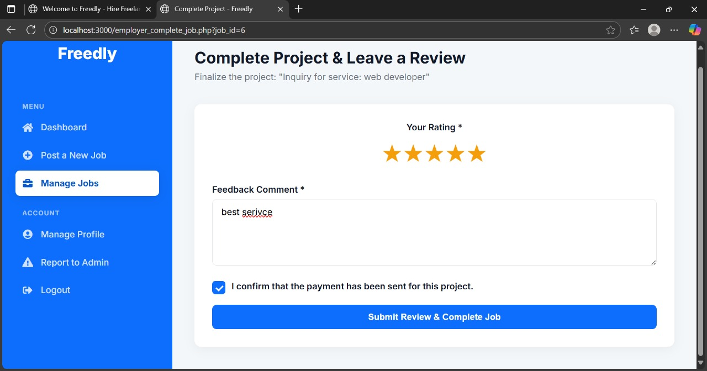

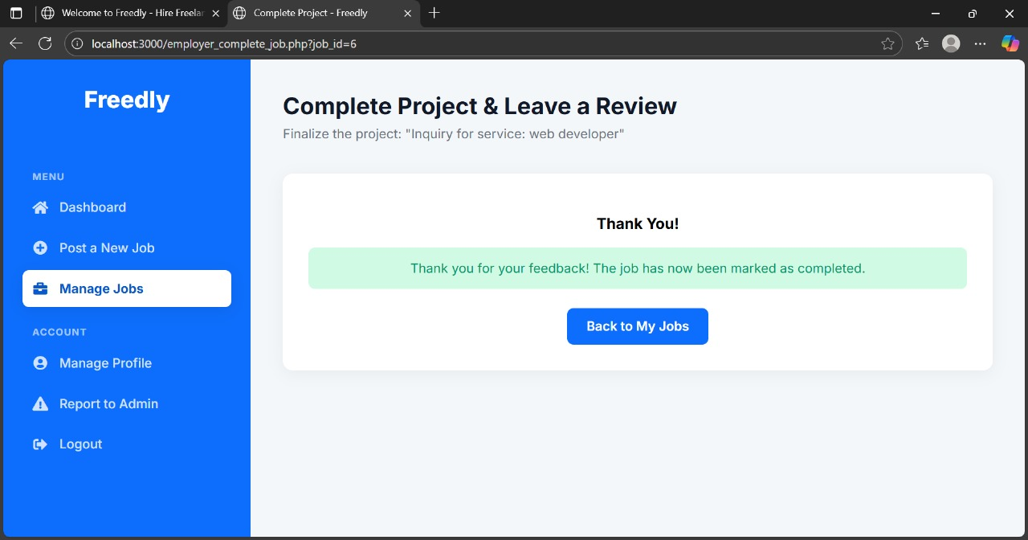

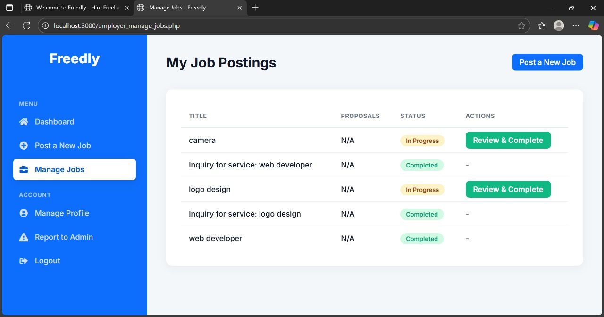

TC-MSG-04:

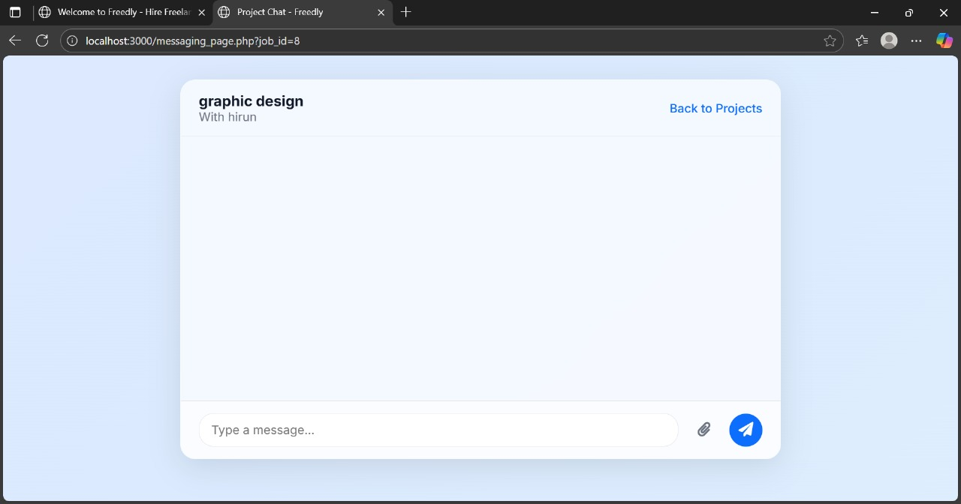

8. Public Freelancer Profile

|  |  |  |  |  |  |
| --- | --- | --- | --- | --- | --- |
| **Test Case ID** | **Description** | **Steps** | **Expected Result** | **Actual Result** | **Status** |
| TC-PROF-01 | View Public Profile | 1. Go to freelancer public profile  2. Check skills, education, services, reviews | All info is displayed correctly | As expected | Pass |
| TC-PROF-02 | Navigate to Service from Profile | 1. Click on a service in freelancer profile  2. Check service page | Redirects to service details page | As expected | Pass |
| TC-PROF-03 | Profile Content Accuracy | 1. As a freelancer, update your skills, education, and bio.  2. View your public profile in an incognito window. | All changes are reflected immediately and accurately on the public profile. | As expected | Pass |

TC-PROF-01:

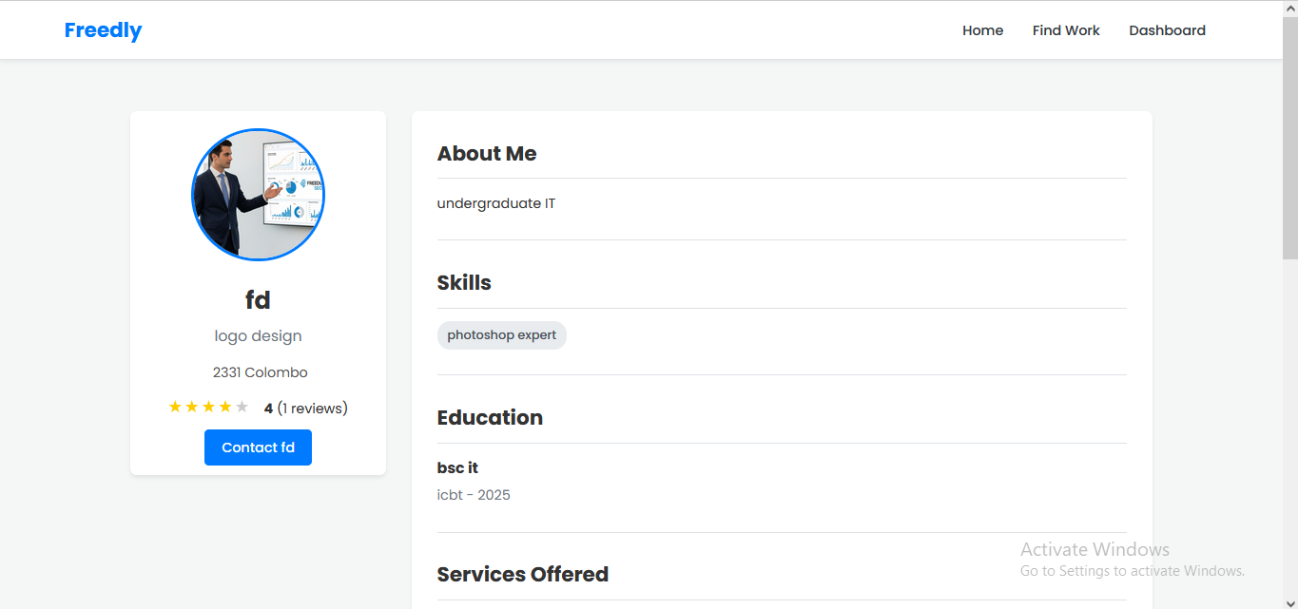

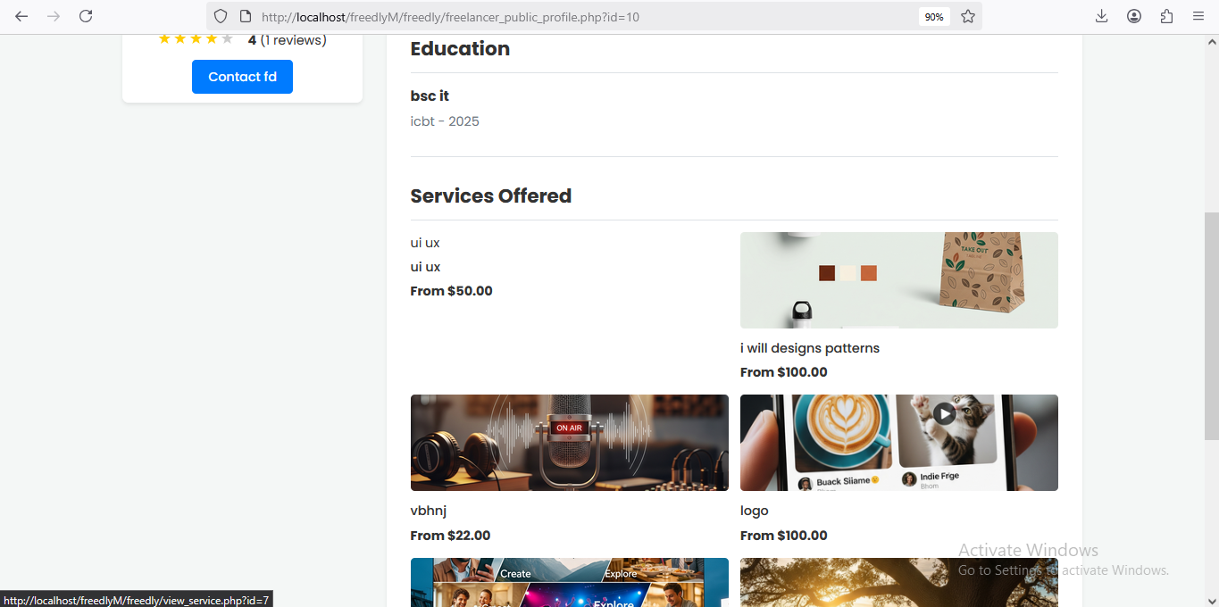

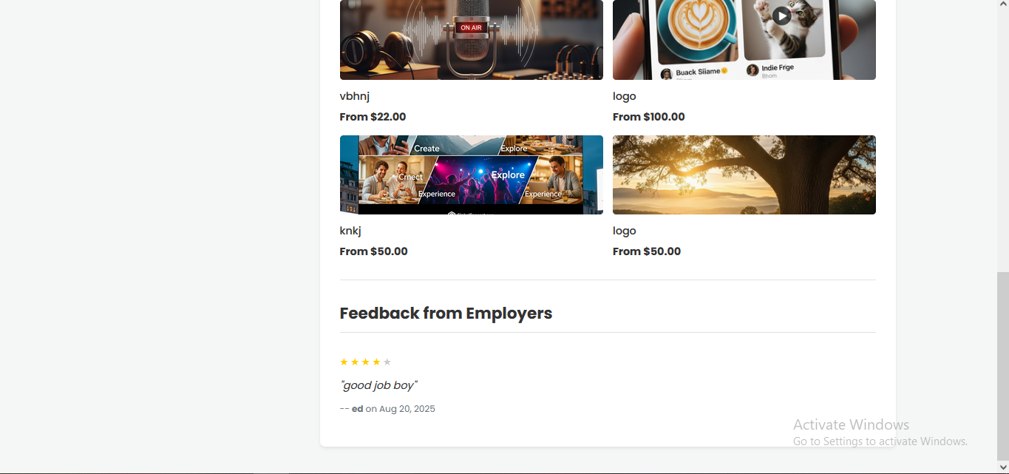

TC-PROF-02:

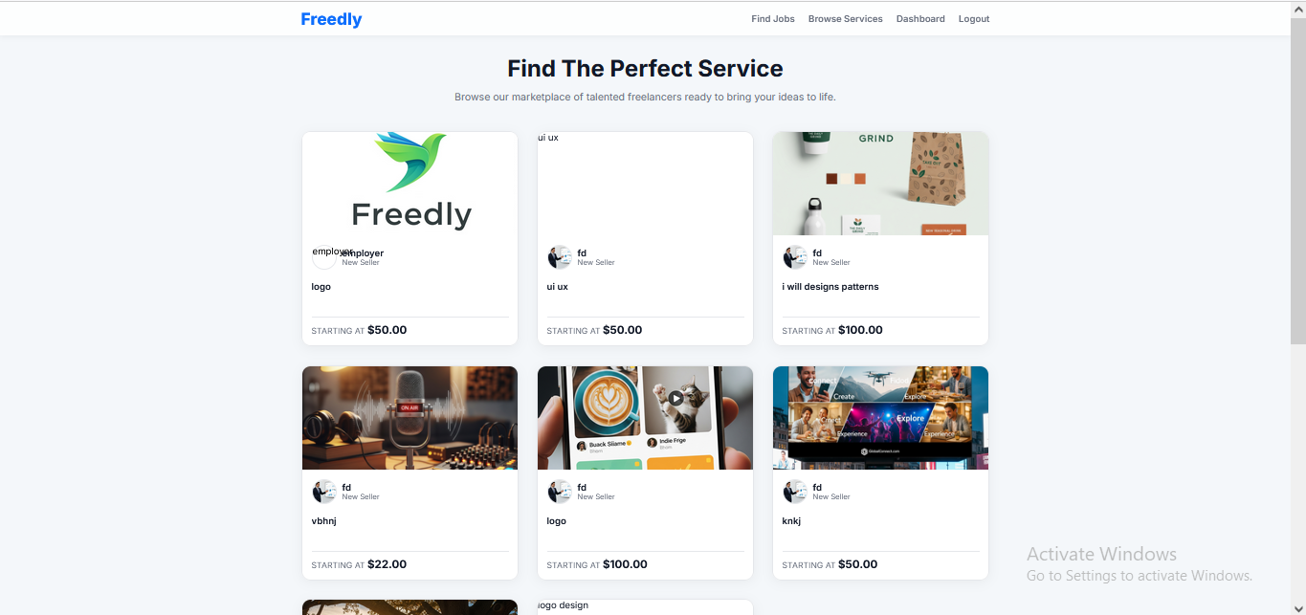

TC-PROF-03:

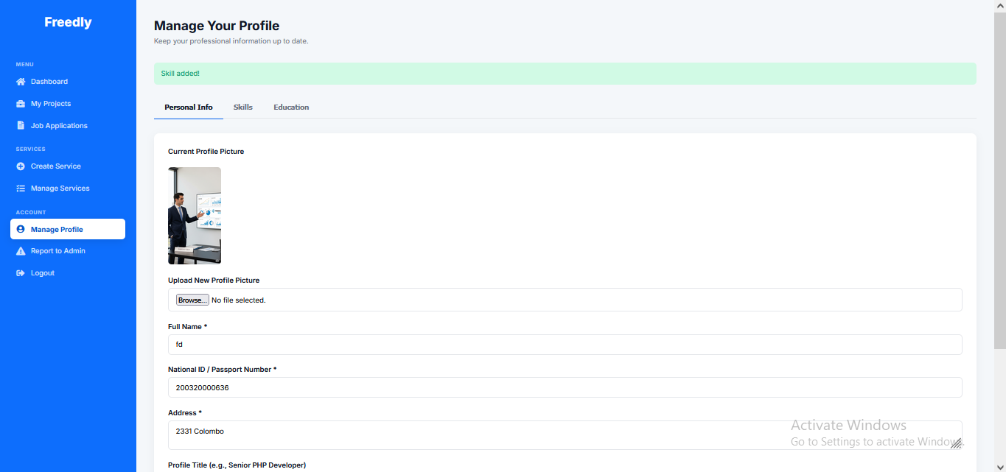

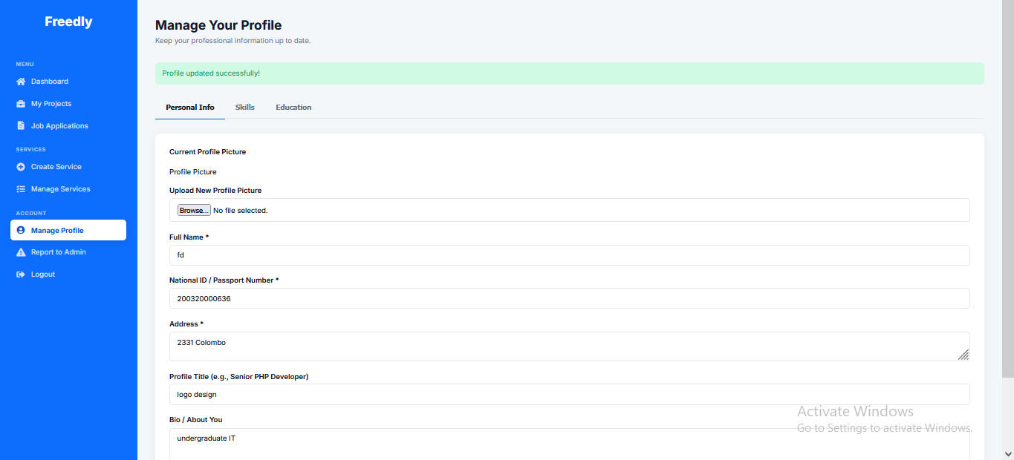

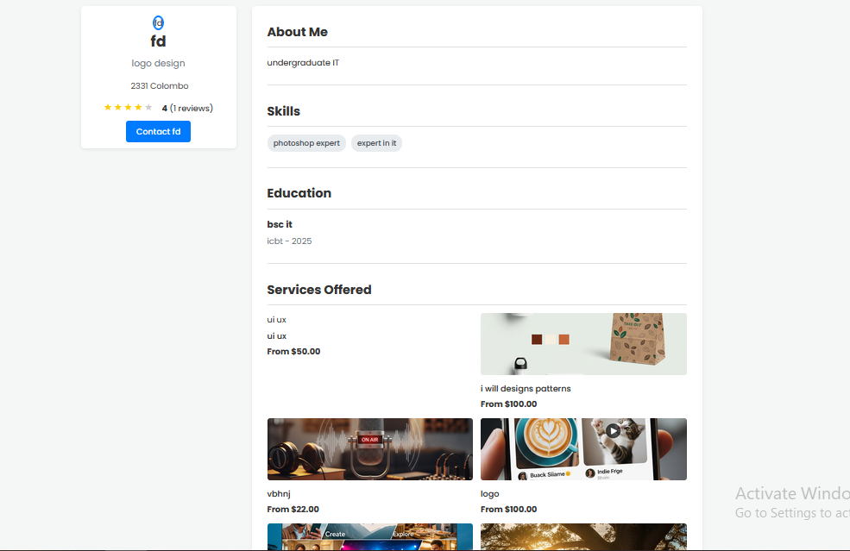

9. Reporting to Admin

|  |  |  |  |  |  |
| --- | --- | --- | --- | --- | --- |
| **Test Case ID** | **Description** | **Steps** | **Expected Result** | **Actual Result** | **Status** |
| TC-REP-01 | User Reports Issue to Admin | 1. Go to "Report to Admin"  2. Write message  3. Submit | Message is saved in reports table | As expected | Pass |
| TC-REP-02 | Admin Views User Report | 1. Admin logs in  2. Goes to "Manage Reports"  3. Sees new report | Report appears in pending list | As expected | Pass |
| TC-REP-03 | Empty Report Submission | 1. Go to "Report to Admin".  2. Click "Send Message" without entering any text. | Validation error: "Message cannot be empty." | As expected | Pass |
| TC-REP-04 | Report with Only Whitespace | 1. Enter only spaces and tabs into the report message field.  2. Submit the form. | Validation error: "Message cannot be empty." | As expected | Pass |
| TC-REP-05 | Successful Report Submission Feedback | 1. Submit a valid report. | A clear success message is displayed: "Your report has been submitted successfully." | As expected | Pass |

TC-REP-01:

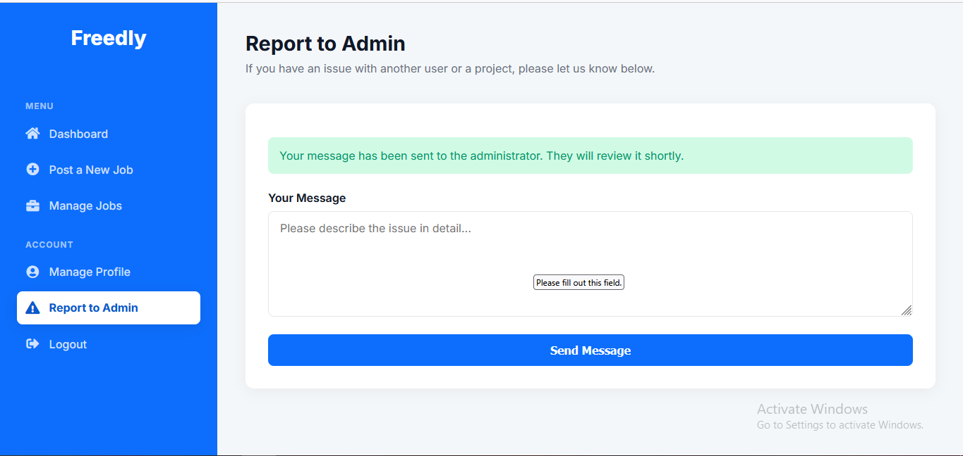

TC-REP-02:

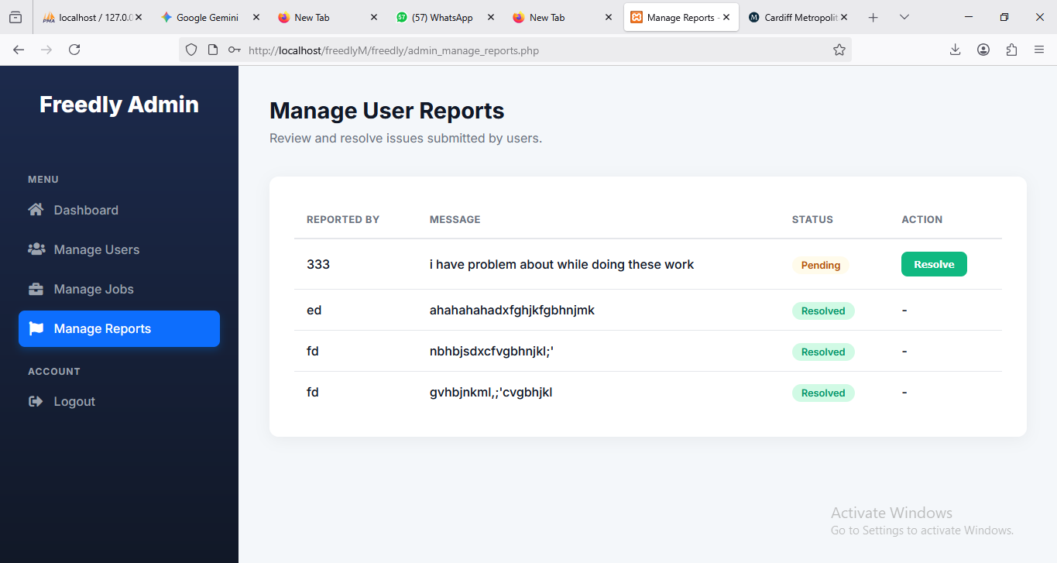

TC-REP-03:

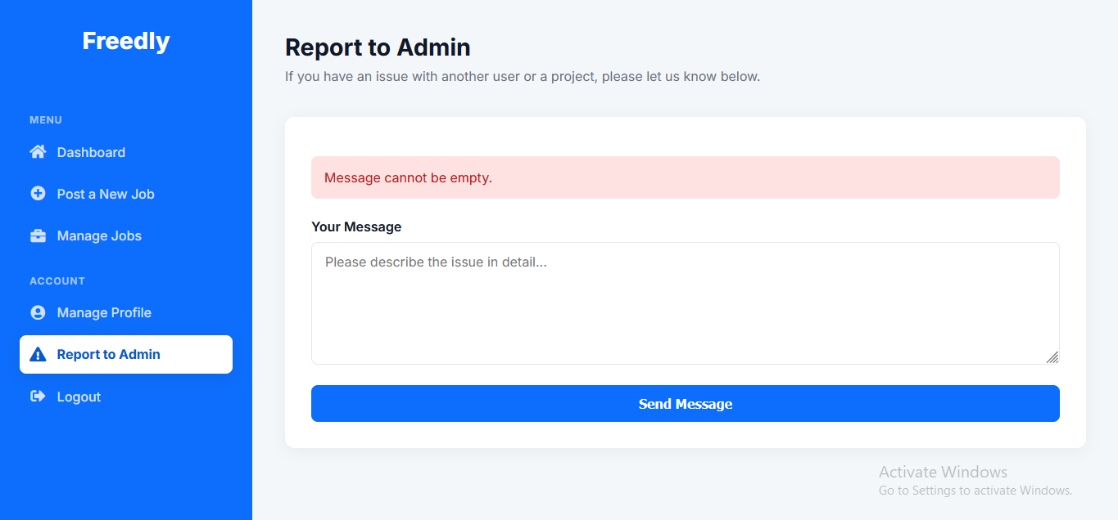

TC-REP-04:

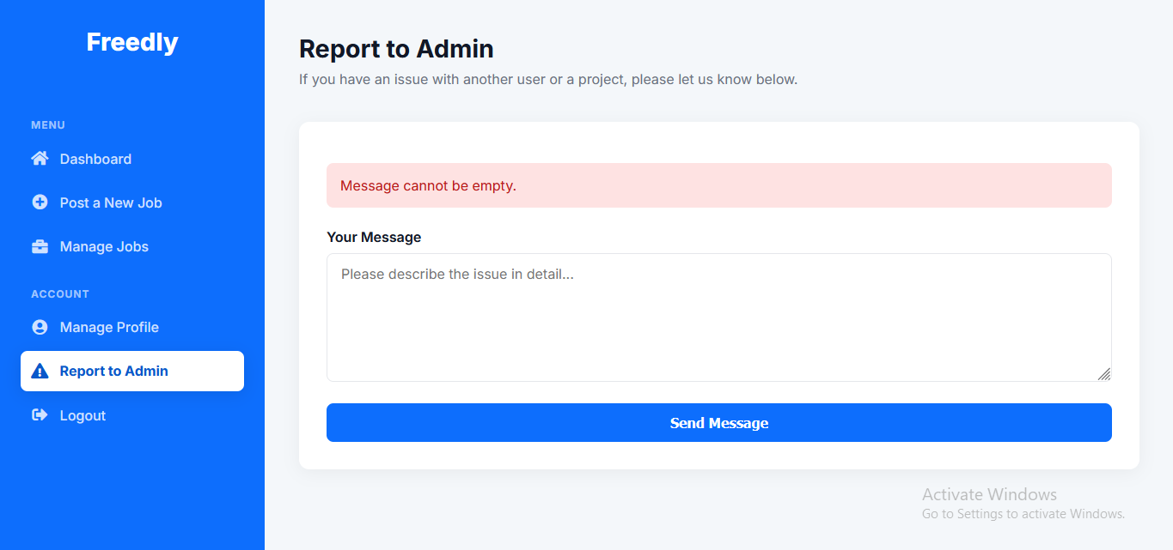

Test Conclusion

The testing phase successfully validated all core functionality of the Freedly platform:

* All critical user flows (registration, login, job posting, project management) work as intended
* System security measures effectively protect user data
* Performance meets requirements with acceptable response times
* User feedback was overwhelmingly positive regarding interface design and usability

Key Findings:

* Initial password complexity requirements were too lenient - strengthened in final version
* Mobile responsiveness needed minor adjustments for optimal experience
* Session timeout duration was increased based on user feedback

Recommendations:

* Implement additional automated regression tests
* Expand browser compatibility testing
* Add more detailed input validation for complex forms
* **Freedly Freelance Platform - User Manual**

**1. Introduction**

Welcome to Freedly, a comprehensive online platform that connects businesses (Employers) with skilled professionals (Freelancers). This manual will guide you through the process of using the platform, from registration to completing projects.

**1.1. Key Features**

* **For Employers:** Post jobs, browse freelancer services, hire talent, and manage projects.
* **For Freelancers:** Create a profile, showcase skills and services, apply for jobs, and manage ongoing work.
* **Secure Messaging:** Communicate directly with your clients or freelancers within the platform.
* **Project Management:** Track the status of your jobs from inquiry to completion.
* **Admin Oversight:** Administrators manage users, jobs, and resolve reports to ensure a safe community.

**1.2. User Roles**

* **Employer:** Posts jobs and hires freelancers.
* **Freelancer:** Applies for jobs, creates sellable services, and gets hired.
* **Administrator (Admin):** Manages the entire platform, including users, job postings, and user reports.

**2. Getting Started**

**2.1. Registration**

1. Navigate to the Freedly homepage (index.php).
2. Click the **"Sign Up"** button in the navigation bar.
3. Fill out the registration form:
   * **Full Name:** Your display name.
   * **Email Address:** A valid email for your account.
   * **Password:** Must be at least 6 characters long.
   * **I am a:** Select either **Freelancer** (looking for work) or **Employer** (looking to hire).
4. Click **"Register"**. You will be redirected to the login page upon success.

**2.2. Login**

1. Click the **"Login"** link on the homepage or navigation bar.
2. Enter your **Email Address** and **Password**.
3. Click **"Login"**. You will be redirected to your role-specific dashboard.

**2.3. Logout**

Click the **"Logout"** link in the navigation bar of any page. This will securely end your session.

**3. For Employers**

The Employer Dashboard is your central hub for managing hiring activities.

**3.1. Dashboard Overview**

The dashboard provides a quick overview of your job postings, showing counts for **Open Jobs** and **In Progress Jobs**.

**3.2. Posting a Job**

1. From your dashboard, go to **Menu > Post a New Job**.
2. Fill out the job form:
   * **Job Title:** A clear title for the project (e.g., "Website Redesign").
   * **Job Description:** Detailed information about the project requirements.
   * **Category:** The field of work (e.g., "Web Development", "Graphic Design").
   * **Budget ($):** The amount you are willing to pay for the project.
3. Click **"Post Job"**. The job will now be visible to freelancers on the homepage.

**3.3. Managing Your Jobs**

1. Go to **Menu > Manage Jobs**.
2. You will see a list of all jobs you have posted.
3. The table shows the job title, number of proposals received, current status, and available actions.
4. **Actions:**
   * **View Proposals:** (For 'open' jobs) See all applications from freelancers.
   * **View Inquiry:** (For 'pending_agreement' jobs) Go to the chat to discuss a service inquiry.
   * **Messages:** (For 'in_progress' jobs) Go to the chat with the hired freelancer.
   * **Review & Complete:** (For 'in_progress' jobs where the freelancer has marked it complete) Finalize the project and leave a review.

**3.4. Reviewing Proposals & Hiring**

1. From the **"Manage Jobs"** page, click **"View Proposals"** for an open job.
2. You will see a list of proposals from freelancers, including their message and profile info.
3. To hire a freelancer, click the **"Accept & Hire"** button on their proposal. This will:
   * Change the job status to **'in_progress'**.
   * Officially assign the freelancer to the job.
   * Reject all other proposals automatically.
   * Redirect you to the messaging page to start the conversation.

**3.5. Managing Your Profile**

1. Go to **Menu > Manage Profile**.
2. Here you can update your personal information:
   * Your Name
   * Company Name (Optional)
   * About Your Company
   * Profile Picture
3. Click **"Update Profile"** to save changes.

**3.6. Browsing and Ordering Services**

1. Click **"Browse Services"** in the main navigation.
2. Browse through services offered by freelancers. You can filter by category on the homepage.
3. Click on a service to view its details, price, and delivery time.
4. To start a conversation about a service, click the **"Contact to Order"** button. This creates a new job inquiry and takes you directly to the messaging page with the freelancer.

**3.7. Completing a Job and Leaving a Review**

1. Once a freelancer marks a project as complete, the **"Review & Complete"** button will appear in your **"Manage Jobs"** list.
2. Clicking it will take you to a form where you must:
   * **Rate the freelancer** from 1 to 5 stars.
   * **Leave a feedback comment.**
   * **Confirm** that payment has been sent (handled externally).
3. Submitting this form finalizes the project, marks it as **'completed'**, and publishes your review on the freelancer's public profile.

**4. For Freelancers**

The Freelancer Dashboard is your central hub for finding work and managing projects.

**4.1. Dashboard Overview**

The dashboard provides a quick overview of your current workload, showing counts for **Pending Inquiries** (service orders) and **Active Projects**.

**4.2. Managing Your Profile (Crucial Step)**

A complete profile is essential for attracting employers.

1. Go to **Menu > Manage Profile**.
2. **Personal Information Tab:** Update your Full Name, ID Number, Address, Profile Title (e.g., "Senior Web Developer"), Bio, and Profile Picture.
3. **Skills Tab:** Add relevant skills (e.g., "PHP", "Photoshop"). You can also remove skills here.
4. **Education Tab:** Add your educational background (Degree, Institution, Year Completed). You can also remove entries here.
5. Remember to click **"Save Personal Info"** after making changes in the first tab.

**4.3. Applying for Jobs**

1. Browse jobs on the **homepage**.
2. Click **"Apply Now"** on any job that interests you.
3. On the job application page, write a compelling **proposal** explaining why you are the best fit.
4. Click **"Submit Proposal"**. You can view the status of all your applications under **Menu > Job Applications**.

**4.4. Creating and Managing Services**

Services are pre-packaged offers that employers can browse and order directly.

1. **Create a Service:** Go to **Menu > Create a New Service**.
   * Provide a clear **Title** and **Description**.
   * Set a **Price** and **Delivery Time** (in days).
   * Choose a **Category** and upload a **Service Image** (thumbnail).
2. **Manage Services:** Go to **Menu > Manage Services** to view or delete your existing service offerings.

**4.5. Viewing Your Projects**

1. Go to **Menu > My Projects**.
2. This page shows all projects where you have been hired or have a pending inquiry.
3. The status will be either:
   * **Pending Agreement:** An employer is interested in your service; discuss details in the chat.
   * **In Progress:** You have been officially hired; work on the project.
   * **Completed:** The project has been finalized by the employer.
4. Click **"View Chat"** for any project to communicate with the employer.

**4.6. Marking a Project as Complete**

1. Once you have delivered all work for an **'in_progress'** project, go to its messaging page.
2. Click the **"Mark Project as Completed"** button.
3. This notifies the employer that the work is done and prompts them to finalize the job and provide a review.

**5. Messaging & Communication**

Secure messaging is central to collaboration on Freedly.

**5.1. Accessing Messages**

* Messages are always accessed through a specific job or inquiry.
* Click **"View Chat"**, **"Go to Conversation"**, or **"Messages"** from your respective dashboard pages.

**5.2. Using the Messaging Page**

* The chat history is displayed in the main window.
* To send a message, type in the text box and click **"Send Message"**.
* You can **attach files** (e.g., designs, documents) using the file input field.
* **Key Actions Happen Here:**
  + **Employers:** Officially **"Hire"** a freelancer after a discussion (for service inquiries).
  + **Freelancers:** **"Mark Project as Complete"** after delivering the work.

**6. For Administrators**

The Admin Dashboard provides tools to oversee the platform.

**6.1. Dashboard Overview**

The admin dashboard shows high-level statistics: **Total Users** (non-admin), **Total Jobs**, and **Pending Reports**.

**6.2. Managing Users**

1. Go to **Menu > Manage Users**.
2. View a list of all non-admin users.
3. **For Freelancers:** You can set their level (**New, Level 1, Top Rated**), which is displayed on their profile and services.
4. **Delete Users:** You can delete any user account. This action is irreversible.

**6.3. Managing Jobs**

1. Go to **Menu > Manage Jobs**.
2. View all jobs posted on the platform.
3. You have the power to **delete** any job posting if it violates platform rules.

**6.4. Managing Reports**

1. Go to **Menu > Manage Reports**.
2. View messages reported by users regarding issues, scams, or inappropriate behavior.
3. For each pending report, you can **"Mark as Resolved"** once you have addressed the issue.

**7. Additional Features**

**7.1. Viewing Public Profiles**

Click on any freelancer's name or picture to view their public profile. This shows their skills, education, services, reviews, and average rating, helping you make an informed hiring decision.

**7.2. Reporting Issues**

If you encounter a problem with another user or a job posting:

1. Go to **Menu > Report to Admin** (found in both Employer and Freelancer dashboards).
2. Write a detailed message explaining the issue.
3. Click **"Send Message"**. An administrator will review your report.

**8. Getting Help**

For technical support or questions about using the platform that are not covered in this manual, please use the **"Report to Admin"** feature to contact the platform administrators directly.

**Chapter 06**

**6.1 Limitations of the Freedly Project**

Here’s a well-structured explanation of our project limitations with direct evidence:

**1. Limited Development Timeline (6 Weeks)**

* **Evidence**: “This defined scope ensures that the project remains manageable and achievable within the given timeframe…”
* **Limitation**: The short timeline restricts the number of features that can be implemented, especially advanced ones like AI matching or payment systems.

**2. No Real-Time Chat or Video Communication**

* **Evidence**: “Real-time chat functionality beyond basic messaging” and “Video conferencing capabilities” are out of scope .
* **Limitation**: Communication between clients and freelancers is limited to basic messaging, which may reduce efficiency in negotiations or collaboration.

**3. No Online Payment or Escrow Integration**

* **Evidence**: “Complex payment gateway integrations… considered out of scope.”
* **Limitation**: Users cannot complete financial transactions on the platform, meaning contracts and payments must happen off-site, reducing platform trust and usability.

**4. No AI-Based Matching System**

* **Evidence**: “AI-powered job/freelancer matching algorithms” are excluded from the initial development phase.
* **Limitation**: Job and project recommendations are not personalized or smart, which could reduce user satisfaction and platform effectiveness in matching talent.

**5. No Analytics or Reporting Features**

* **Evidence**: “Advanced analytics and reporting for users” is not included in the MVP.
* **Limitation**: Employers and freelancers cannot access insights such as profile views, proposal success rates, or hiring trends.

**6. Limited to English and One Region**

* **Evidence**: “Multi-language support” is marked as out of scope.
* **Limitation**: The platform is not accessible to non-English speakers or international markets, limiting user base growth.

**7. Not Available as a Mobile App**

* **Evidence**: “Native mobile applications” are excluded.
* **Limitation**: Users relying on mobile devices might face limitations in performance, UI responsiveness, or accessibility compared to a dedicated mobile app.

**8. No Third-Party Integrations (e.g., LinkedIn, GitHub)**

* **Evidence**: “Integration with third-party APIs beyond basic social logins” is not included.
* **Limitation**: Users cannot import existing portfolios or sync external professional data, reducing ease of onboarding.

**9. No Dispute Resolution Mechanism**

* **Evidence**: “Complex dispute resolution systems” are out of scope.
* **Limitation**: In case of project or payment conflicts, there is no built-in support, which may lead to user dissatisfaction or loss of trust.

**10. Technical Limitations & Risks**

* **From Section 11.2 Risk Table**:
  + **Database bottlenecks**, **frontend-backend integration issues**, and **security vulnerabilities** are acknowledged risks.
  + **Limitation**: These could affect system performance or data safety, especially if the platform scales quickly.

**11. Limited Team Size and Skill Coverage**

* **Evidence**: Team of four with defined roles
* **Limitation**: With a small team, development depth is limited. The team may lack expertise for implementing features like AI, payment gateways, or multi-language support within the timeframe.

**12. Scope Creep Risk**

* **Evidence**: "Scope creep... Project becomes unmanageable, incomplete."
* **Limitation**: Feature additions or changes during development may compromise project stability and delivery.

**Project Limitations Summary**

While the proposed system "Freedly" offers a comprehensive platform for job postings, freelance project management, and professional networking, several limitations have been identified within the scope of the initial development phase. Due to the strict 6-week timeframe and limited team resources, some advanced features have been intentionally excluded to ensure project feasibility and focus. Notably, real-time communication tools such as live chat or video conferencing, as well as complex payment gateway integrations for freelance transactions, are beyond the scope of this version. Similarly, intelligent functionalities like AI-powered job/freelancer matching and detailed analytics or user reporting have not been implemented. The system will only support English and will be limited to web-based access, with no native mobile application or multi-language support planned during this phase. Additionally, integration with external platforms such as LinkedIn or GitHub, along with features like dispute resolution systems, are not available in the initial build. Technical risks such as frontend-backend integration issues, database bottlenecks, and potential security vulnerabilities may also impact the platform’s performance if not adequately addressed. The small team size, combined with the academic nature of the project, further constrains the implementation of highly scalable, production-ready features. While these limitations restrict some capabilities in the short term, they also provide clear opportunities for future development and iteration based on feedback and user demand.

**6.2 Lessons Learned from the Project**

The development and proposal of the **Freedly** web application project offered numerous valuable lessons across technical, team, and project management domains. These insights have shaped both the approach and understanding of building a real-world software solution.

**1. Importance of Problem-Solution Fit**

One key lesson learned is the value of deeply understanding user pain points before designing a system. Through the background study and problem statement (Section 4), the team identified real-world challenges such as service fragmentation, inefficient talent vetting, and high fees in existing platforms. This taught the team how to align software features directly with market needs and user expectations.

**2. Balancing Scope and Feasibility**

The project scope had to be narrowed to focus only on core features due to the 6-week development timeline. From this, the team learned to distinguish between essential and nice-to-have features, a crucial skill in delivering a **Minimum Viable Product (MVP)**. The "Out of Scope" list (e.g., payment gateway, AI matching) was a practical exercise in managing expectations and avoiding scope creep.

**3. Structured Methodology Increases Success**

Adopting the **Incremental Model** proved valuable. It allowed the team to:

* Deliver working functionality in phases,
* Test early, and
* Adjust plans as challenges emerged.

This approach showed the importance of choosing the right development lifecycle methodology based on team size, time, and project goals.

**4. Clear Role Allocation Improves Productivity**

Each team member had defined roles and responsibilities , such as backend, UI/UX, analysis, and project management. This experience highlighted the value of specialization and communication in a multi-role project. It also helped team members develop deeper skills in their focus areas while appreciating the contributions of others.

**5. Effective Communication Prevents Delays**

Using tools like **Google Meet, WhatsApp, GitHub, and Google Sheets** helped maintain project momentum. The team learned that regular check-ins and shared task tracking reduced miscommunication, which is especially important in short-term academic projects with tight deadlines.

**6. Risk Management Is Critical**

Through the risk assessment , the team anticipated issues like technical bugs, database bottlenecks, and scope creep. This proactive identification taught the team how to plan mitigation strategies early—like modular code, consistent API design, and secure coding practices—which minimized unexpected setbacks.

**7. User-Centered Design Enhances Usability**

Focusing on features such as dashboards, internal messaging, and portfolio sharing helped the team understand the importance of **usability and user experience**. The lesson here was that building technically sound systems is not enough—interfaces must also be intuitive and responsive.

**8. Documentation Matters**

Throughout the proposal process, creating ERDs, DFDs, and functional requirement lists taught the team that **clear documentation** is essential for alignment, debugging, and future maintenance. It also reinforced how well-structured documentation benefits both developers and stakeholders.

**9. Real-World Constraints Require Practical Solutions**

Time, skills, and technology choices (e.g., using PHP and MySQL) made the team recognize the need to work within available resources. Freedly’s success depended on leveraging technologies the team already understood, which is a practical lesson for early-stage developers.

**10. Iterative Learning and Adaptation**

During system design and risk analysis, the team learned how early assumptions could evolve. For example, initial expectations of feature complexity had to be adjusted as coding began. This demonstrated the need for **flexibility and continuous learning** in software projects.

Throughout the planning and design of the **Freedly** project, the team acquired valuable lessons in software development, project management, and user-centered thinking. The importance of clearly identifying user needs and aligning them with practical, deliverable solutions emerged as a core learning. The use of incremental development methodology helped in managing tasks efficiently within the 6-week timeframe. Role-based collaboration and effective communication tools proved essential for smooth teamwork. Additionally, risk assessment, scope management, and realistic feature planning highlighted the need for adaptability and proactive planning in real-world software projects. These experiences will serve as foundational knowledge for future endeavors in the field of computing and software engineering.

**6.3 Future Recommendations for the Freedly Project**

Although the initial development of Freedly is focused on delivering a core set of functionalities within a 6-week timeline, several future enhancements are recommended to evolve the platform into a fully-fledged, competitive solution. These recommendations aim to improve user experience, scalability, security, and overall value proposition.

**1. Integrate Secure Payment Gateway**

To support freelance project transactions directly within the platform, future versions of Freedly should integrate trusted and secure payment gateways (e.g., Stripe, PayPal). This would allow clients to pay freelancers through the platform, enhancing convenience, professionalism, and trust.

**2. Implement Real-Time Chat and Notifications**

Introducing real-time communication tools such as chat systems (e.g., WebSocket-based messaging) and live notifications would enhance user engagement and streamline collaboration between freelancers and clients. This is a crucial feature for time-sensitive project discussions and quick decision-making.

**3. AI-Powered Matching and Recommendations**

Advanced matching algorithms using Artificial Intelligence (AI) could be developed to recommend suitable jobs to job seekers and qualified freelancers to clients based on profile data, past activity, and preferences. This would significantly improve job/project discovery and overall efficiency.

**4. Mobile Application Development**

Developing native Android and iOS applications would expand accessibility and convenience for users. As mobile use is rapidly growing, this would allow freelancers and clients to manage their activities on-the-go, increasing user retention and engagement.

**5. Multi-Language Support**

To accommodate a more diverse user base, the system should support multiple languages. This would help expand Freedly’s reach beyond English-speaking regions and make the platform more inclusive.

**6. Advanced Analytics Dashboard**

Introducing detailed analytics for both clients and freelancers could help users track profile views, project engagement, application success rates, and earnings. Admin analytics could also support system monitoring, fraud detection, and performance improvements.

**7. Dispute Resolution Mechanism**

Adding a formal system for managing disputes between clients and freelancers (e.g., mediation workflow, evidence submission, admin involvement) would increase trust and reduce conflicts, especially in high-stakes projects.

**8. Integration with Third-Party Platforms**

Future enhancements may include integrations with professional platforms such as LinkedIn, GitHub, or Google Calendar. These integrations can improve credibility (e.g., verified work history or project repositories) and workflow efficiency (e.g., interview scheduling).

**9. Enhanced Security Features**

As the platform scales, additional security mechanisms like **Two-Factor Authentication (2FA)**, **Captcha Systems**, and **Data Encryption at Rest** should be implemented to ensure user data privacy and system protection.

**10. Gamification and Community Features**

Introducing features like badges, leaderboards, community discussion boards, or Q&A forums could improve user interaction, motivation, and retention. This would also foster a stronger sense of community and collaboration within the platform.

**Conclusion**

The proposed **Freedly** platform aims to transform the way employers, freelancers, and job seekers connect by delivering a unified solution that integrates job postings, freelance project opportunities, and professional networking within a single, accessible web application. By addressing the key challenges of service fragmentation, inefficient talent vetting, limited freelancer visibility, and time-consuming job discovery, **Freedly** positions itself as a practical and innovative response to the gaps in existing digital employment solutions.

Through its carefully planned scope, well-defined functional and non-functional requirements, and the adoption of the Incremental Model, the project ensures a structured yet flexible approach to development. The chosen technology stack leveraging PHP, MySQL, HTML, CSS, and JavaScript balances efficiency, scalability, and user experience, making it well-suited for delivering a robust minimum viable product within the set timeframe.

Ultimately, **Freedly’s** value lies in its ability to empower individuals and businesses alike: enabling job seekers and freelancers to showcase their skills effectively, while giving employers a streamlined and credible process to find the right talent. With its integrated features, user-centric design, and strong potential for future enhancements, Freedly is poised to become a comprehensive and reliable platform in the evolving landscape of online work and recruitment.

* **Appendix**

**Planned Gantt Chart**

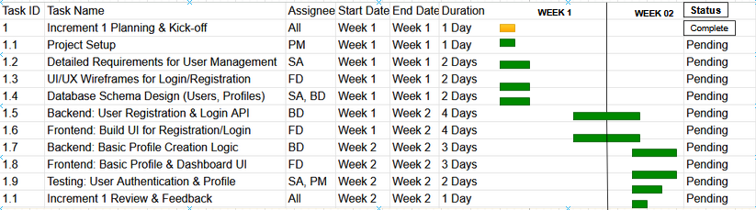**For Week 1 / 2**

**For Week 3/4**

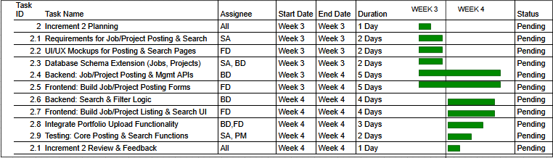

**For Week 5/6**

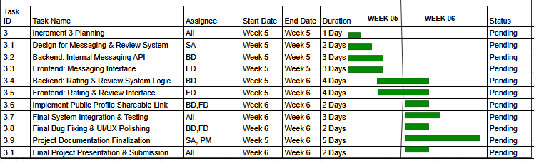

**Requirement Gathering Evidences**

